**Milestone III: Query Performance**

Work flow

Professor’s solutions were used for performance testing. The ipython code for creating random data was used from Kyle (Cats) and Tony/Sanjay(Sales). For performance testing, queries were run 3 times with the average time taken as the performance metric, the % change was calculated using

[1 – (with index time/without index time)]*100%

Screenshots & raw data from queries are included at the end.

**Sales**

Tested the following indexes:

CREATE INDEX sales_cust_id ON sales.sale(customer_id);

CREATE INDEX sales_prod_id ON sales.sale(product_id);

CREATE INDEX cust_state_id ON sales.customer(state_id);

CREATE INDEX product_cat_id ON sales.product(category_id);

**Query 1: None**

Tried: CREATE INDEX sales_cust_id ON sales.sale(customer_id);

Analysis: 0.4% slower compared to default query, not incorporated by optimizer

Reasoning: Do not use this index. Sequential scanning on customer_id requires less cost to execute.

**Query 2: None**

Tried: CREATE INDEX sales_cust_id ON sales.sale(customer_id);

Analysis: 0.9% slower compared to default query, not incorporated by optimizer

Reasoning: Do not use this index. Sequential scanning on sale table is preferred since less cost is necessary.

Tried: CREATE INDEX cust_state_id ON sales.customer(state_id);

Analysis: 0.4% slower compared to default query, not incorporated by optimizer

Reasoning: Do not use this index. Sequential scanning on state table is preferred since less cost is necessary.

**Query 3: sales_cust_id**

Tried: CREATE INDEX sales_cust_id ON sales.sale(customer_id);

Analysis: 19.3% faster compared to default query, incorporated by optimizer

Reasoning: Do use this index. By subsetting the data using an index scan, the time required to satisfy the index condition is faster and the cost for scanning is faster. The ‘WHERE’ clause in this query allows for optimal indexing.

**Query 4: None**

Tried: CREATE INDEX sales_cust_id ON sales.sale(customer_id);

Analysis: 0% change compared to default query, not incorporated by optimizer

Reasoning: Do not use this index. Sequential scanning on the sale table is favorable, lower cost for the query. No need to index the foreign key.

Tried: CREATE INDEX sales_prod_id ON sales.sale(product_id);

Analysis: 0% change compared to default query, not incorporated by optimizer

Reasoning: Do not use this index. Sequential scanning on the sale table is favorable, lower cost for the query. No need to index the foreign key.

**Query 5: None**

Tried: CREATE INDEX sales_cust_id ON sales.sale(customer_id);

Analysis: 0.5% faster compared to default query, not incorporated by optimizer

Reasoning: Do not use this index. Sequential scanning on the sale table is favorable, lower cost for the query. No need to index the foreign key.

Tried: CREATE INDEX sales_prod_id ON sales.sale(product_id);

Analysis: 7.3% slower compared to default query, not incorporated by optimizer

Reasoning: Do not use this index. Sequential scanning on the sale table is favorable, lower cost for the query. No need to index the foreign key.

**Query 6: None**

Tried: CREATE INDEX sales_cust_id ON sales.sale(customer_id);

Analysis: 3.1% slower compared to default query, not incorporated by optimizer

Reasoning: Do not use this index. Sequential scanning on the sale table is favorable, lower cost for the query. No need to index the foreign key.

Tried: CREATE INDEX sales_prod_id ON sales.sale(product_id);

Analysis: 10.7% slower compared to default query, not incorporated by optimizer

Reasoning: Do not use this index. Sequential scanning on the sale table is favorable, lower cost for the query. No need to index the foreign key.

**Cats**

Tested the following indexes:

CREATE INDEX login_user_id_index ON cats.login(user_id);

CREATE INDEX friend_user_id_index ON cats.friend(user_id);

CREATE INDEX watch_user_id_index ON cats.watch(user_id);

CREATE INDEX watch_video_id_index ON cats.watch(video_id);

CREATE INDEX likes_user_id_index ON cats.likes(user_id);

CREATE INDEX likes_video_id_index ON cats.likes(video_id);

**Query 1: watch_user_id_index, likes_user_id_index, likes_video_id_index**

Tried: CREATE INDEX watch_user_id_index ON cats.watch(user_id);

Analysis: 6.3% slower compared to default query, is incorporated by optimizer

Reasoning: Do use this index. Although the performance time did not decrease, the optimizer used this index instead of a sequential scan of the watch table as this allowed for heap blocks to be created and condition checks. With larger data sets provided, performance differences should be more noticeable. The where clause made this index optimal.

Tried: CREATE INDEX watch_video_id_index ON cats.watch(video_id);

Analysis: 2.8% slower compared to default query, not incorporated by optimizer

Reasoning: Do not use this index. Indexing the query on video_id in the watch table does not increase the performance of the query

Tried: CREATE INDEX likes_user_id_index ON cats.likes(user_id);

Analysis: 5.3% slower compared to default query, incorporated by optimizer

Reasoning: Do use this index. Although the performance time did not decrease, the optimizer used this index instead of a sequential scan of the likes table as this allowed for heap blocks to be created and condition checks. With larger data sets provided, performance differences should be more noticeable. The where clause made this index optimal.

Tried: CREATE INDEX likes_video_id_index ON cats.likes(video_id);

Analysis: 7.7% slower compared to default query, incorporated by optimizer

Reasoning: Do use this index. Although the performance time did not decrease, the optimizer used this index instead of a sequential scan of the likes table as this allowed for heap blocks to be created and condition checks. With larger data sets provided, performance differences should be more noticeable. The where clause made this index optimal.

**Query 2: friend_user_id_index, watch_user_id_index, likes_user_id_index, likes_video_id_index**

Tried: CREATE INDEX friend_user_id_index ON cats.friend(user_id);

Analysis: 5.8% faster compared to default query, incorporated by optimizer

Reasoning: Do use this index. Index scanning allowed the query to run faster, and with larger data sets the performance should only increase. The where clause made this index optimal.

Tried: CREATE INDEX watch_user_id_index ON cats.watch(user_id);

Analysis: 2.5% faster compared to default query, incorporated by optimizer

Reasoning: Do use this index. Index scanning allowed the query to run faster, and with larger data sets the performance should only increase. The where clause made this index optimal.

Tried: CREATE INDEX watch_video_id_index ON cats.watch(video_id);

Analysis: 3.9% faster compared to default query, not incorporated by optimizer

Reasoning: Do not use this index. Although this was contained in a where clause, the cost to index was higher than the cost to perform sequential scanning.

Tried: CREATE INDEX likes_user_id_index ON cats.likes(user_id);

Analysis: 0.9% faster compared to default query, incorporated by optimizer

Reasoning: Do use this index. Index scanning allowed the query to run faster, and with larger data sets the performance should only increase. The where clause made this index optimal.

Tried: CREATE INDEX likes_video_id_index ON cats.likes(video_id);

Analysis: 5.4% faster compared to default query, incorporated by optimizer

Reasoning: Do use this index. Index scanning allowed the query to run faster, and with larger data sets the performance should only increase. The where clause made this index optimal.

**Query 3: friend_user_id_index, watch_user_id_index, likes_user_id_index**

Tried: CREATE INDEX friend_user_id_index ON cats.friend(user_id);

Analysis: 2.9% faster compared to default query, incorporated by optimizer

Reasoning: Do use this index. Index scanning allowed the query to run faster, and with larger data sets the performance should only increase. The where clause made this index optimal.

Tried: CREATE INDEX watch_user_id_index ON cats.watch(user_id);

Analysis: 4.9% faster compared to default query, incorporated by optimizer

Reasoning: Do use this index. Index scanning allowed the query to run faster, and with larger data sets the performance should only increase. The where clause made this index optimal.

Tried: CREATE INDEX watch_video_id_index ON cats.watch(video_id);

Analysis: 2.9% faster compared to default query, not incorporated by optimizer

Reasoning: Do not use this index. Although this was contained in a where clause, the cost to index was higher than the cost to perform sequential scanning.

Tried: CREATE INDEX likes_user_id_index ON cats.likes(user_id);

Analysis: 4.4% faster compared to default query, incorporated by optimizer

Reasoning: Do use this index. Index scanning allowed the query to run faster, and with larger data sets the performance should only increase. The where clause made this index optimal.

Tried: CREATE INDEX likes_video_id_index ON cats.likes(video_id);

Analysis: 5.4% slower compared to default query, not incorporated by optimizer

Reasoning: Do not use this index. Although this was contained in a where clause, the cost to index was higher than the cost to perform sequential scanning.

**Query 4: watch_user_id_index, likes_user_id_index, likes_video_id_index**

Tried: CREATE INDEX watch_user_id_index ON cats.watch(user_id);

Analysis: 1.9% slower compared to default query, incorporated by optimizer

Reasoning: Do use this index. Although the performance time did not decrease, the optimizer used this index instead of a sequential scan of the watch table as this allowed for heap blocks to be created and condition checks. With larger data sets provided, performance differences should be more noticeable. The where clause made this index optimal.

Tried: CREATE INDEX watch_video_id_index ON cats.watch(video_id);

Analysis: 7.2% faster compared to default query, not incorporated by optimizer

Reasoning: Do not use this index. The index was not used by the optimizer.

Tried: CREATE INDEX likes_user_id_index ON cats.likes(user_id);

Analysis: 10.6% slower compared to default query, incorporated by optimizer

Reasoning: Do use this index. Although the query performance did not become better, the optimizer included the index and with larger data sets the performance should increase.

Tried: CREATE INDEX likes_video_id_index ON cats.likes(video_id);

Analysis: 5.8% faster compared to default query, incorporated by optimizer

Reasoning: Do use this index. The performance increased and the index was incorporated therefore the where clause was of assistance and allowed for better performance

**Query 5: friend_user_id_index, watch_user_id_index, likes_user_id_index, likes_video_id_index**

Tried: CREATE INDEX friend_user_id_index ON cats.friend(user_id);

Analysis: 8.5% slower compared to default query, incorporated by optimizer

Reasoning: Do use this index. Although the query performance did not become better, the optimizer included the index and with larger data sets the performance should increase.

Tried: CREATE INDEX watch_user_id_index ON cats.watch(user_id);

Analysis: 3% slower compared to default query, incorporated by optimizer

Reasoning: Do use this index. Although the query performance did not become better, the optimizer included the index and with larger data sets the performance should increase.

Tried: CREATE INDEX watch_video_id_index ON cats.watch(video_id);

Analysis: 3.5% slower compared to default query, not incorporated by optimizer

Reasoning: Do not use this index. The index was not used by the optimizer, despite being associated with a where clases.

Tried: CREATE INDEX likes_user_id_index ON cats.likes(user_id);

Analysis: 1% faster compared to default query, incorporated by optimizer

Reasoning: Do use this index. The performance increased and the index was incorporated therefore the where clause was of assistance and allowed for better performance

Tried: CREATE INDEX likes_video_id_index ON cats.likes(video_id

Analysis: 10% faster compared to default query, incorporated by optimizer

Reasoning: Do use this index. The performance increased and the index was incorporated therefore the where clause was of assistance and allowed for better performance

**Appendix**

**Sales**

Query 1:

Sales_1

No Index

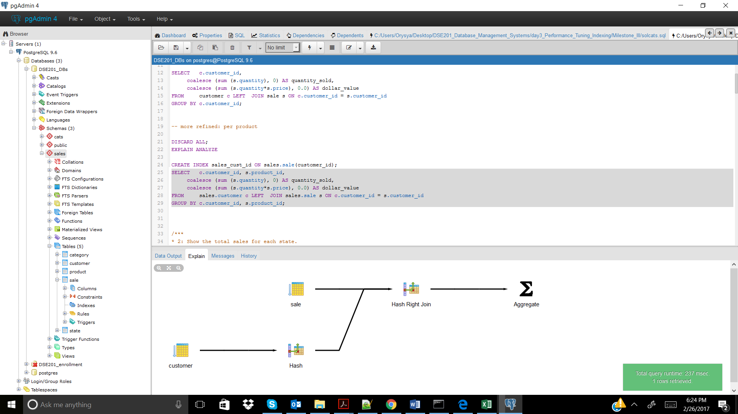

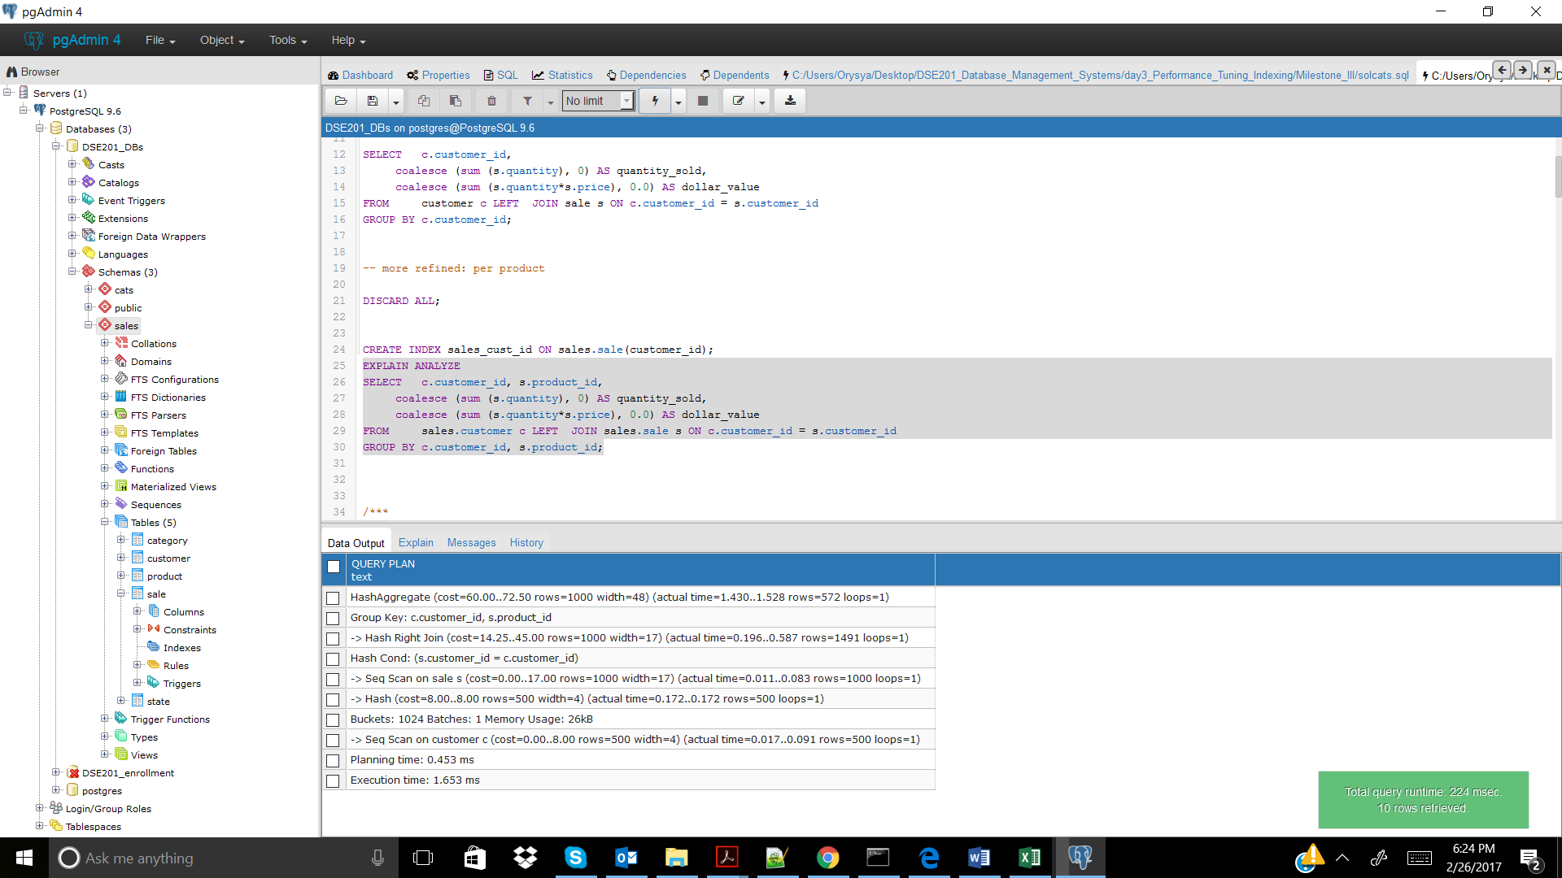

CREATE INDEX sales_cust_id ON sales.sale(customer_id); -- No index needed

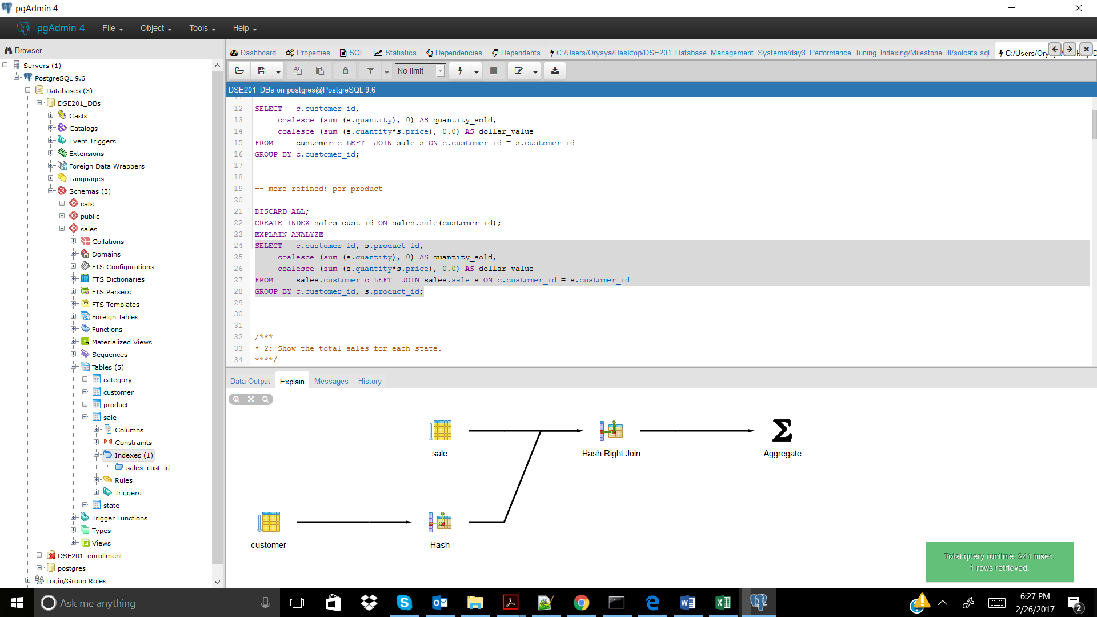

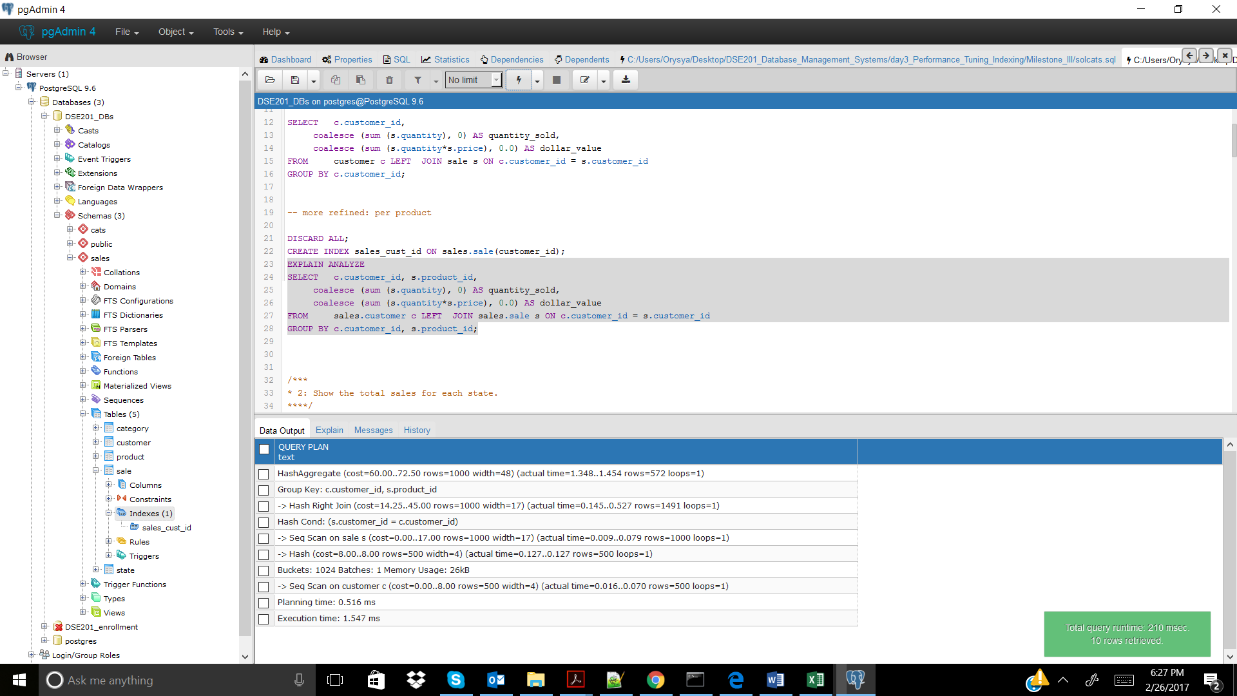

Sales_2

No Index

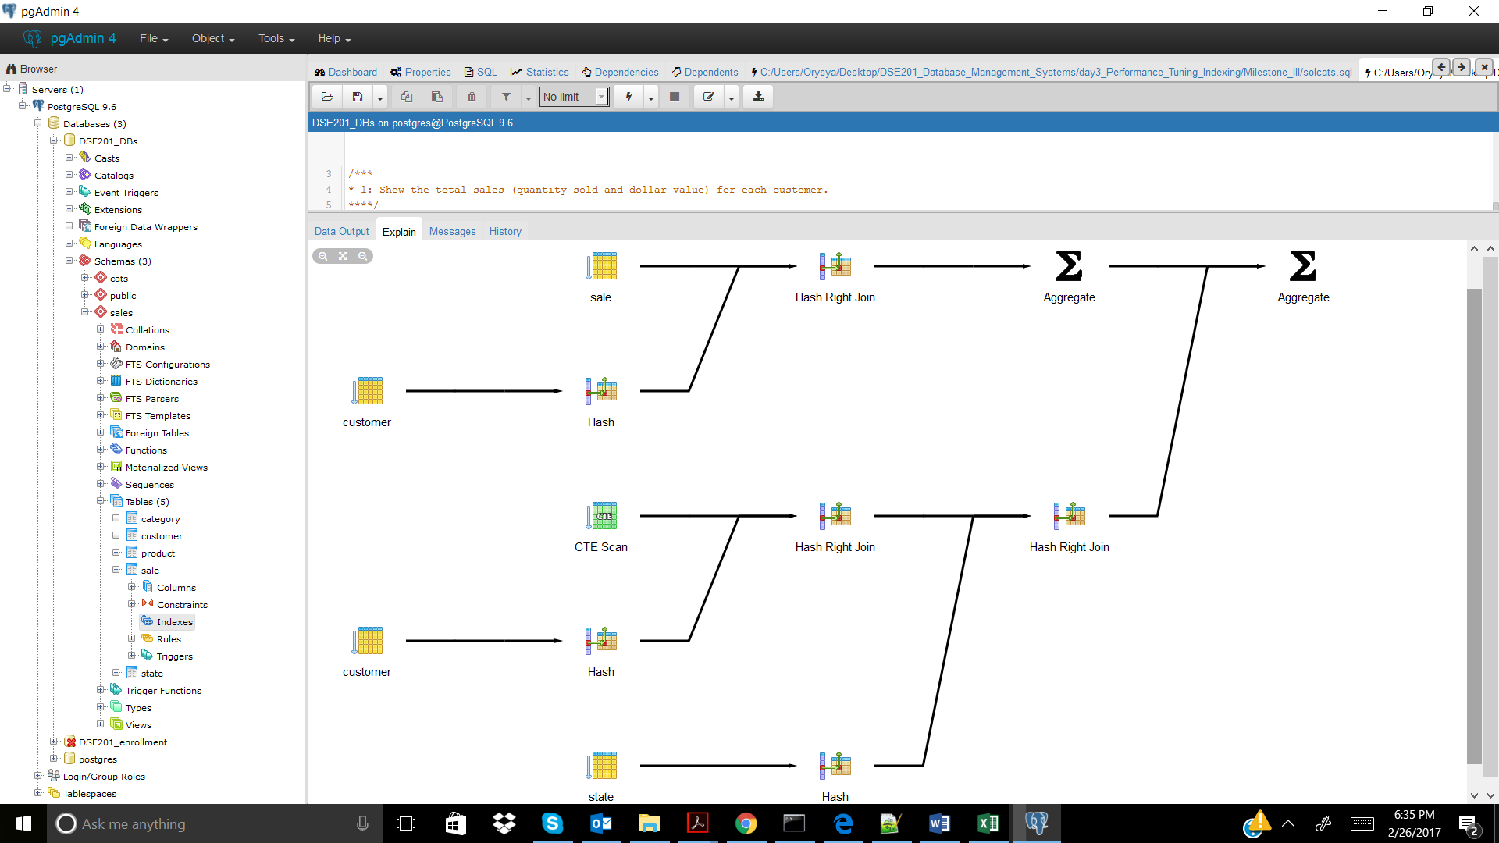

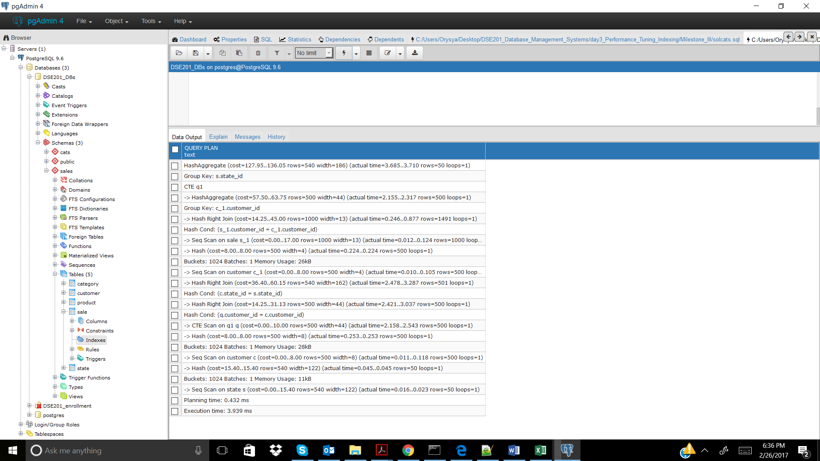

CREATE INDEX sales_cust_id ON sales.sale(customer_id); -- doesn't help

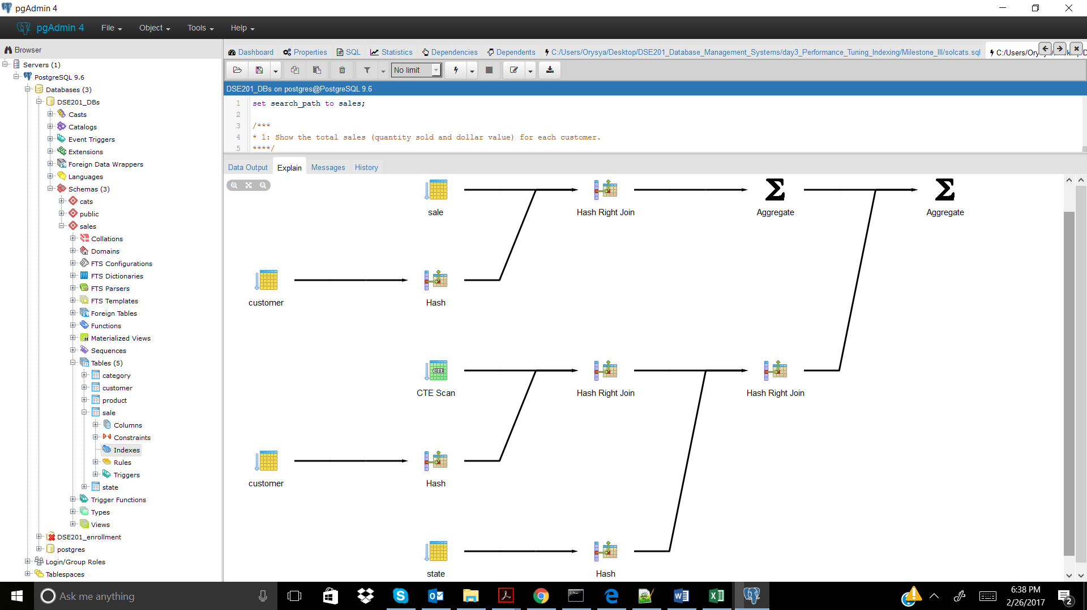

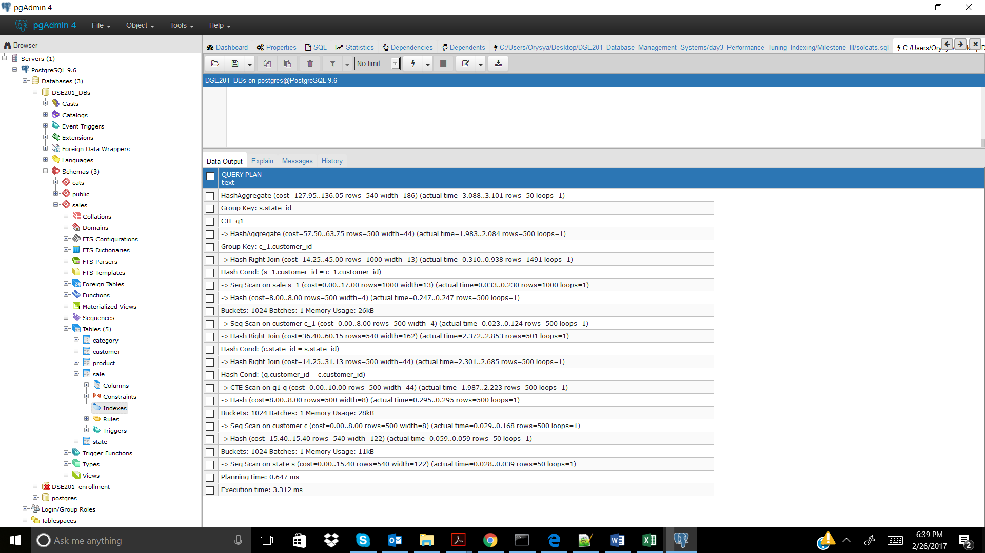

CREATE INDEX cust_state_id ON sales.customer(state_id); -- doesn't help 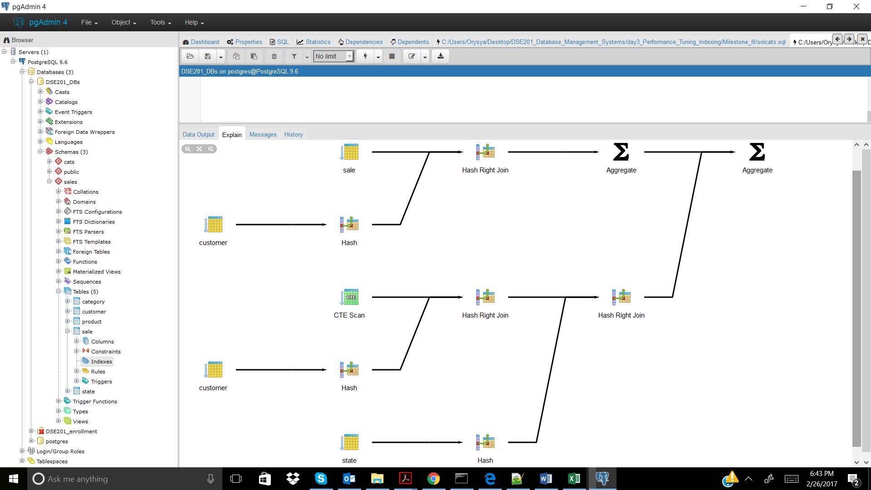

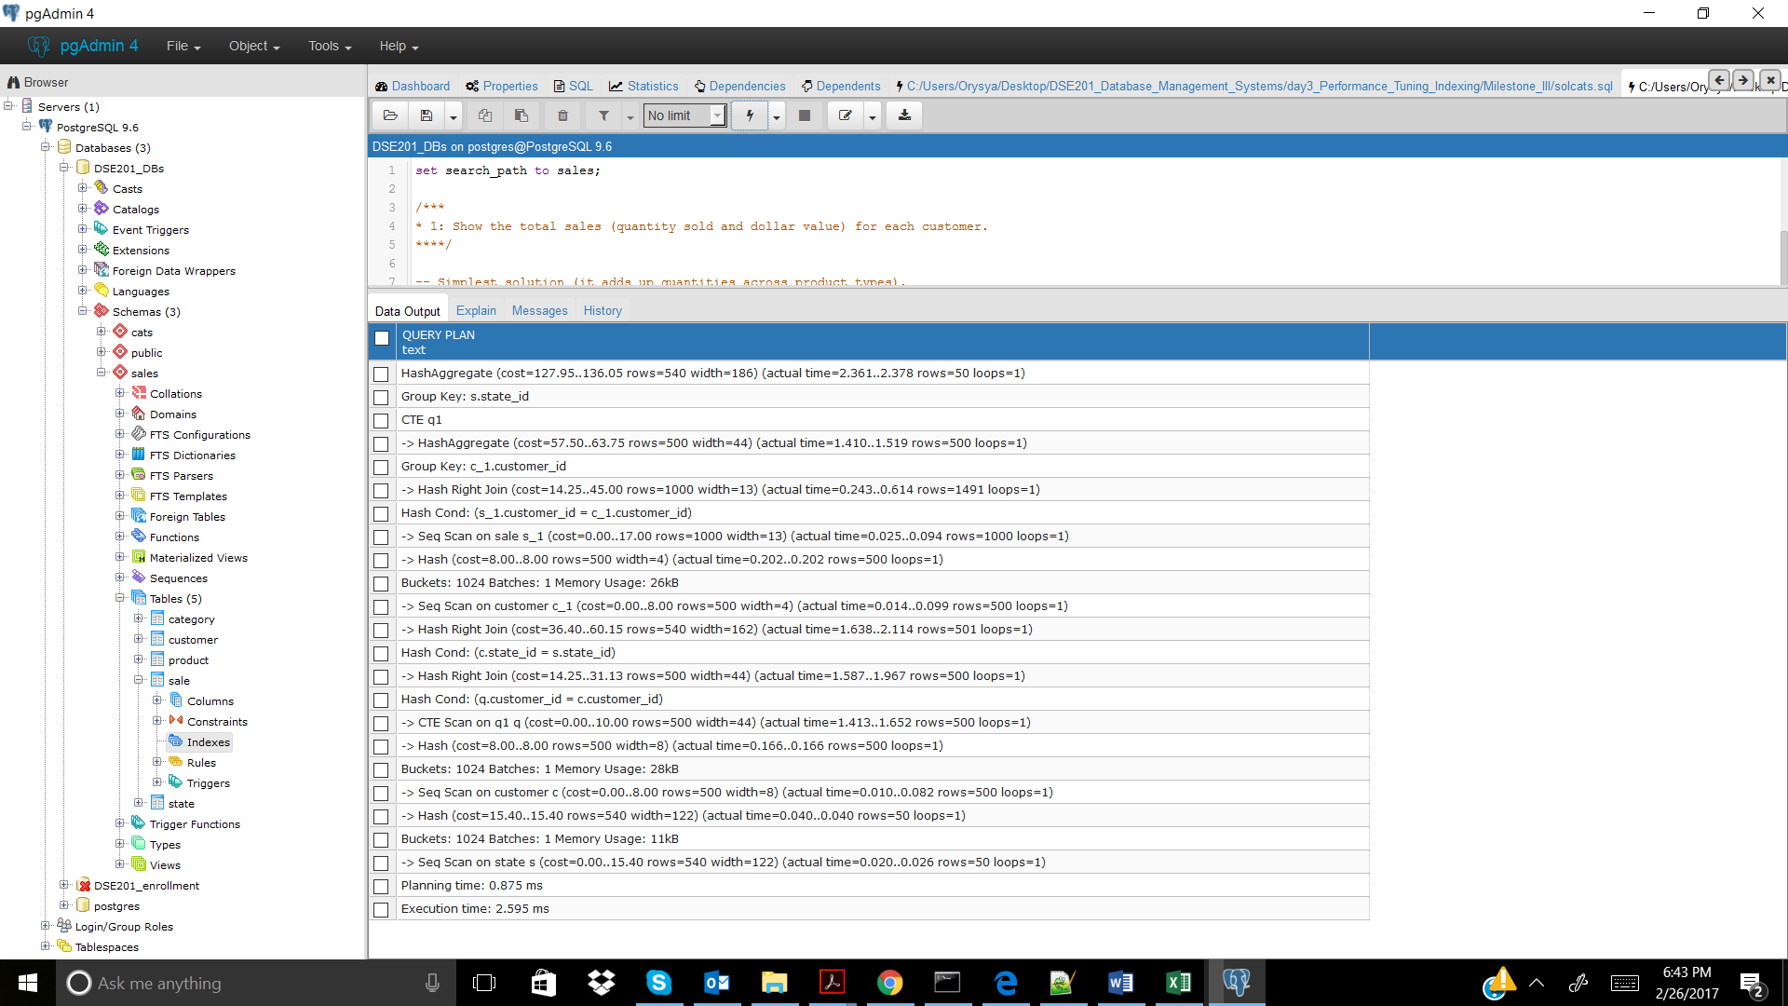

Sales_3

No Index

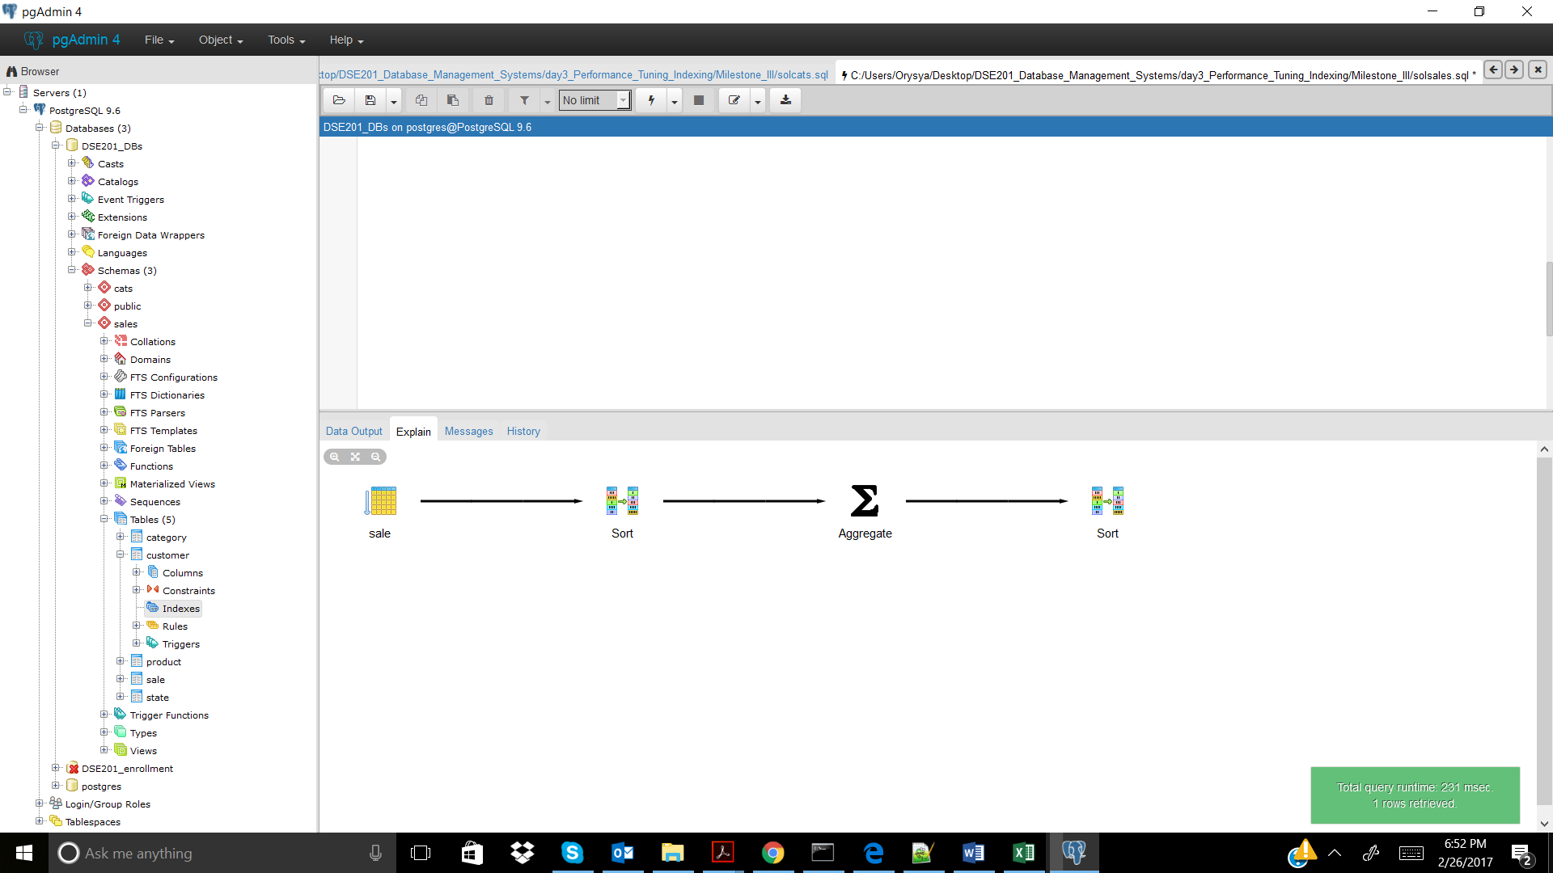

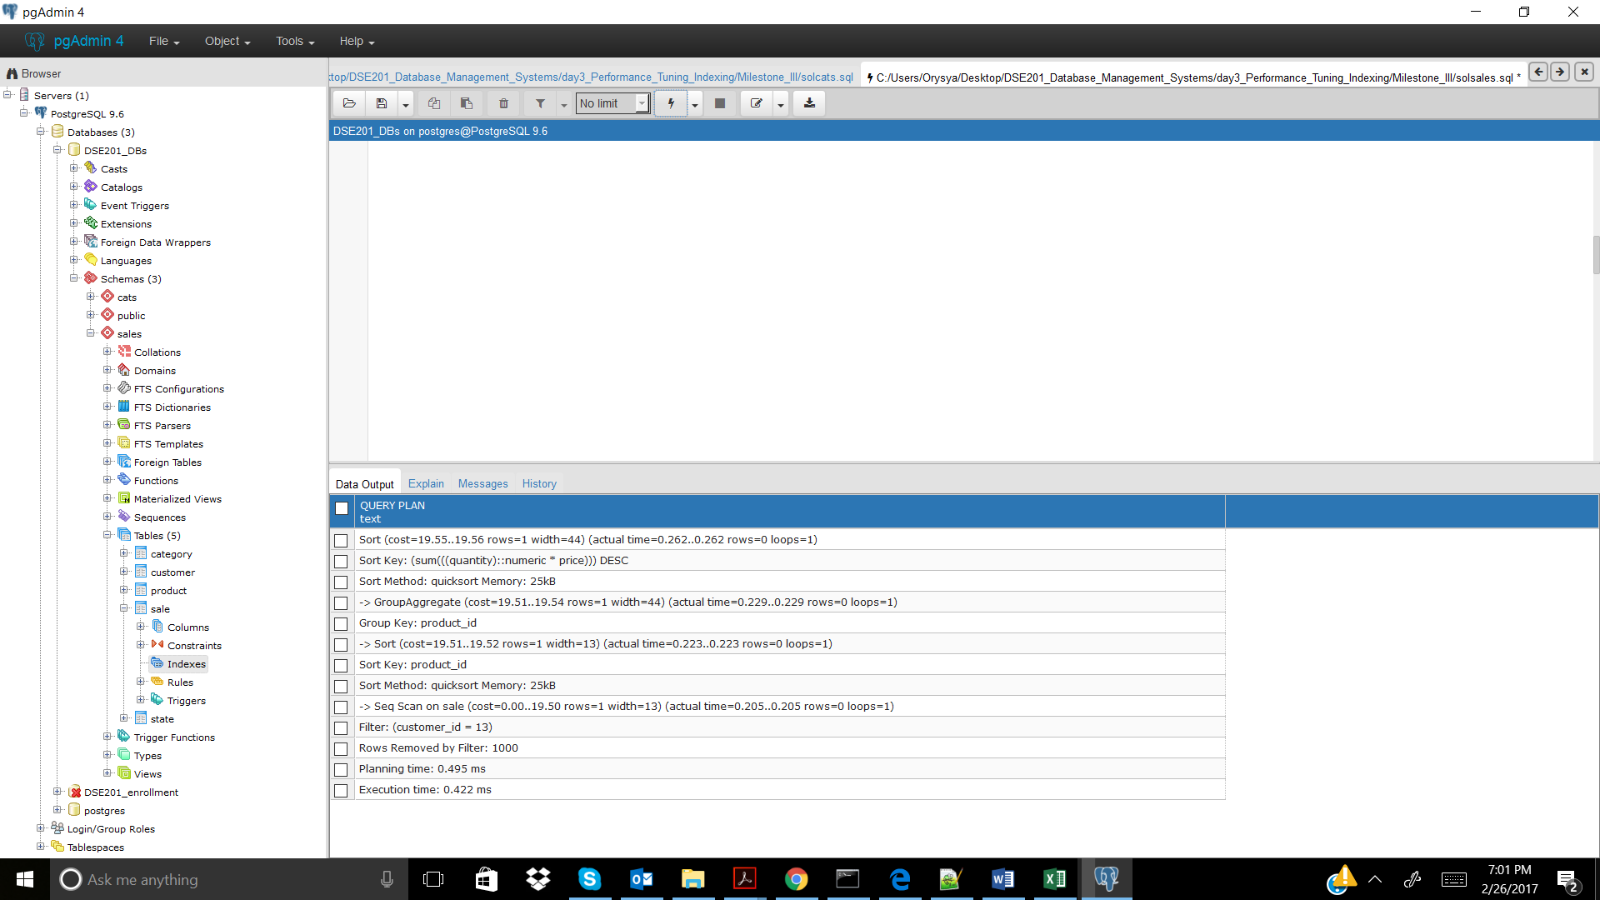

CREATE INDEX sales_cust_id ON sales.sale(customer_id); -- this helped 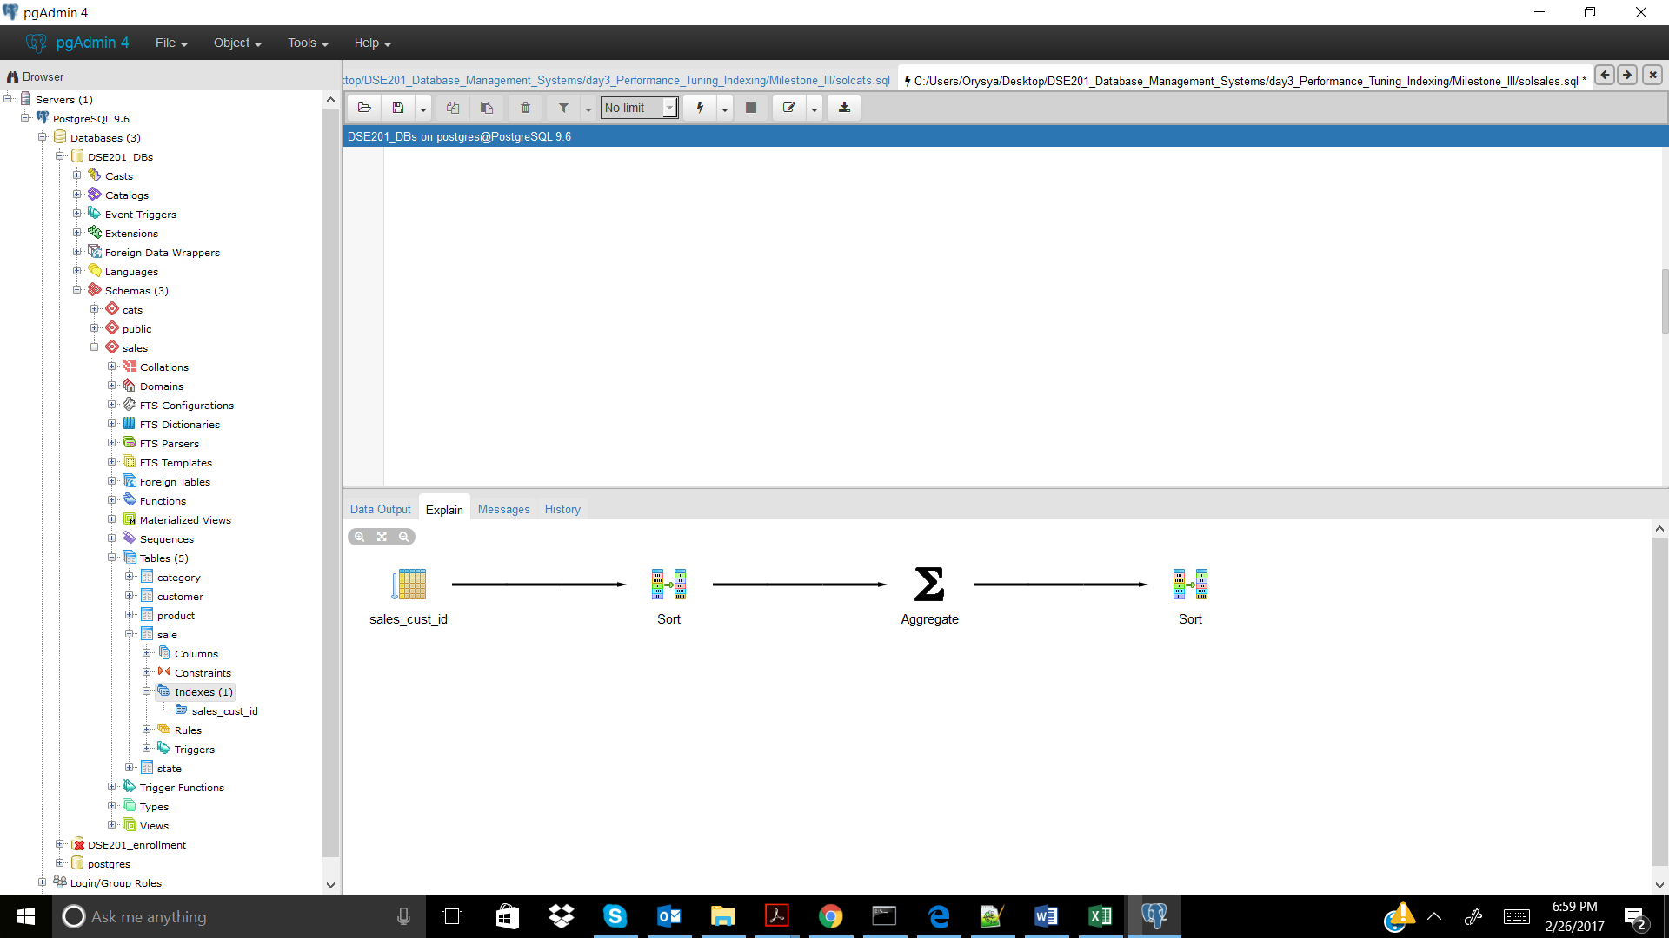

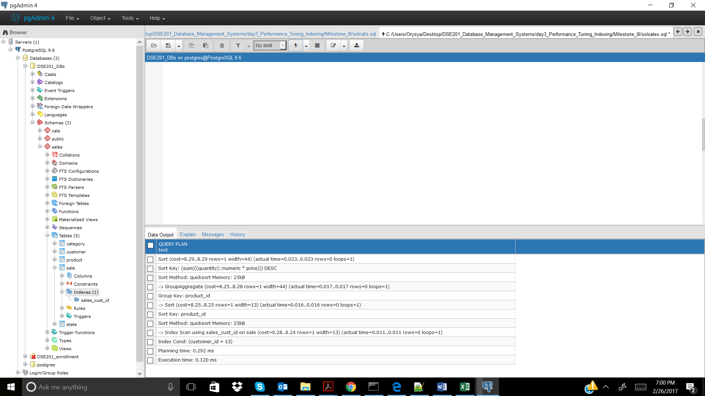

Sales_4

No Index

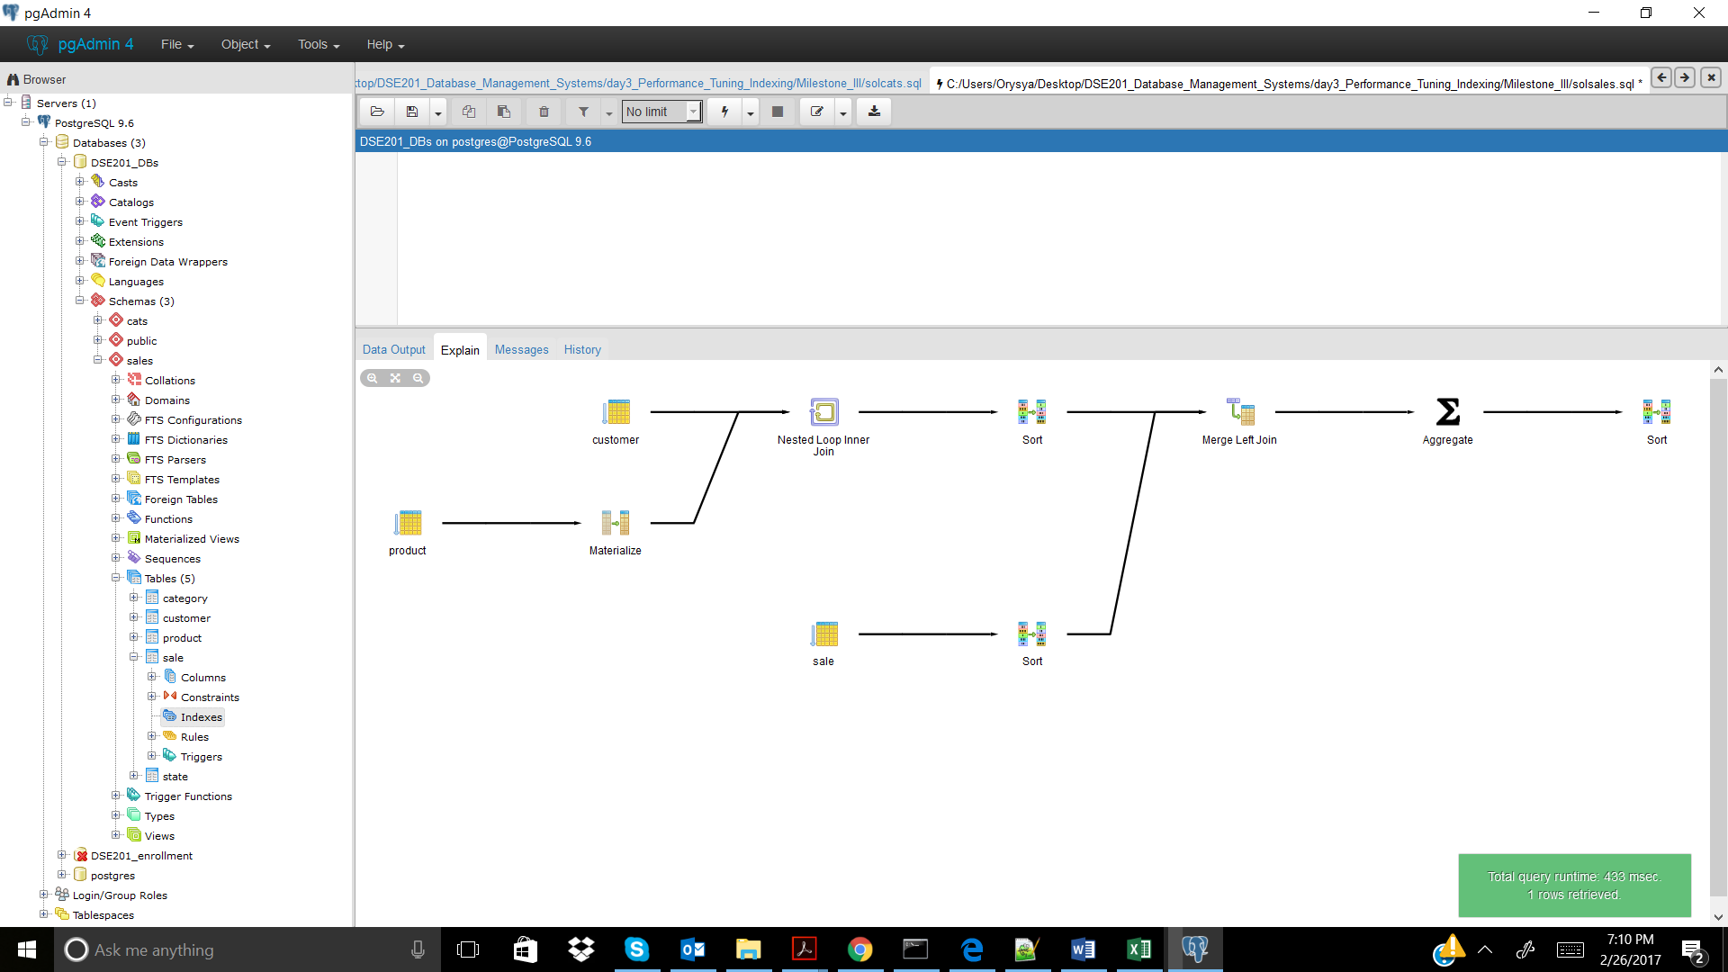

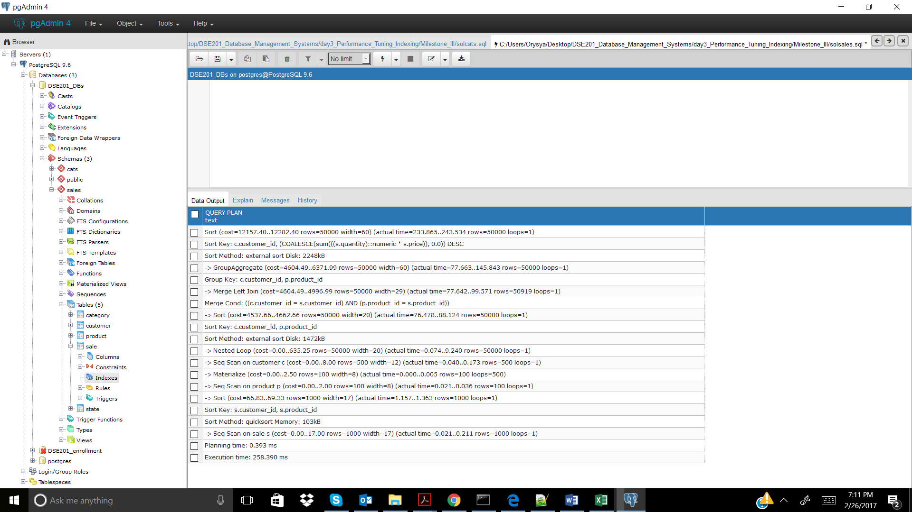

CREATE INDEX sales_cust_id ON sales.sale(customer_id); -- didn't help

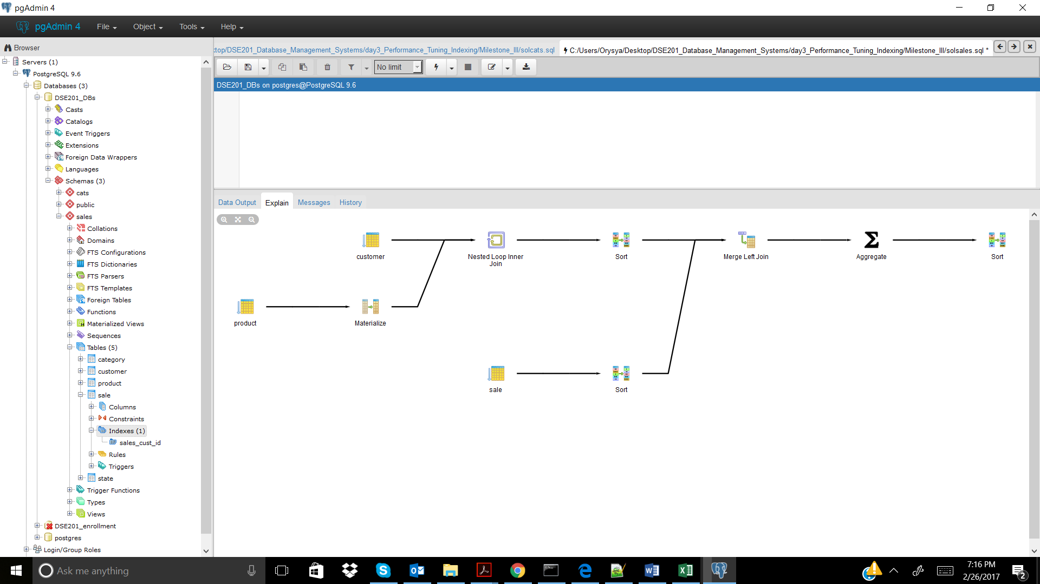

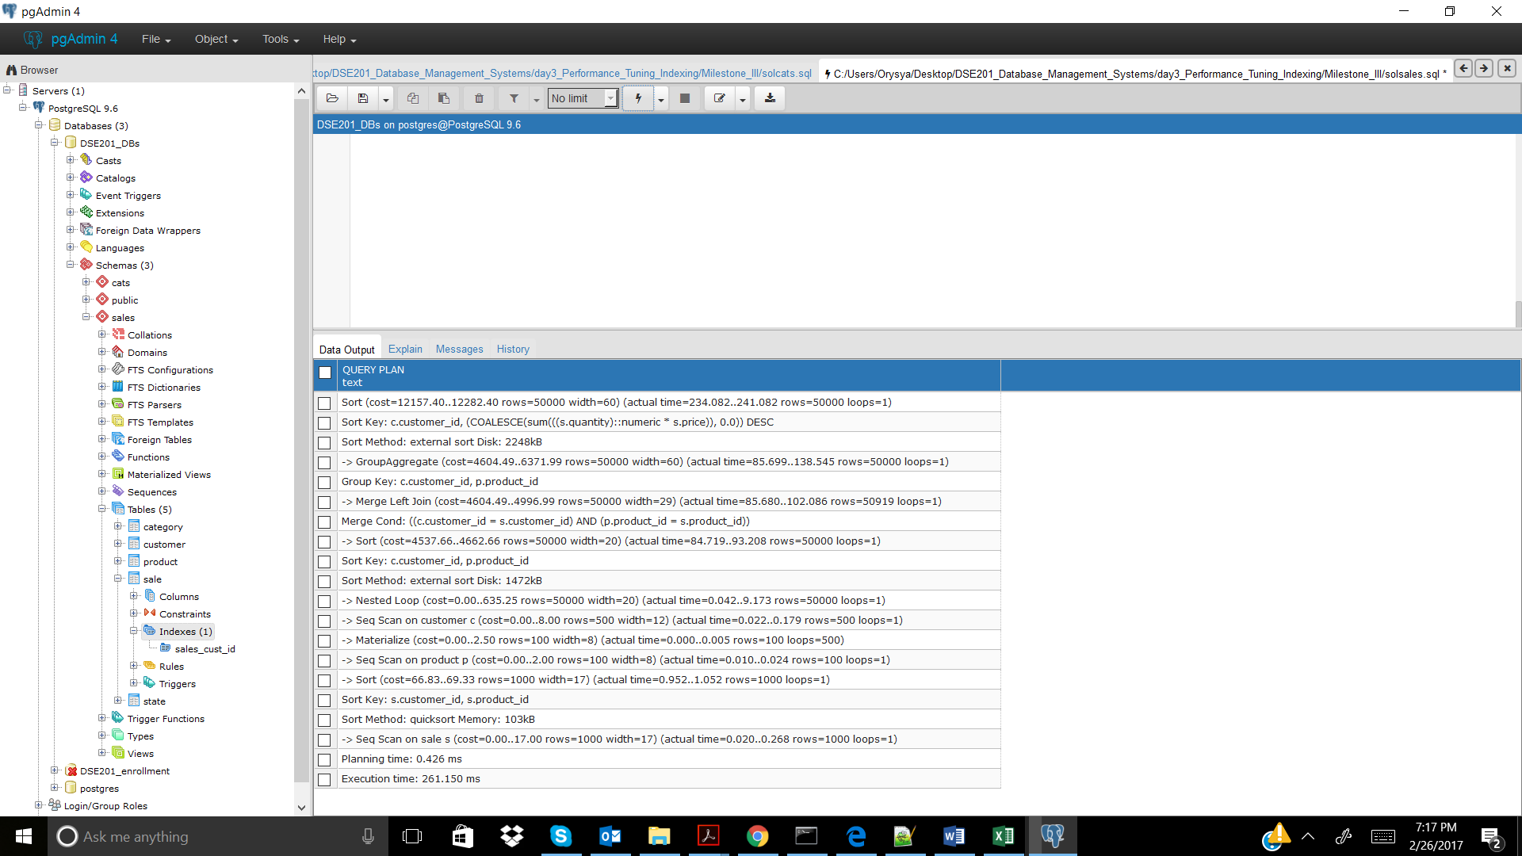

CREATE INDEX sales_prod_id ON sales.sale(product_id); -- didn't help 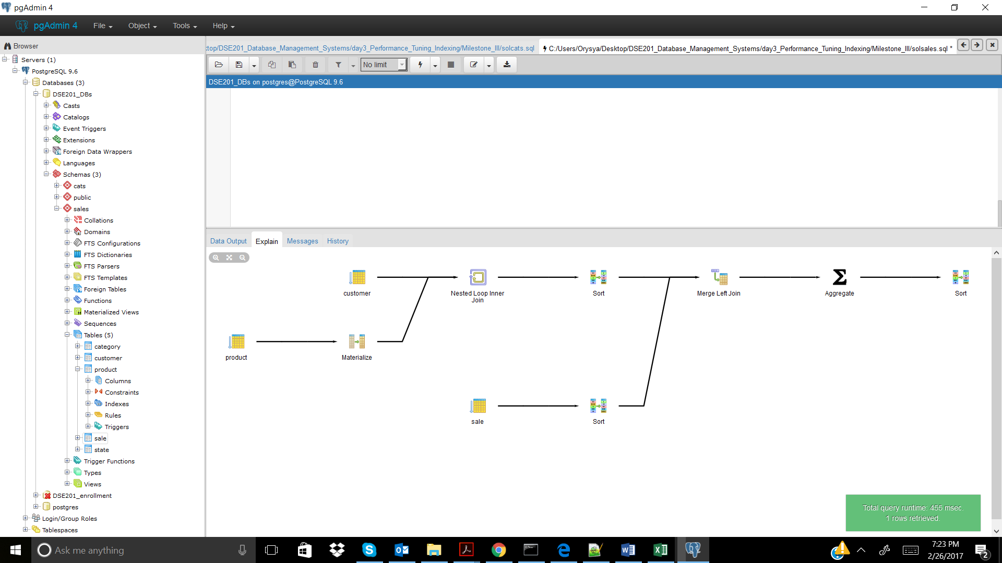

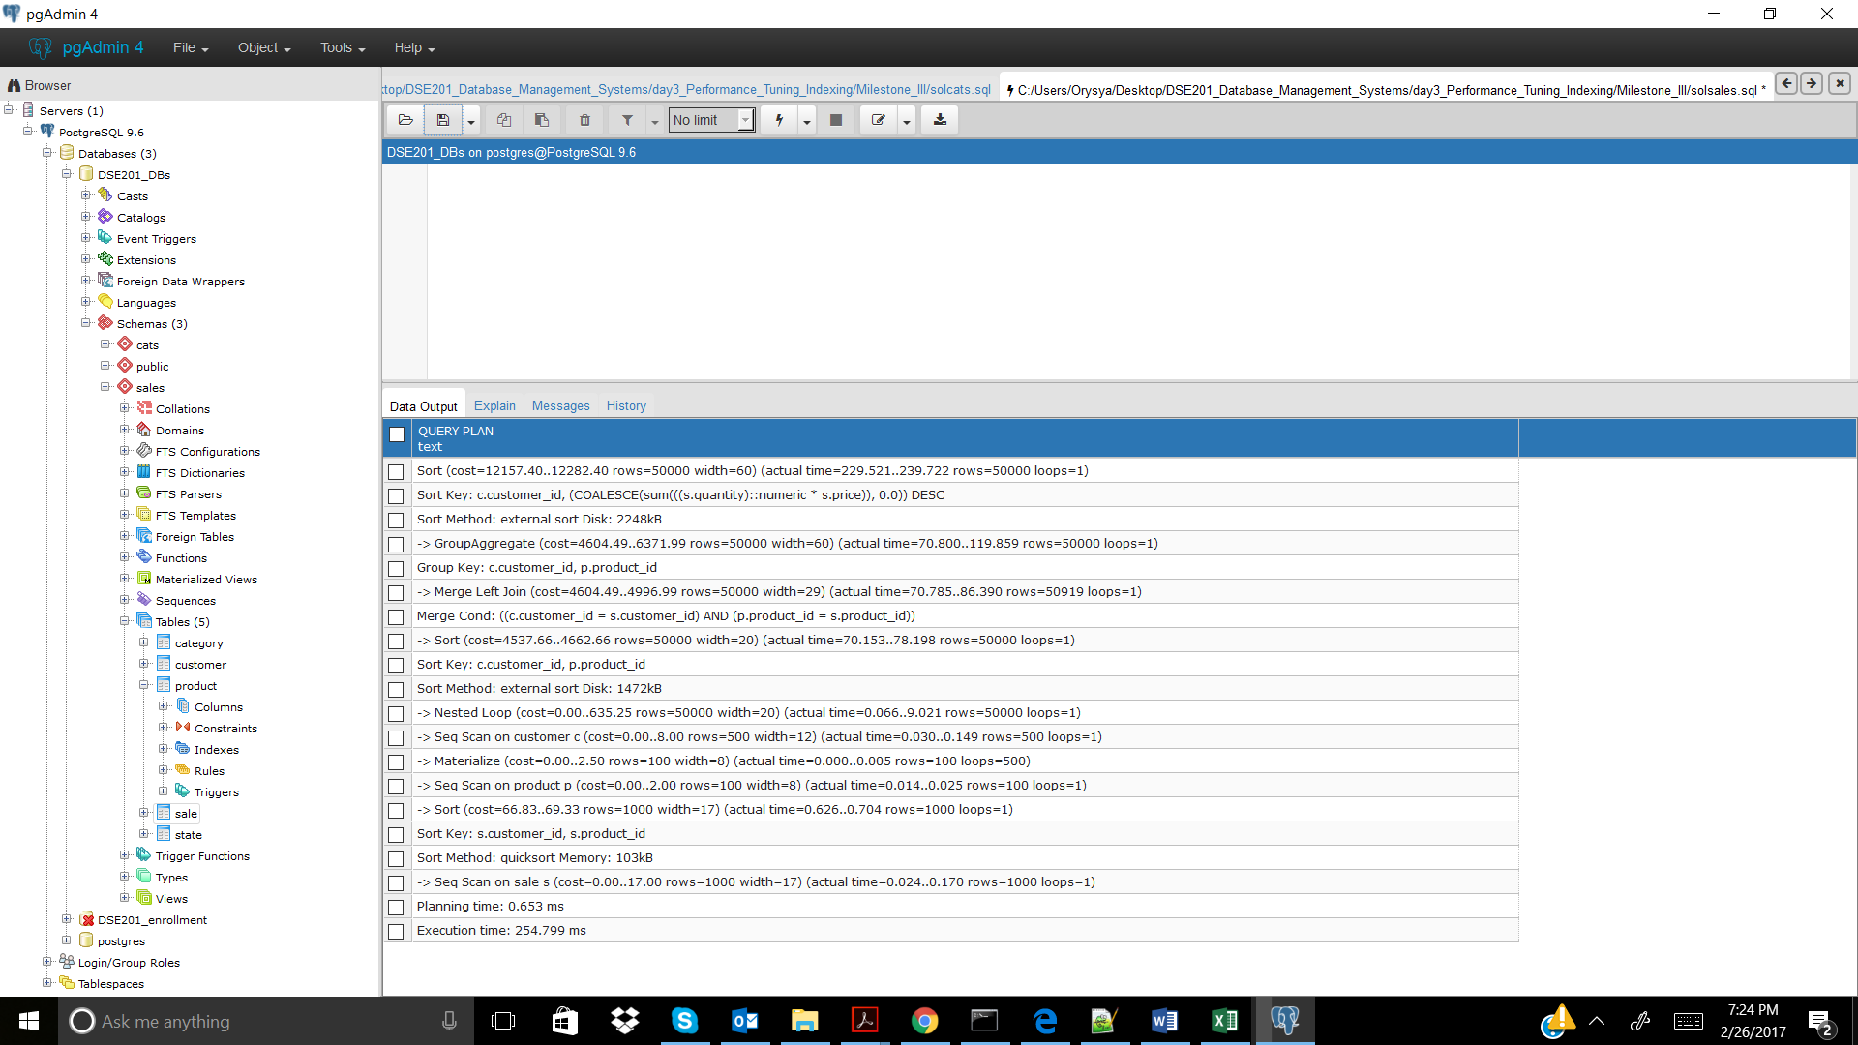

Sales_5

No Index

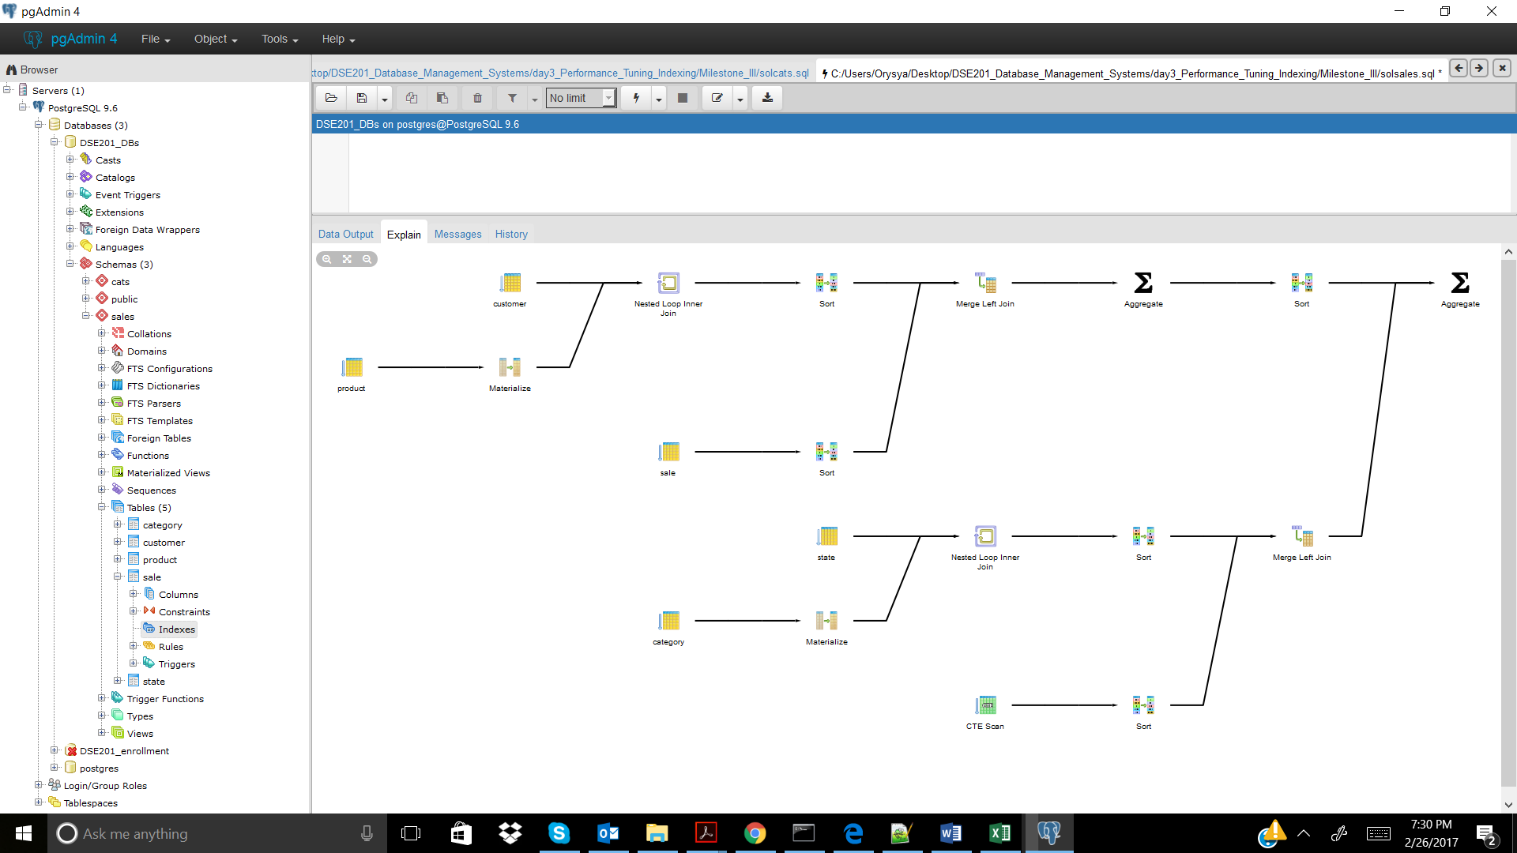

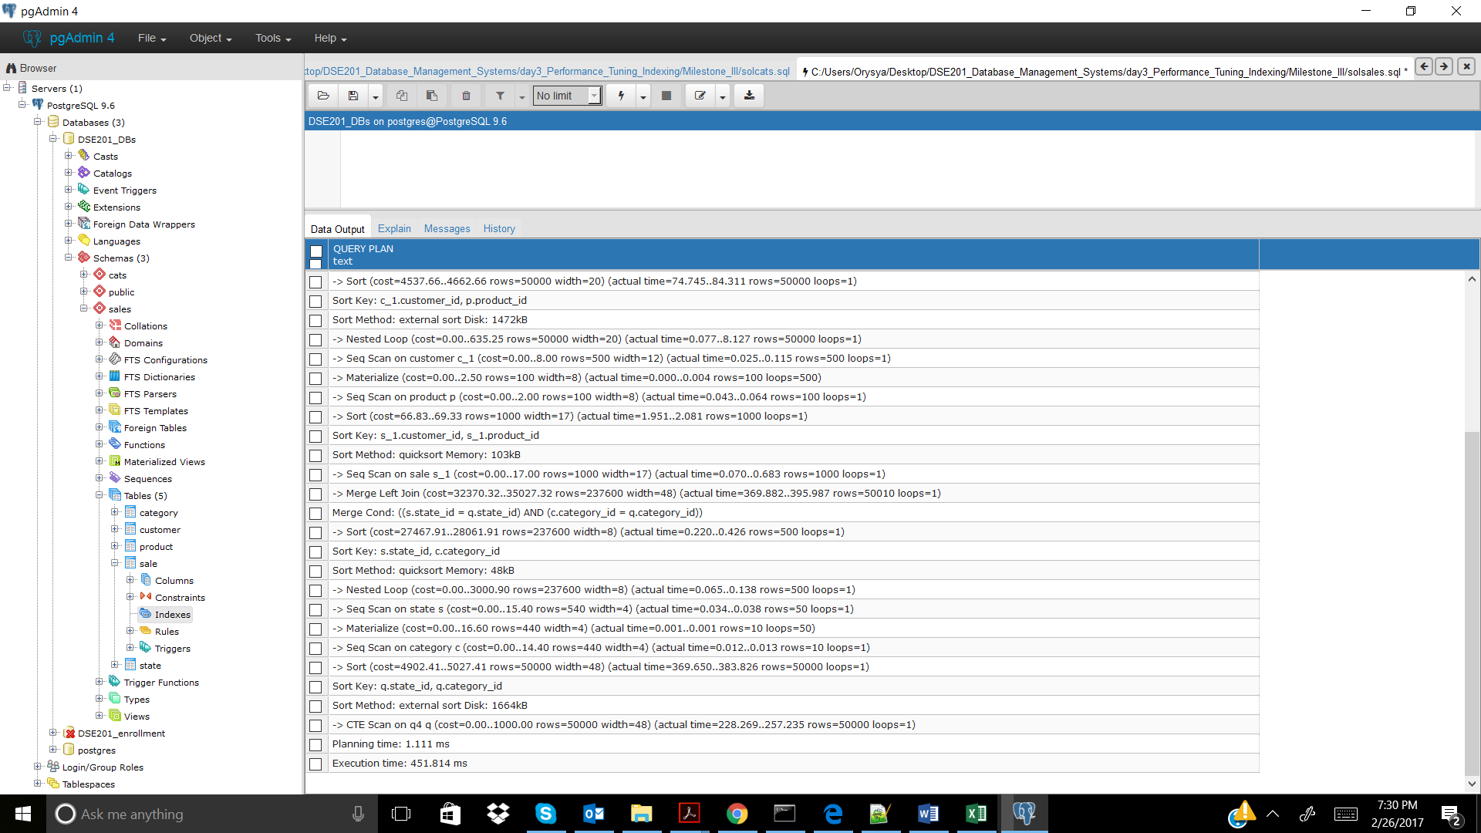

CREATE INDEX sales_cust_id ON sales.sale(customer_id); -- didn't help

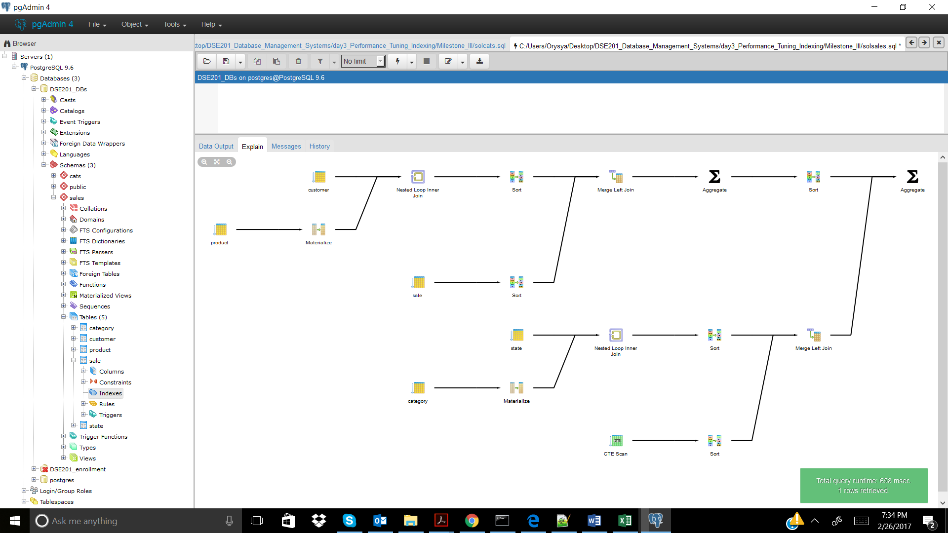

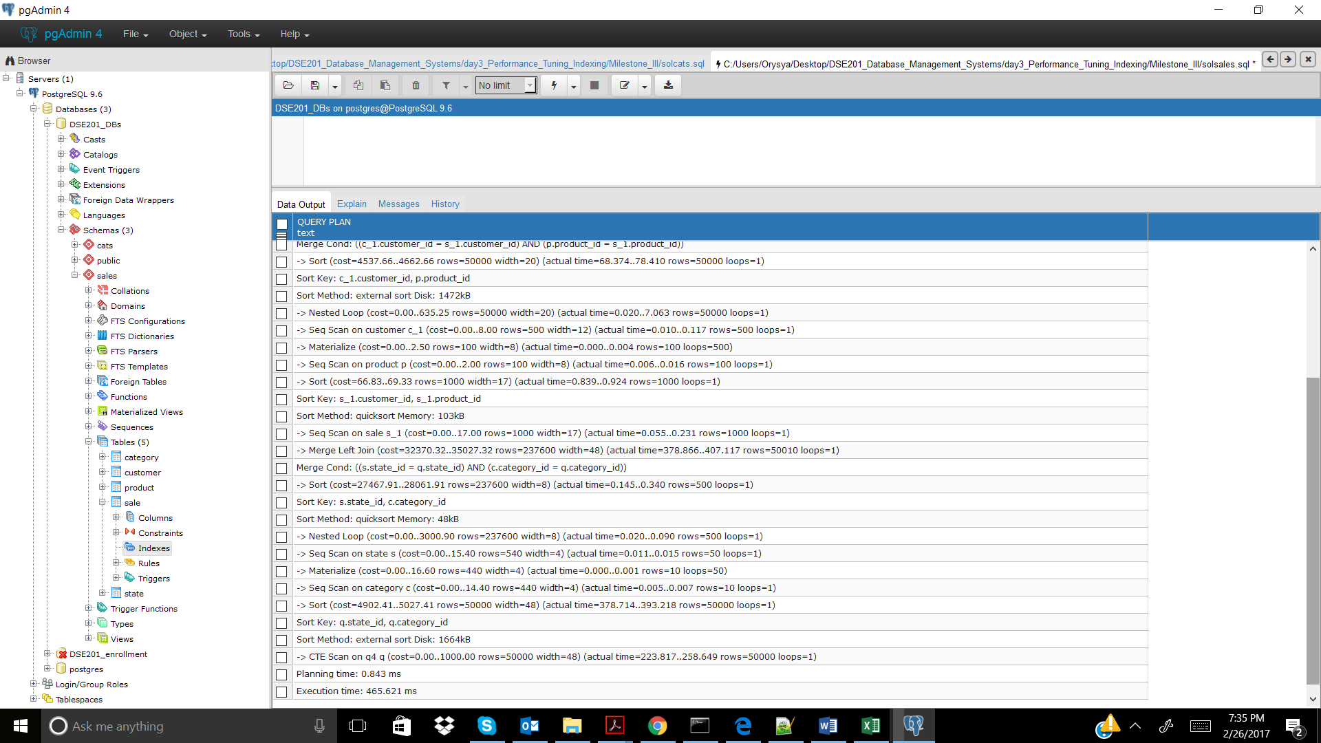

CREATE INDEX sales_prod_id ON sales.sale(product_id); -- didn't help 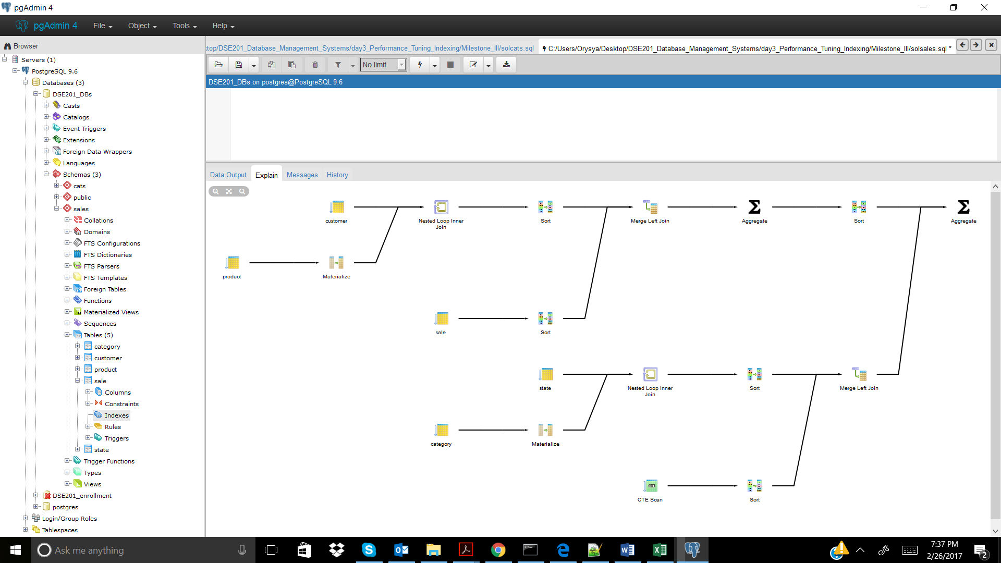

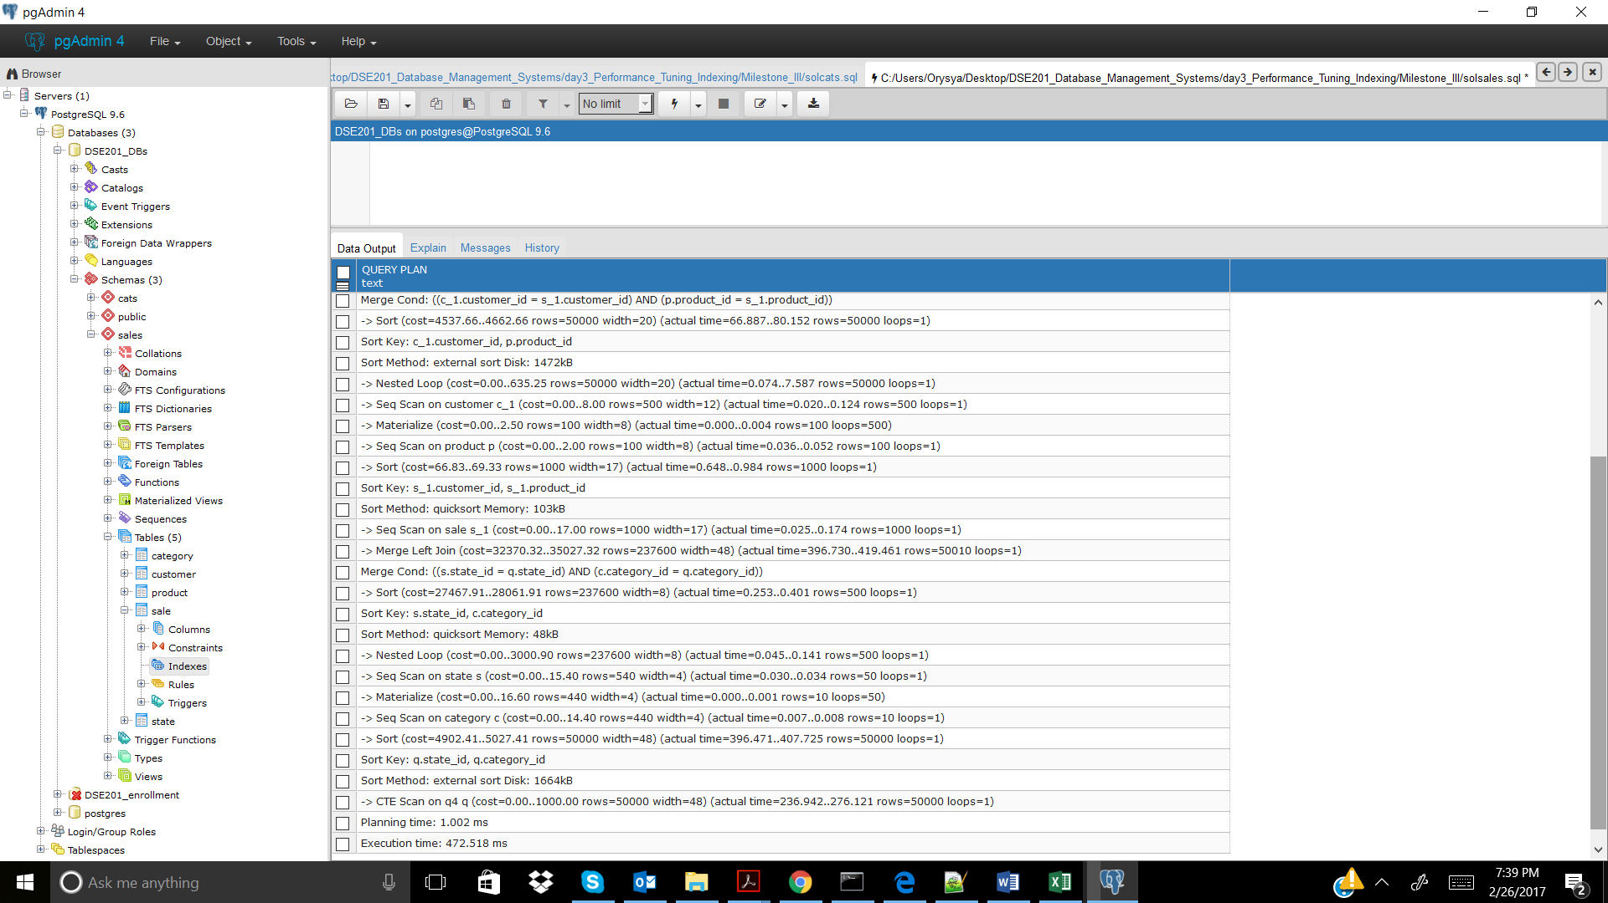

Sales_6

No Index

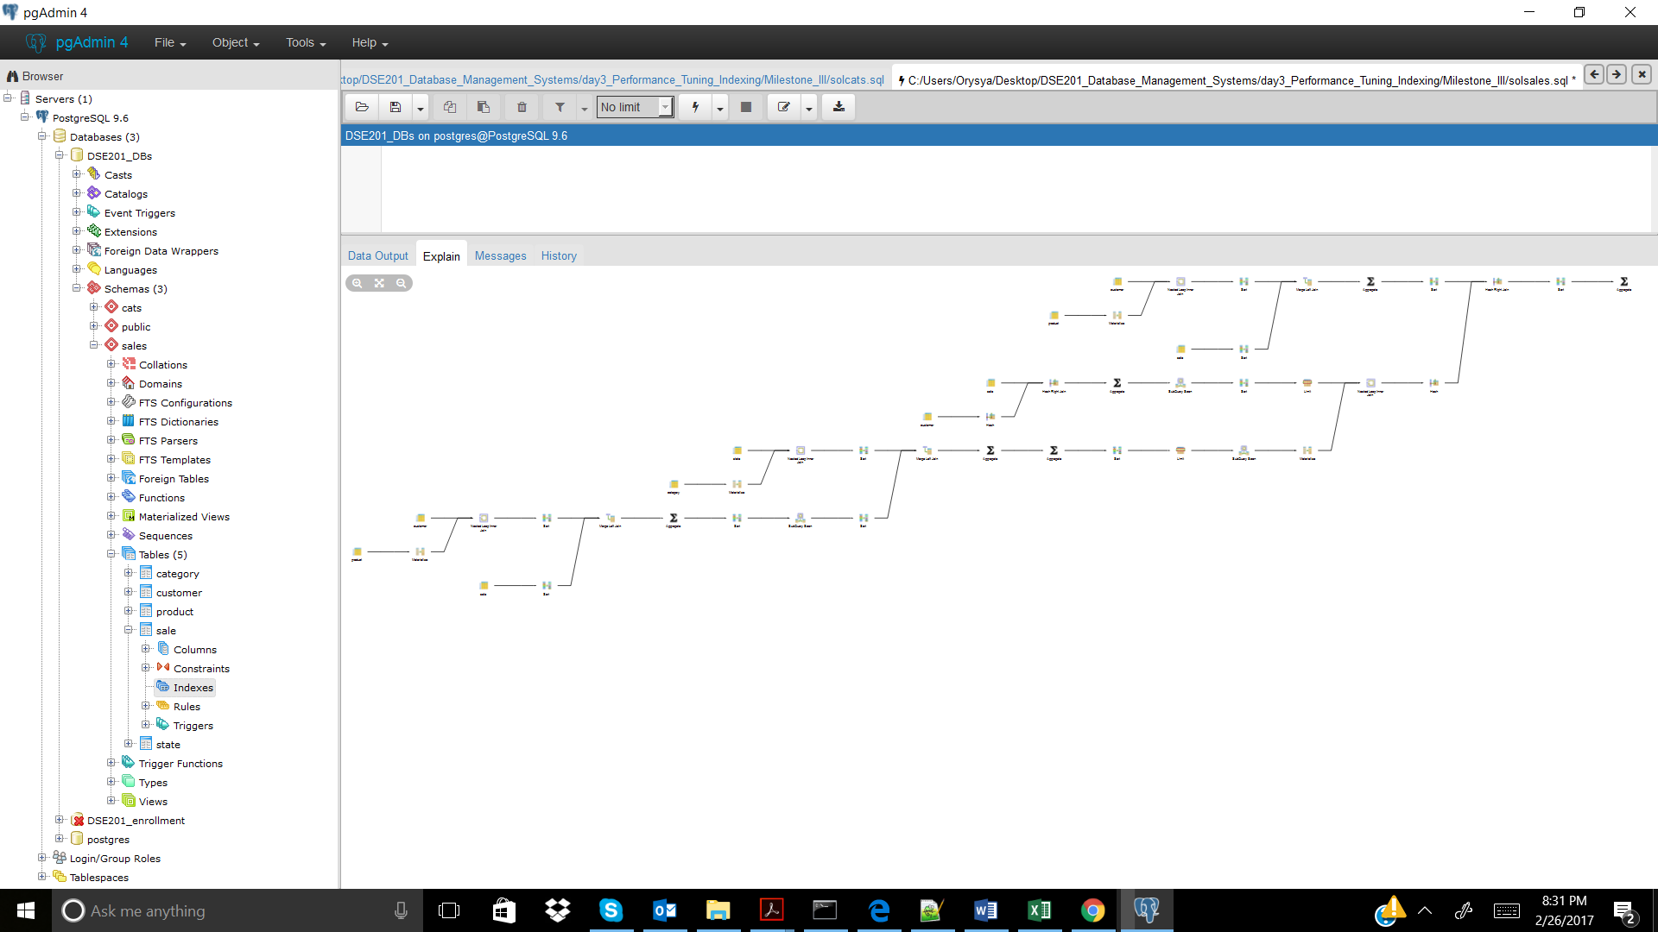

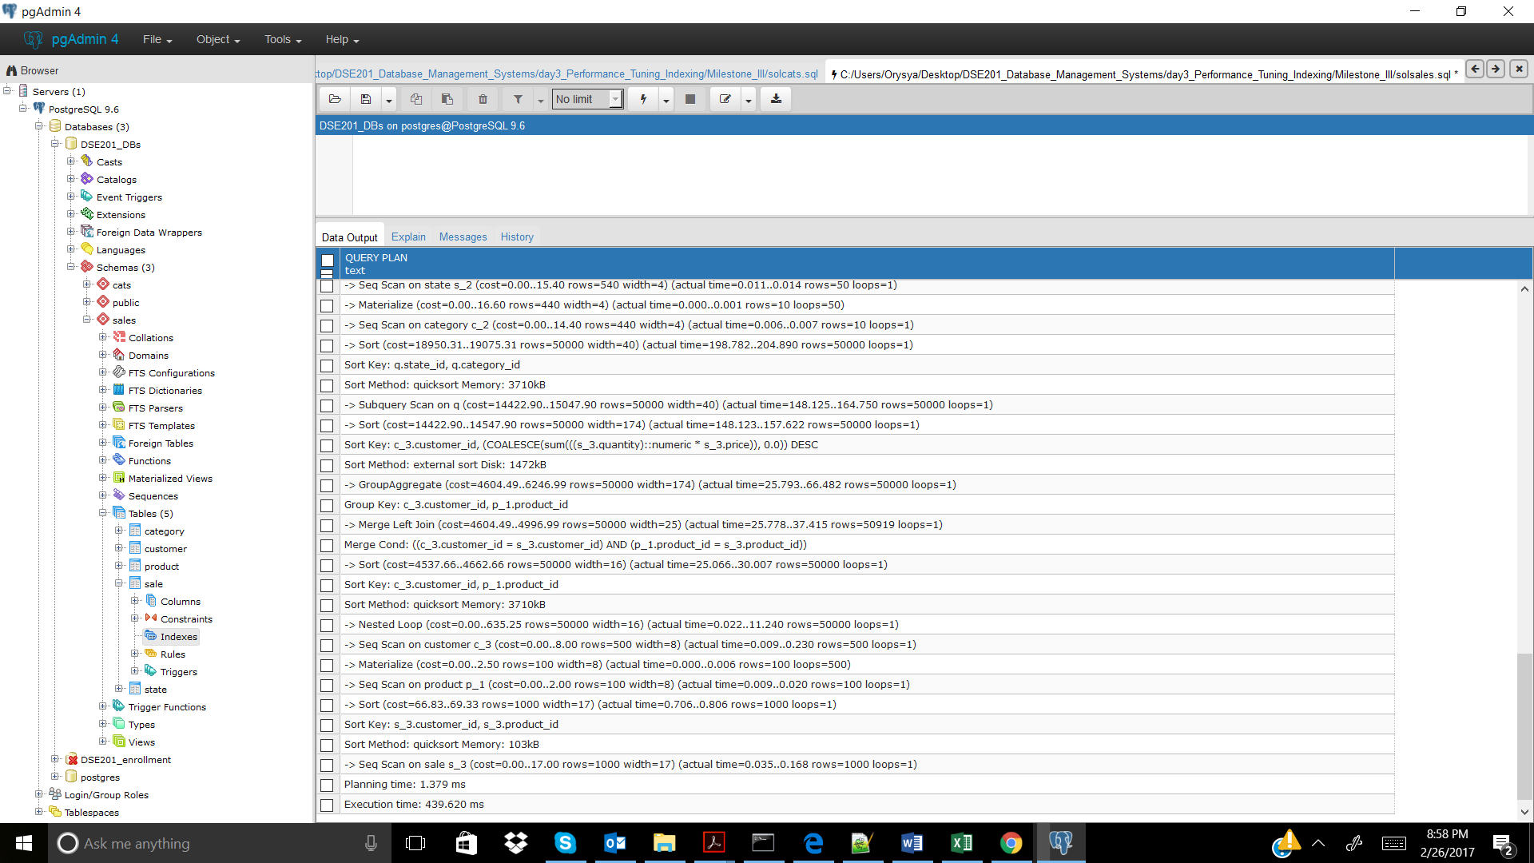

CREATE INDEX sales_cust_id ON sales.sale(customer_id); -- didn't help

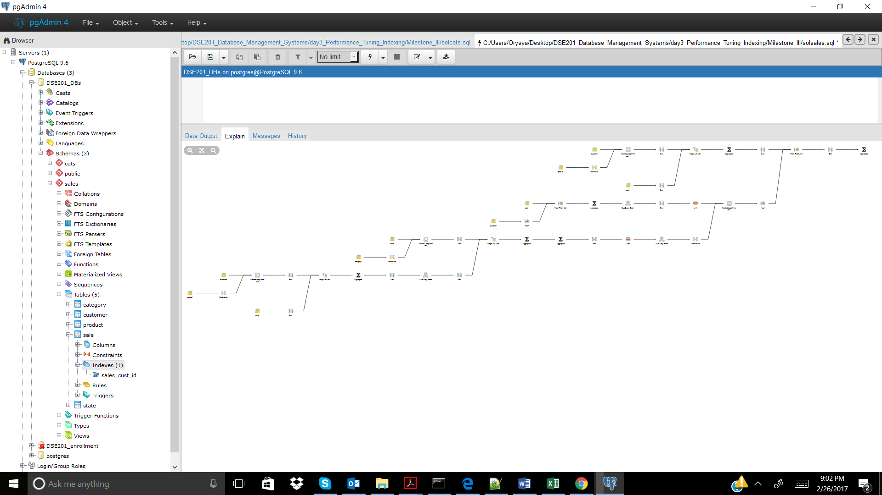

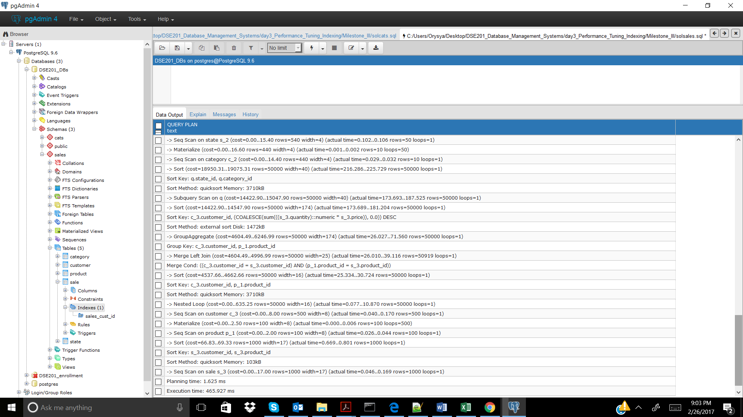

CREATE INDEX sales_prod_id ON sales.sale(product_id); -- didn't help 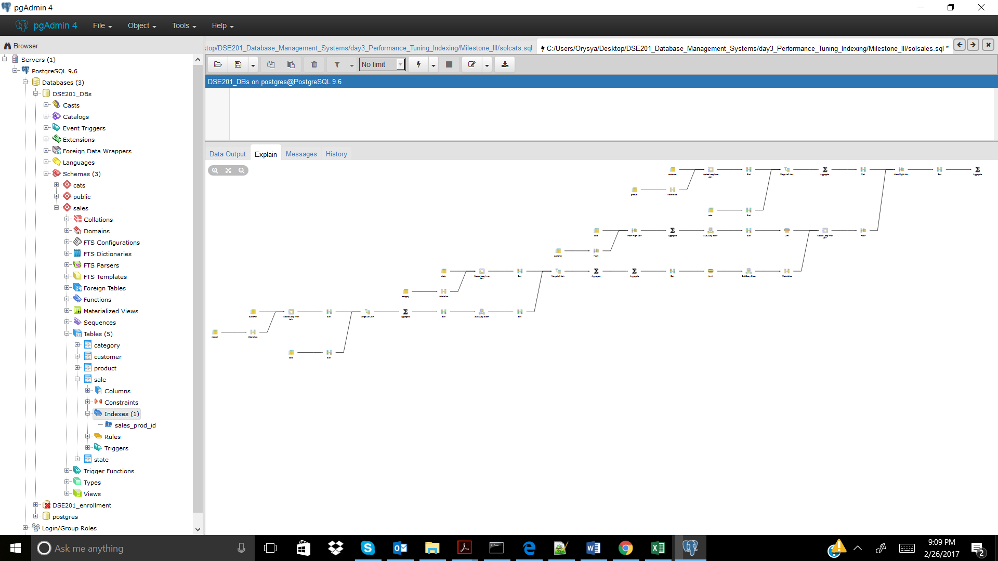

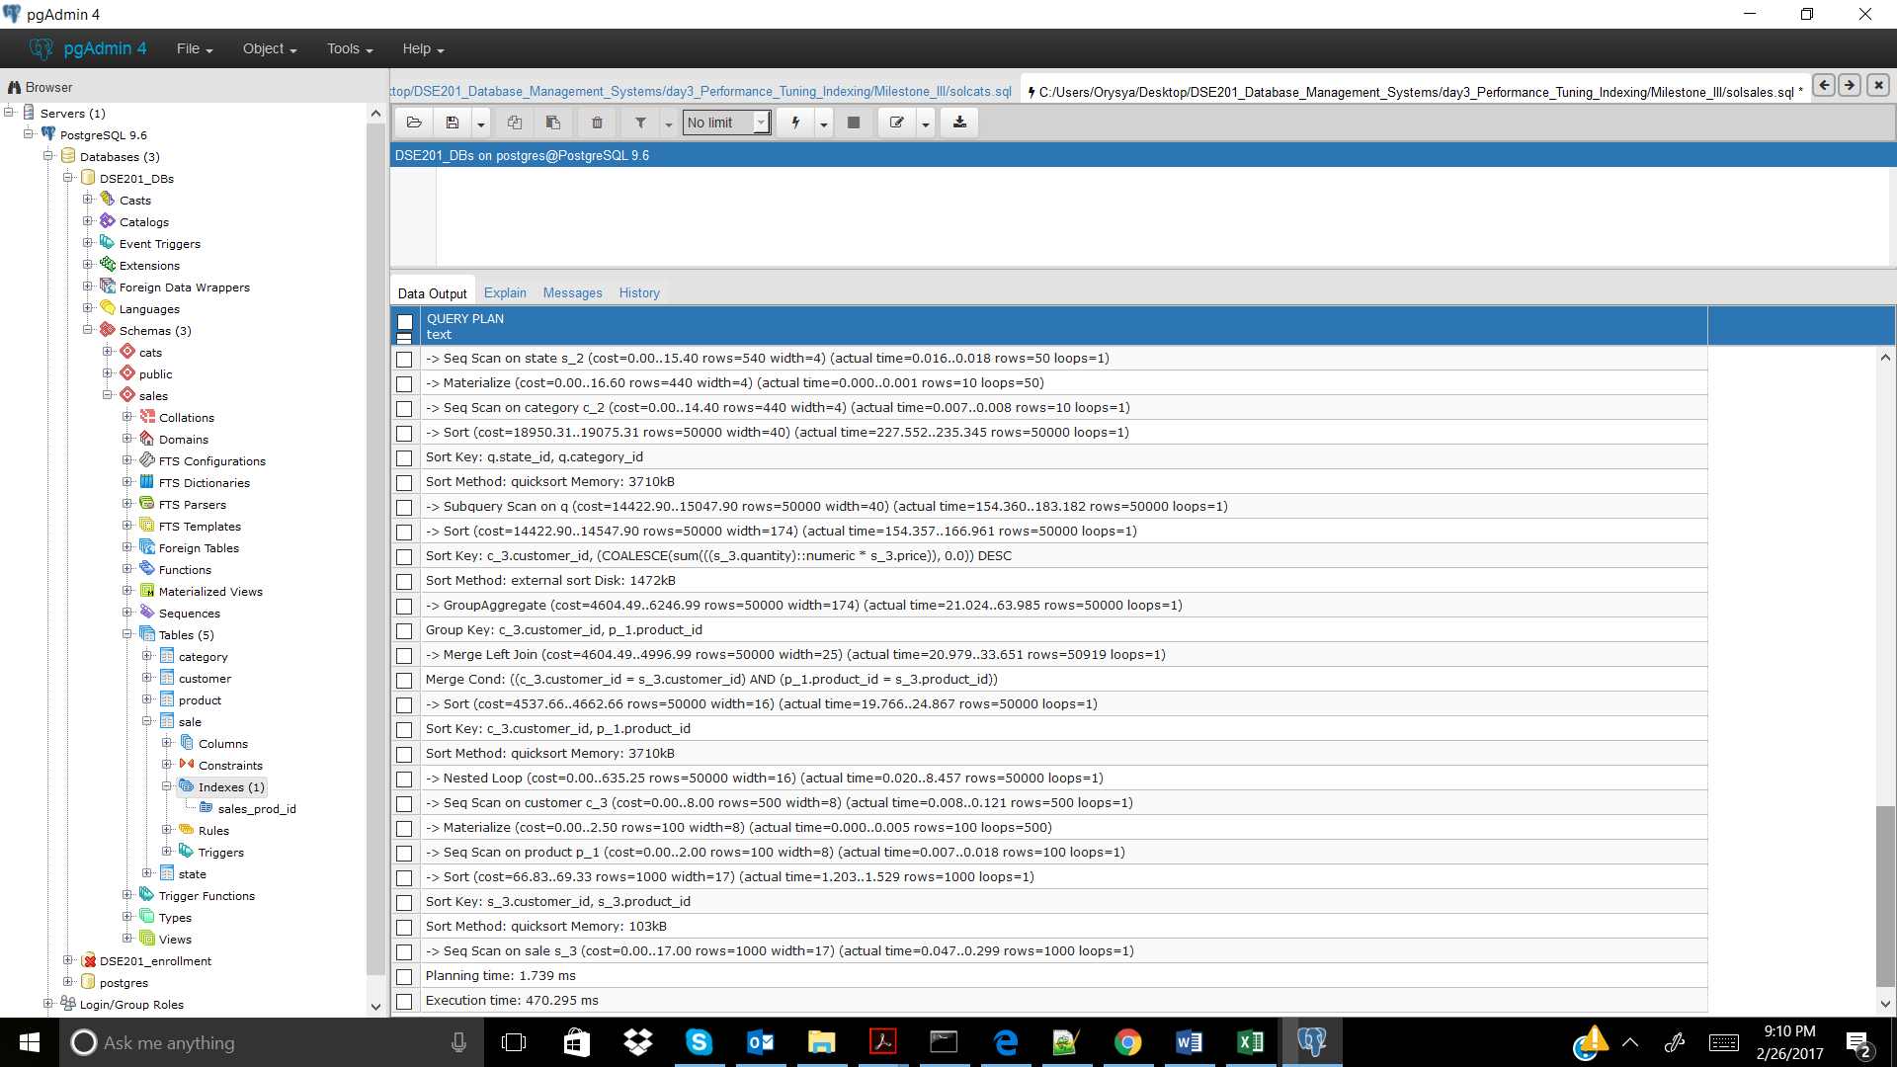

Cats_1

No Index

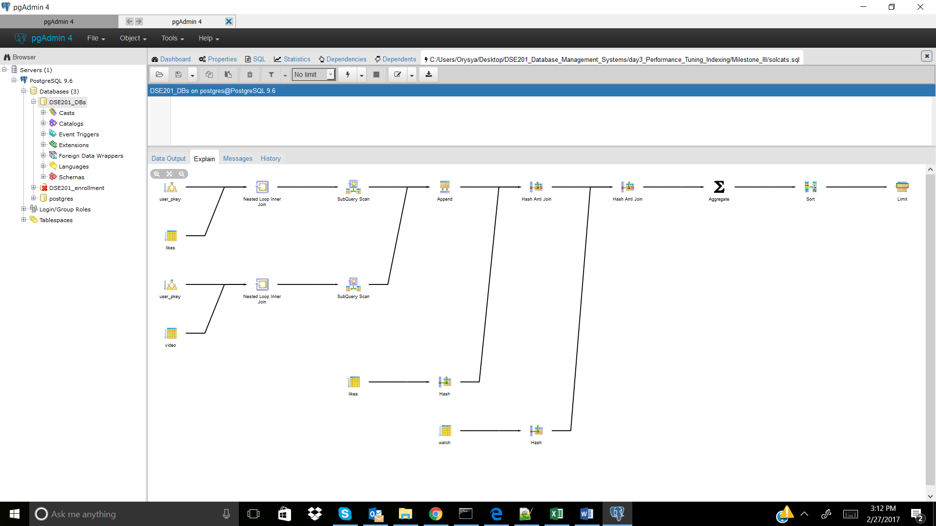

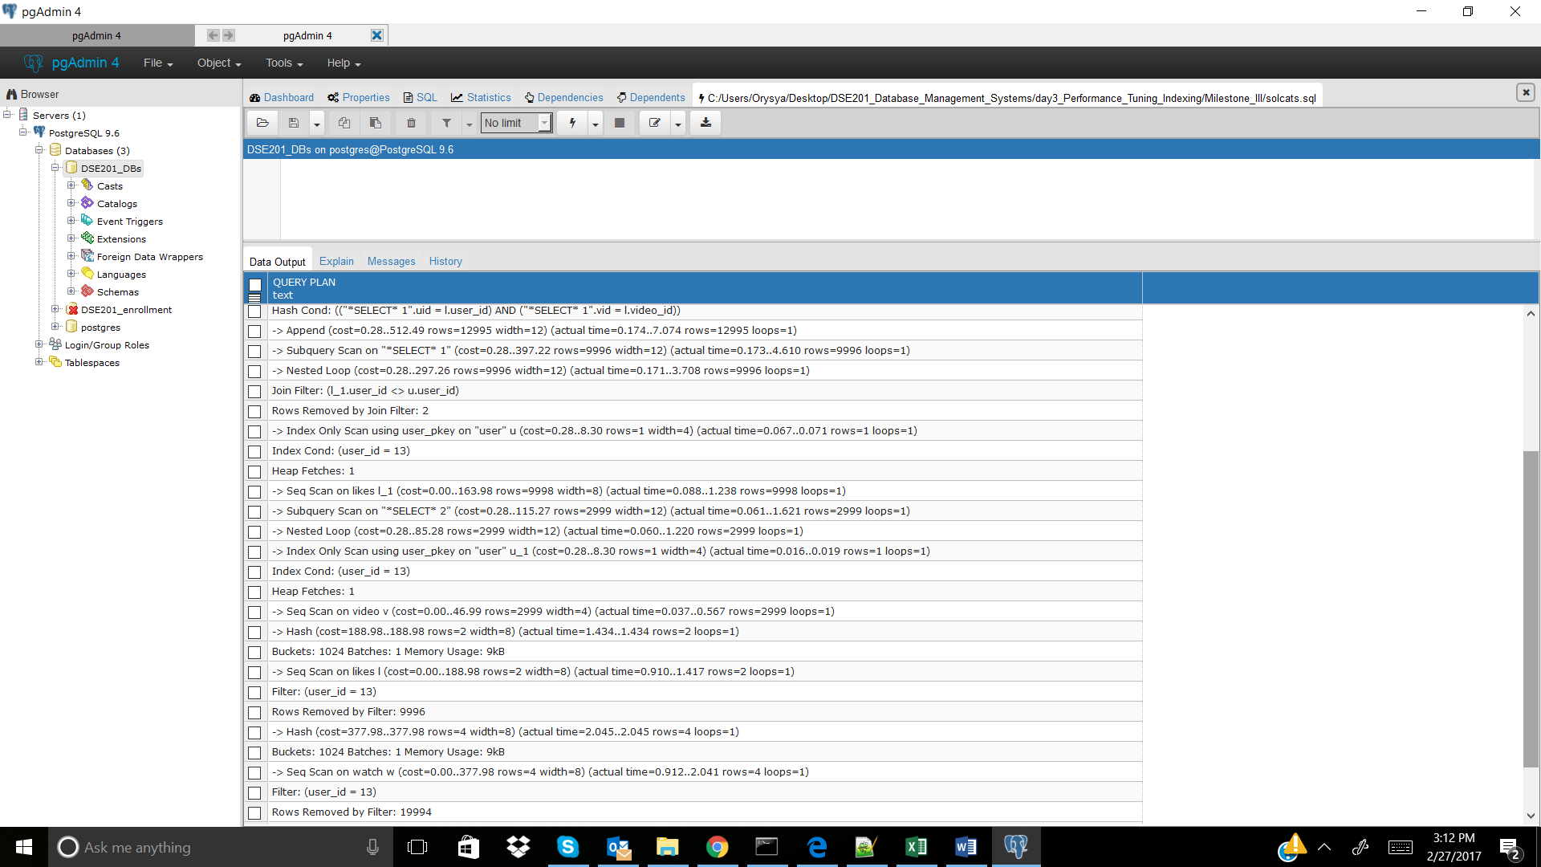

CREATE INDEX watch_user_id_index ON cats.watch(user_id); -- didn't improve, but was incorporated

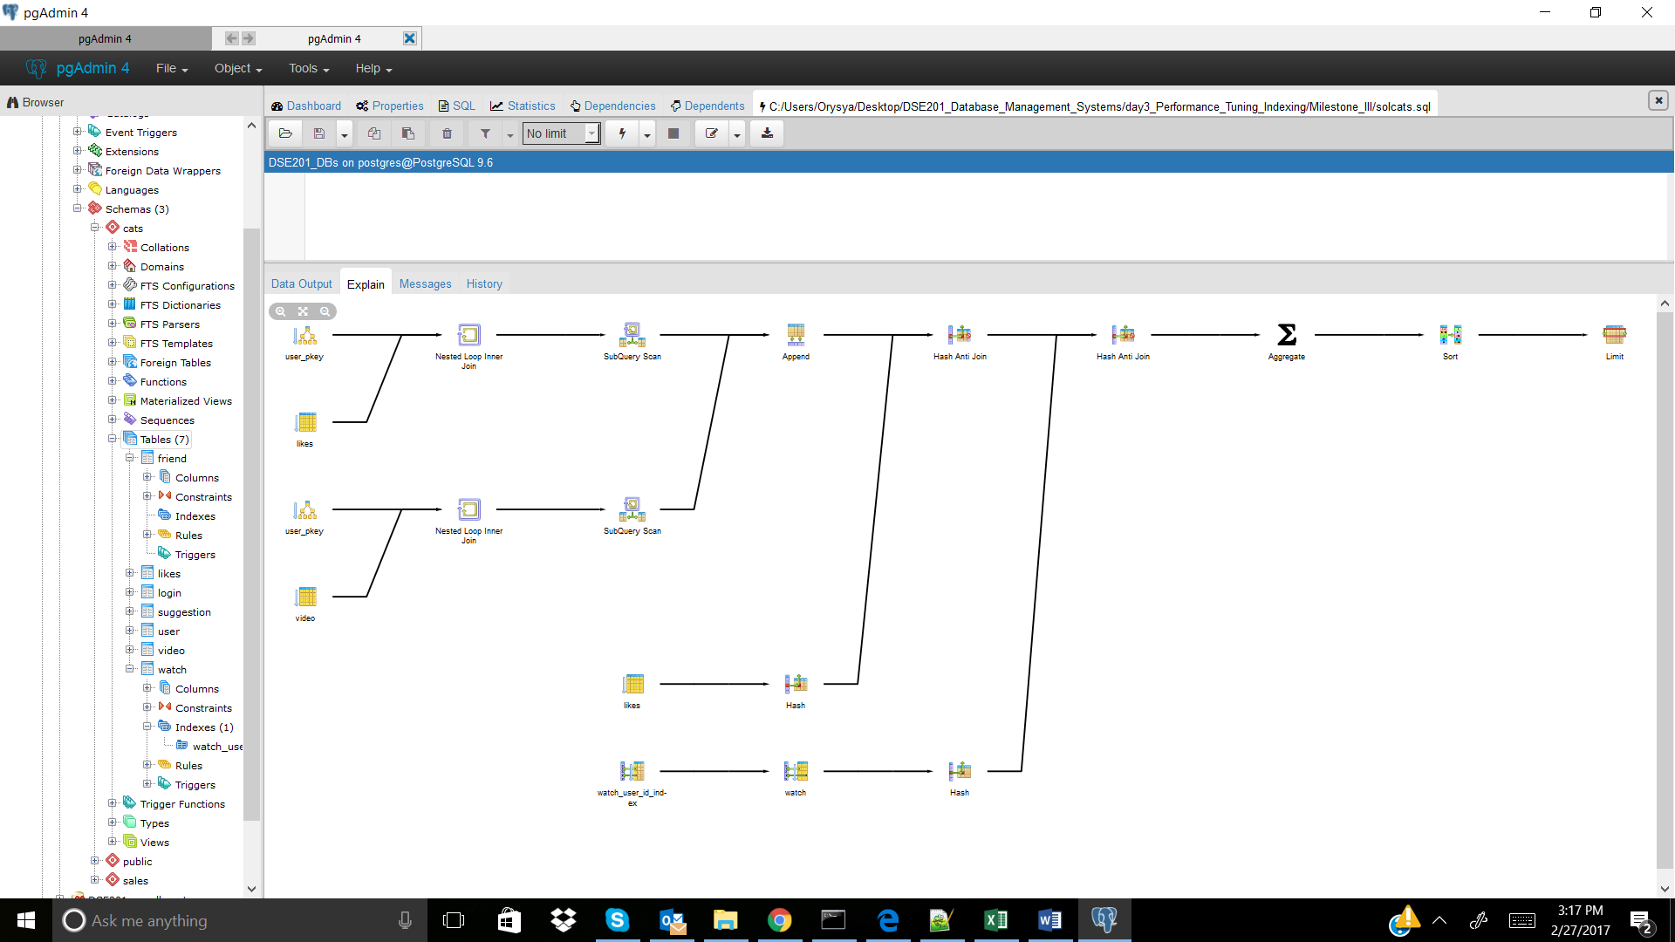

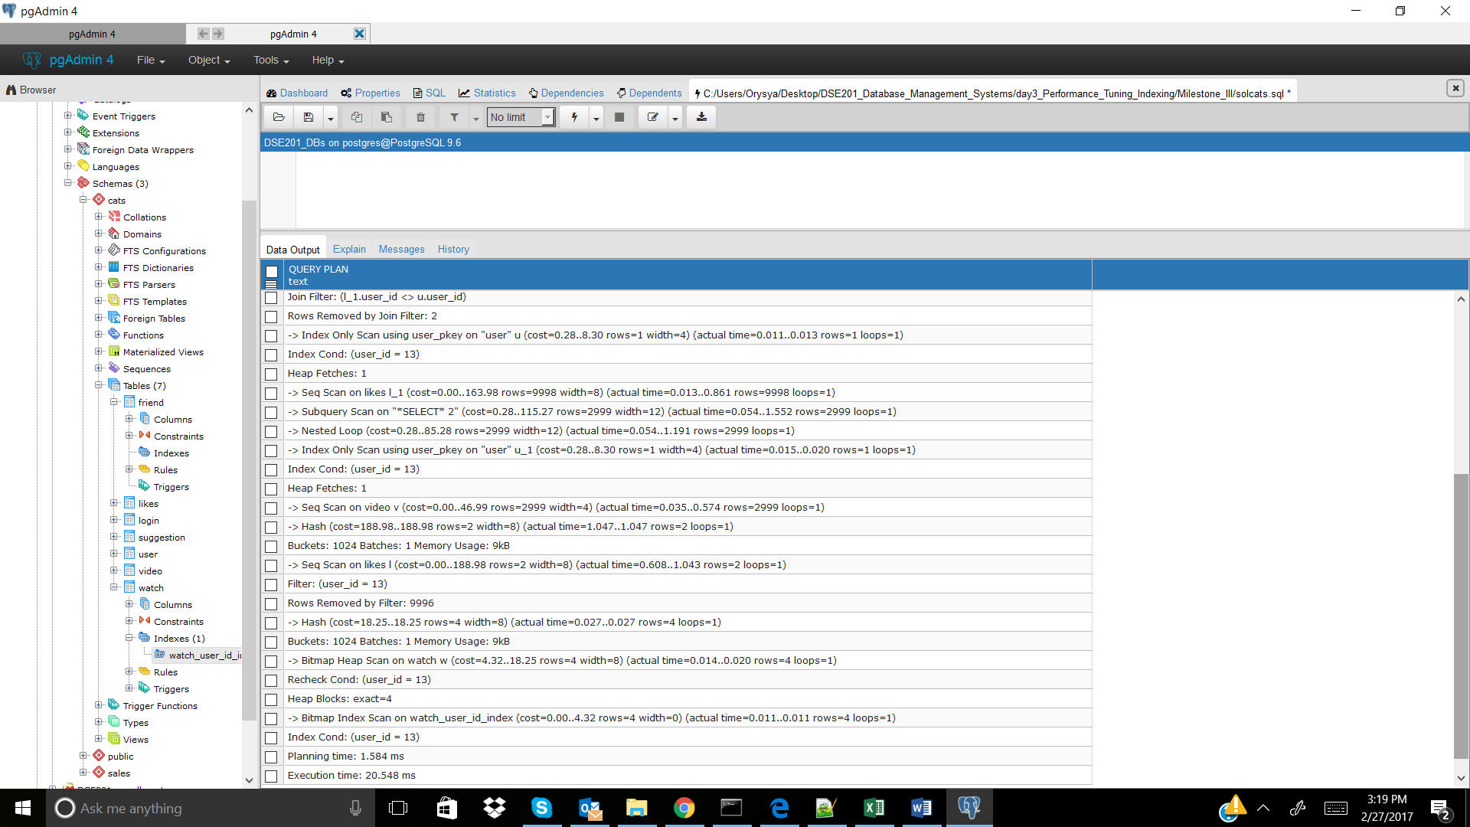

CREATE INDEX watch_video_id_index ON cats.watch(video_id); -- didn't improve, was not incorportated

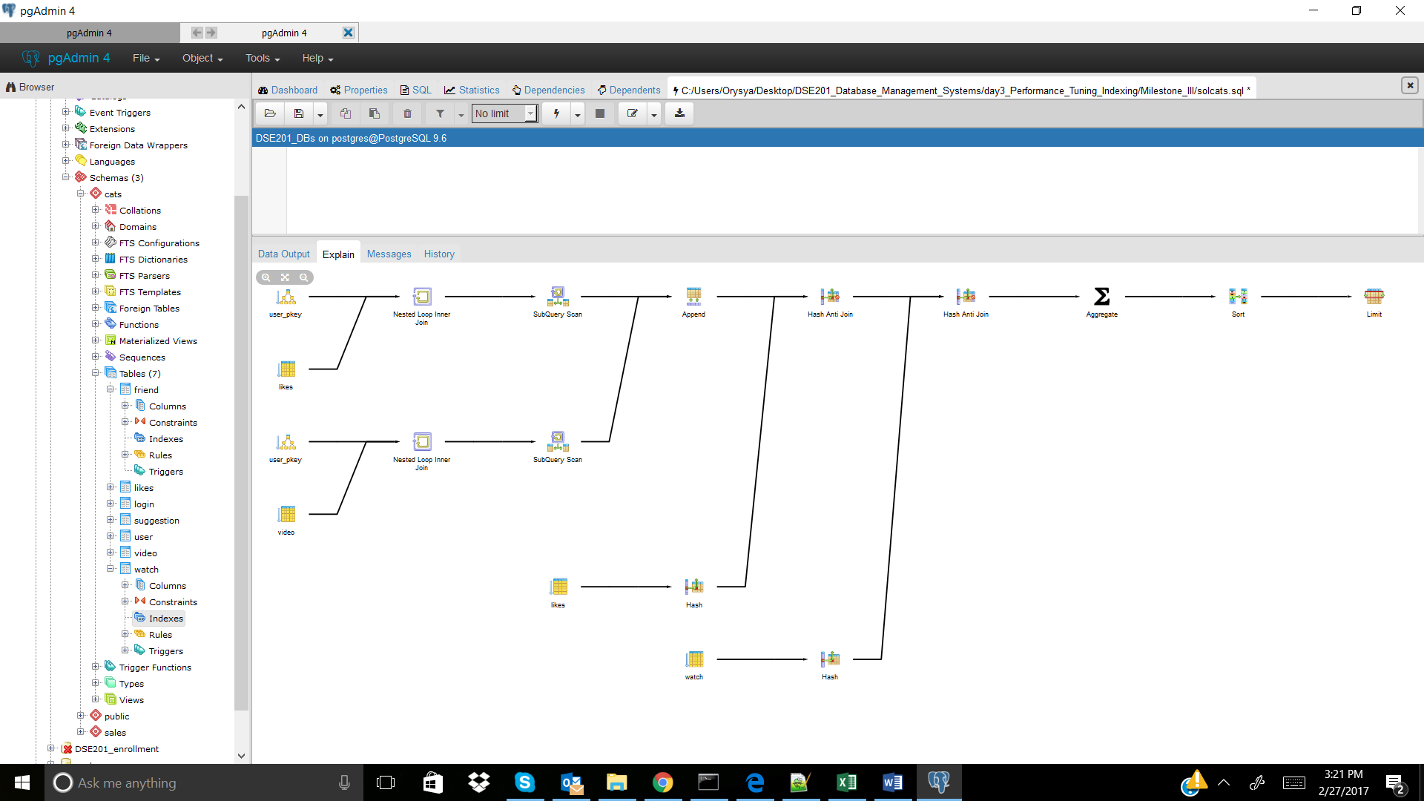

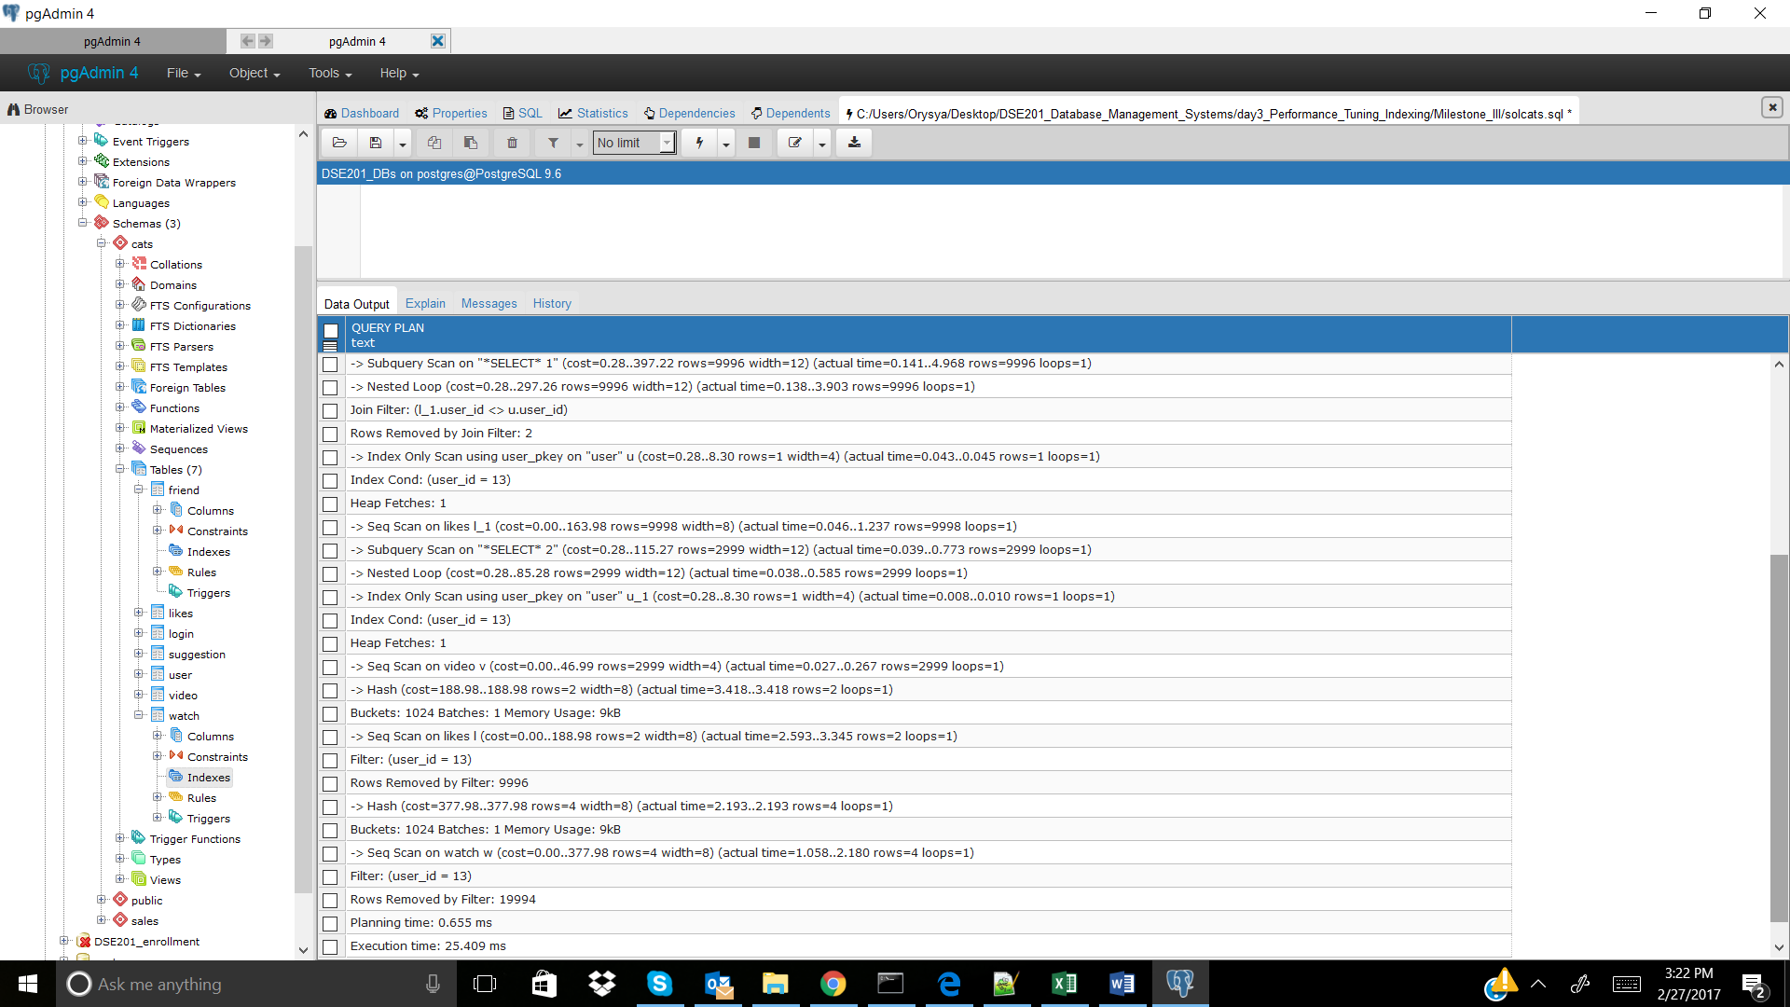

CREATE INDEX likes_user_id_index ON cats.likes(user_id); -- didn't improve, but was incorporated

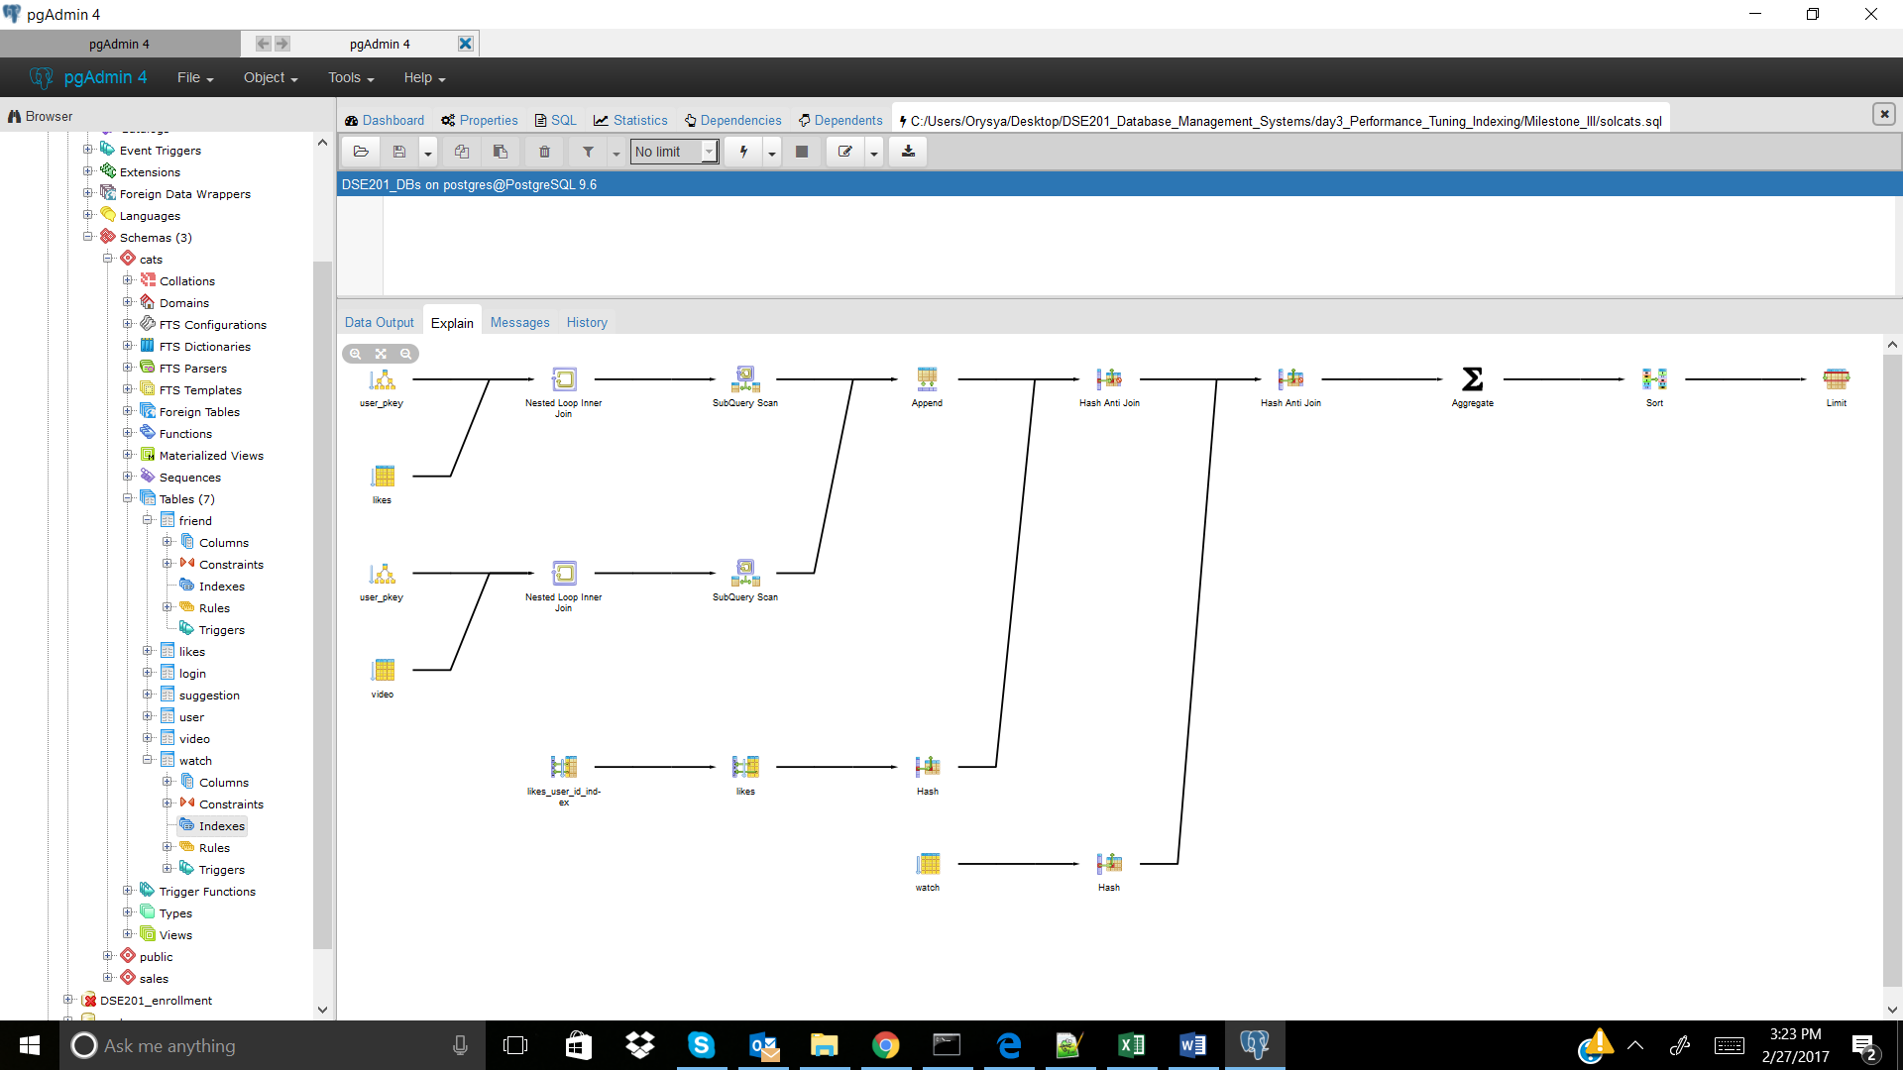

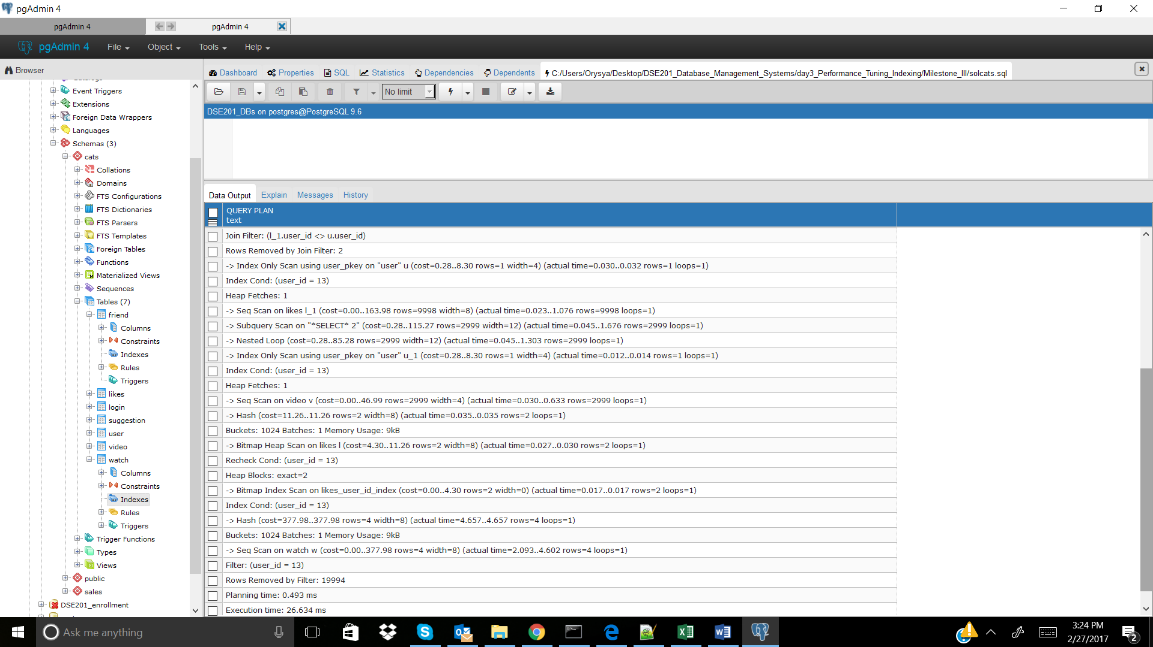

CREATE INDEX likes_video_id_index ON cats.likes(video_id); -- didn't improve, was not incorportated

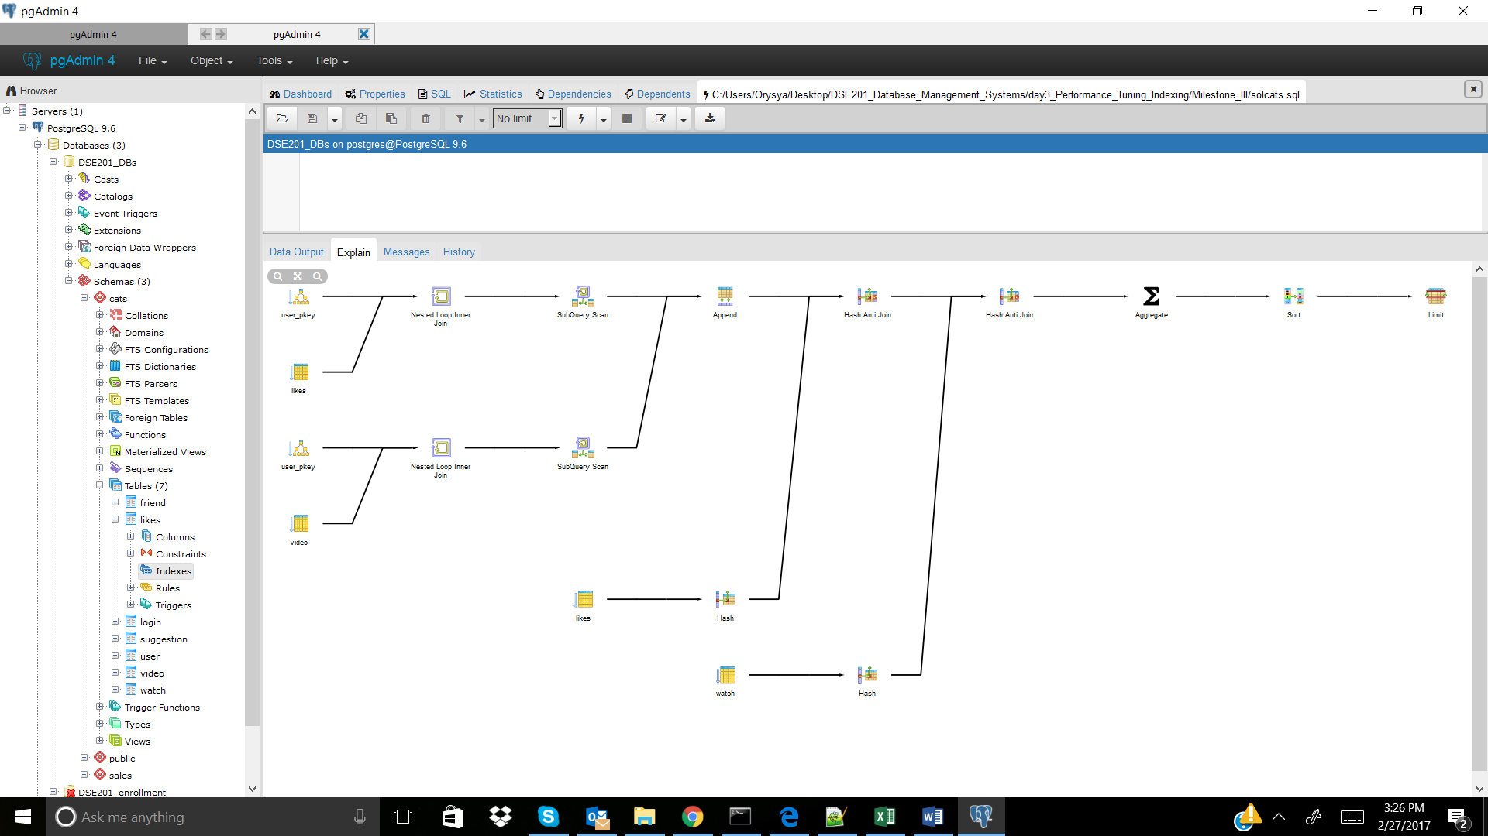

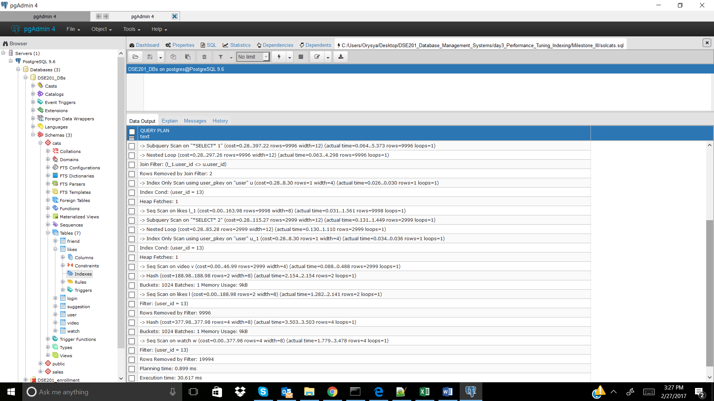

Cats_2

No Index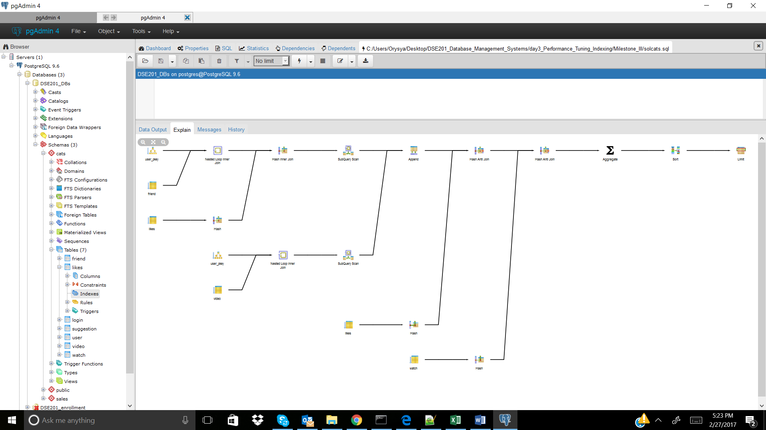

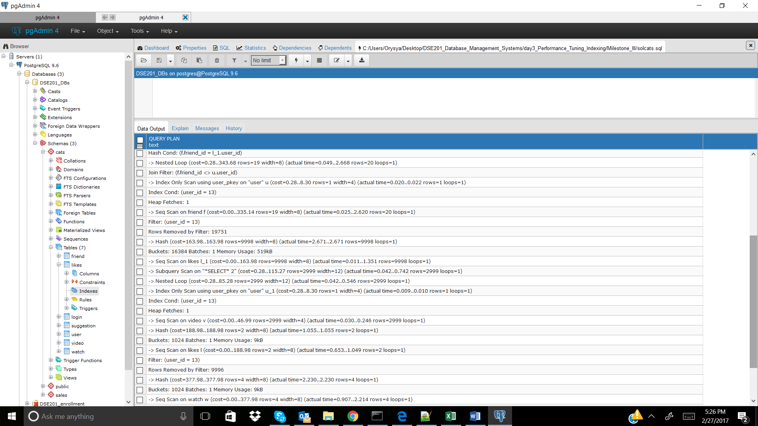

CREATE INDEX friend_user_id_index ON cats.friend(user_id); -- didn't improve, but was incorporated

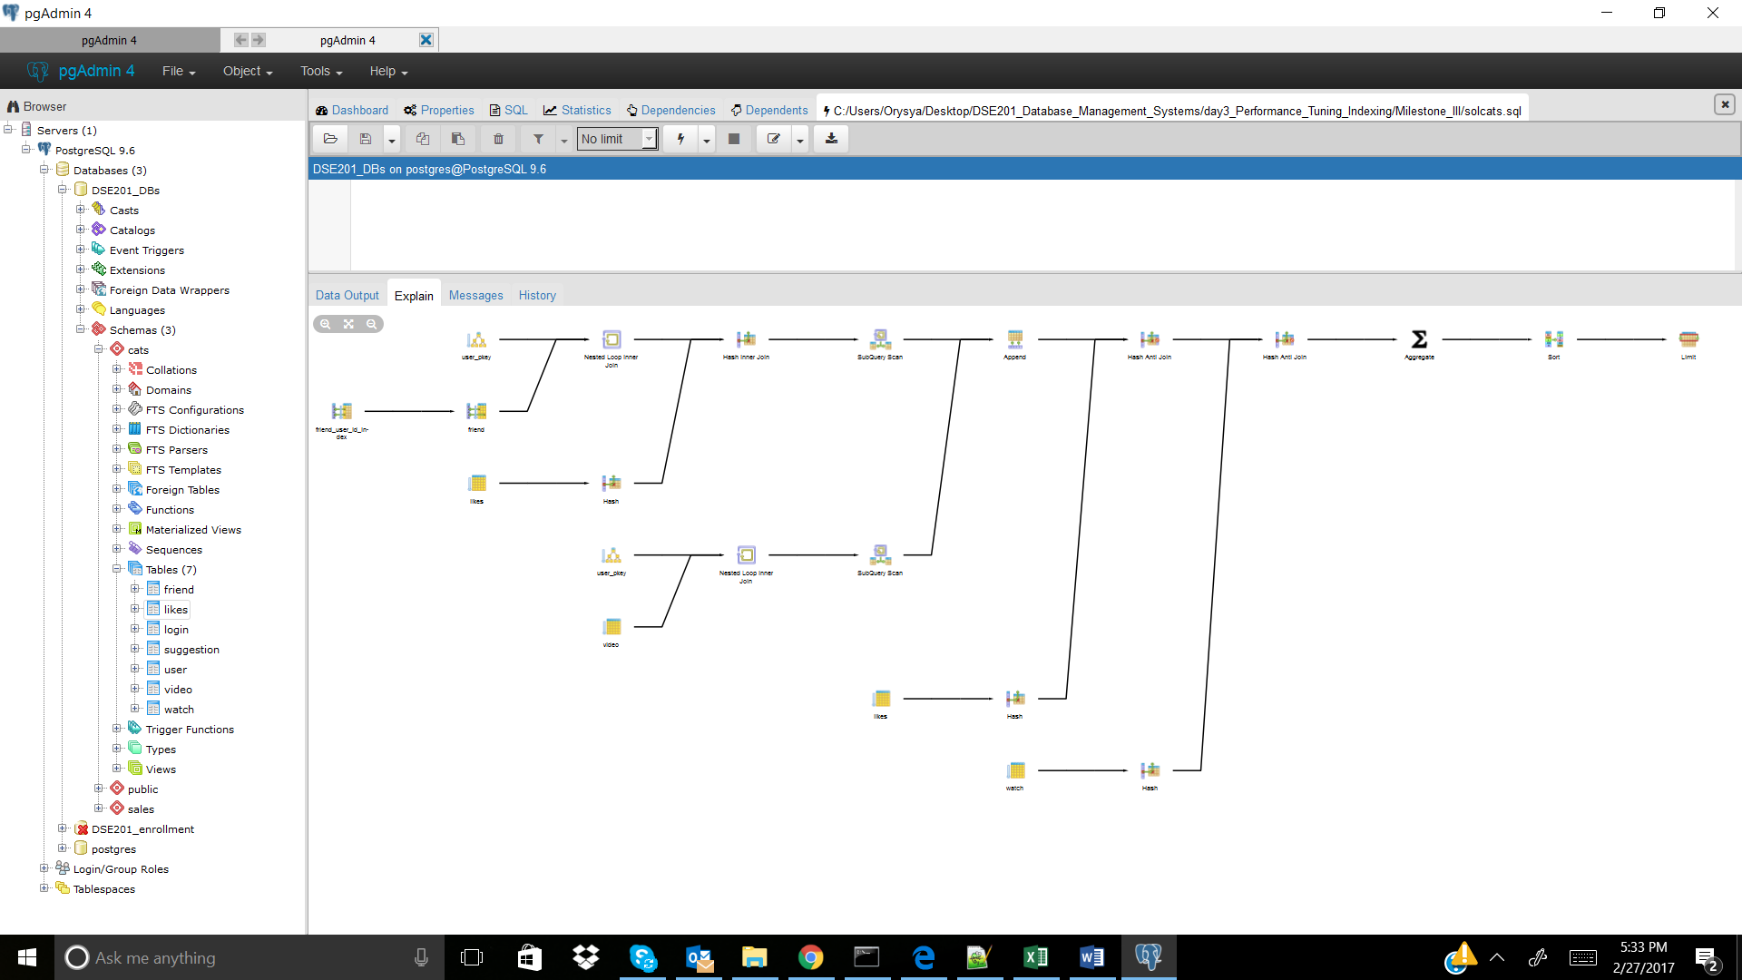

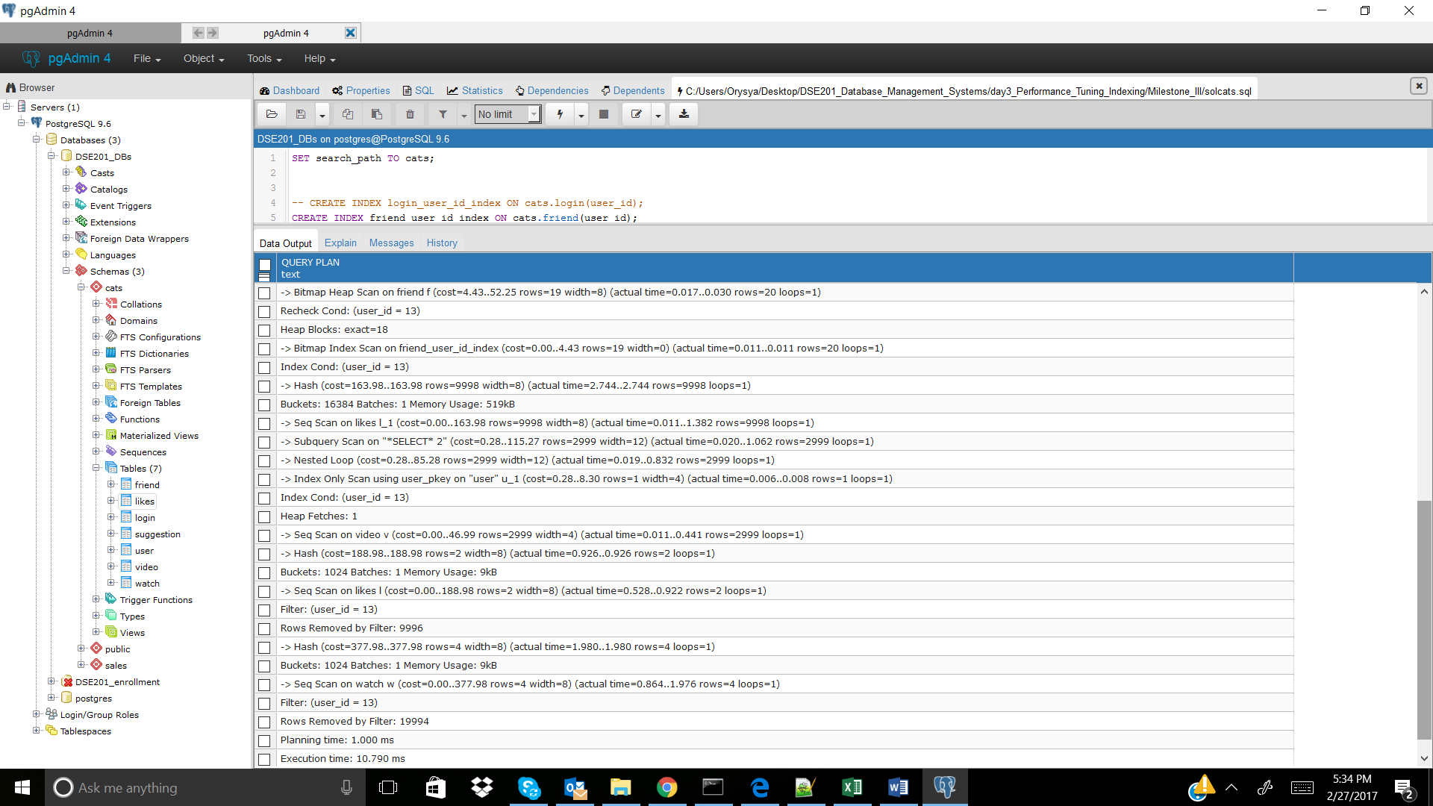

CREATE INDEX watch_user_id_index ON cats.watch(user_id); -- didn't improve, but was incorporated

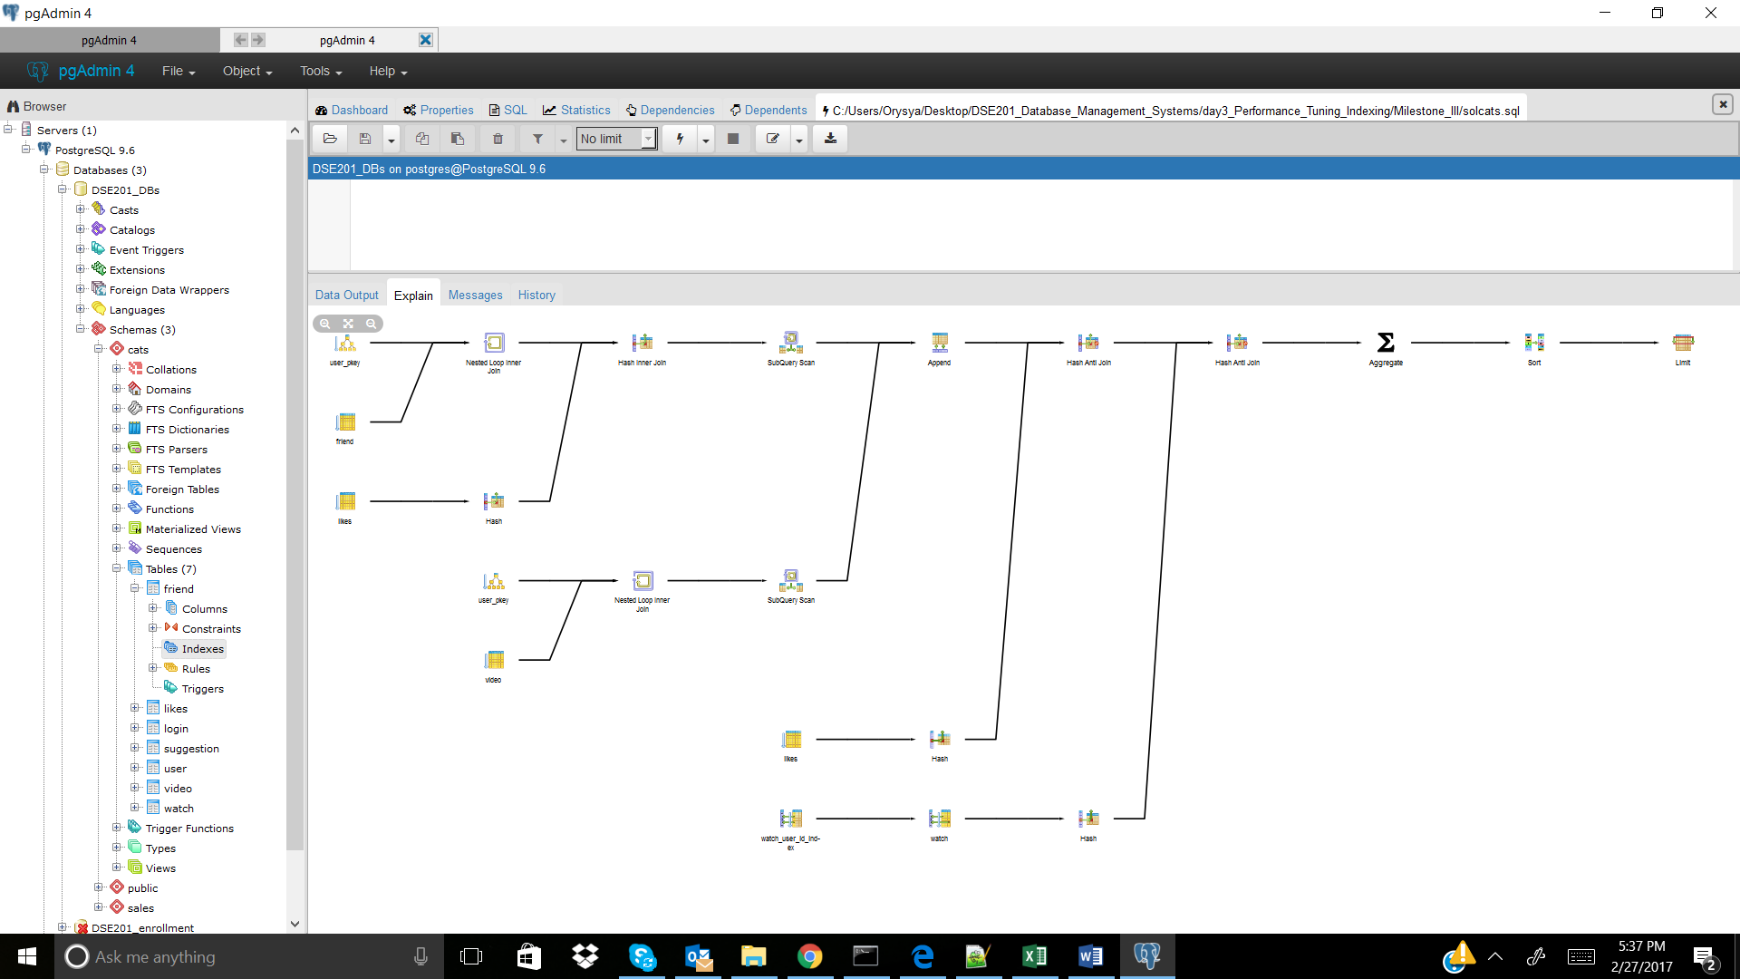

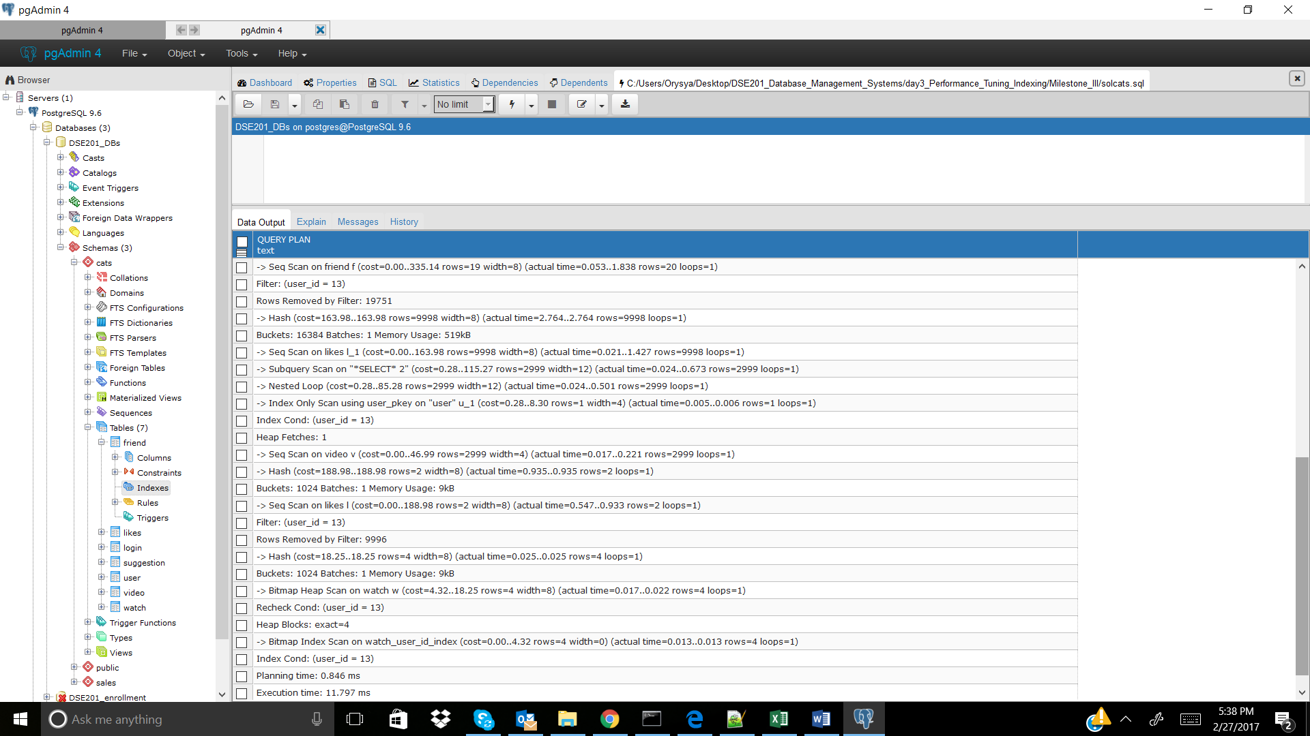

CREATE INDEX watch_video_id_index ON cats.watch(video_id); -- didn't improve, not incorporated

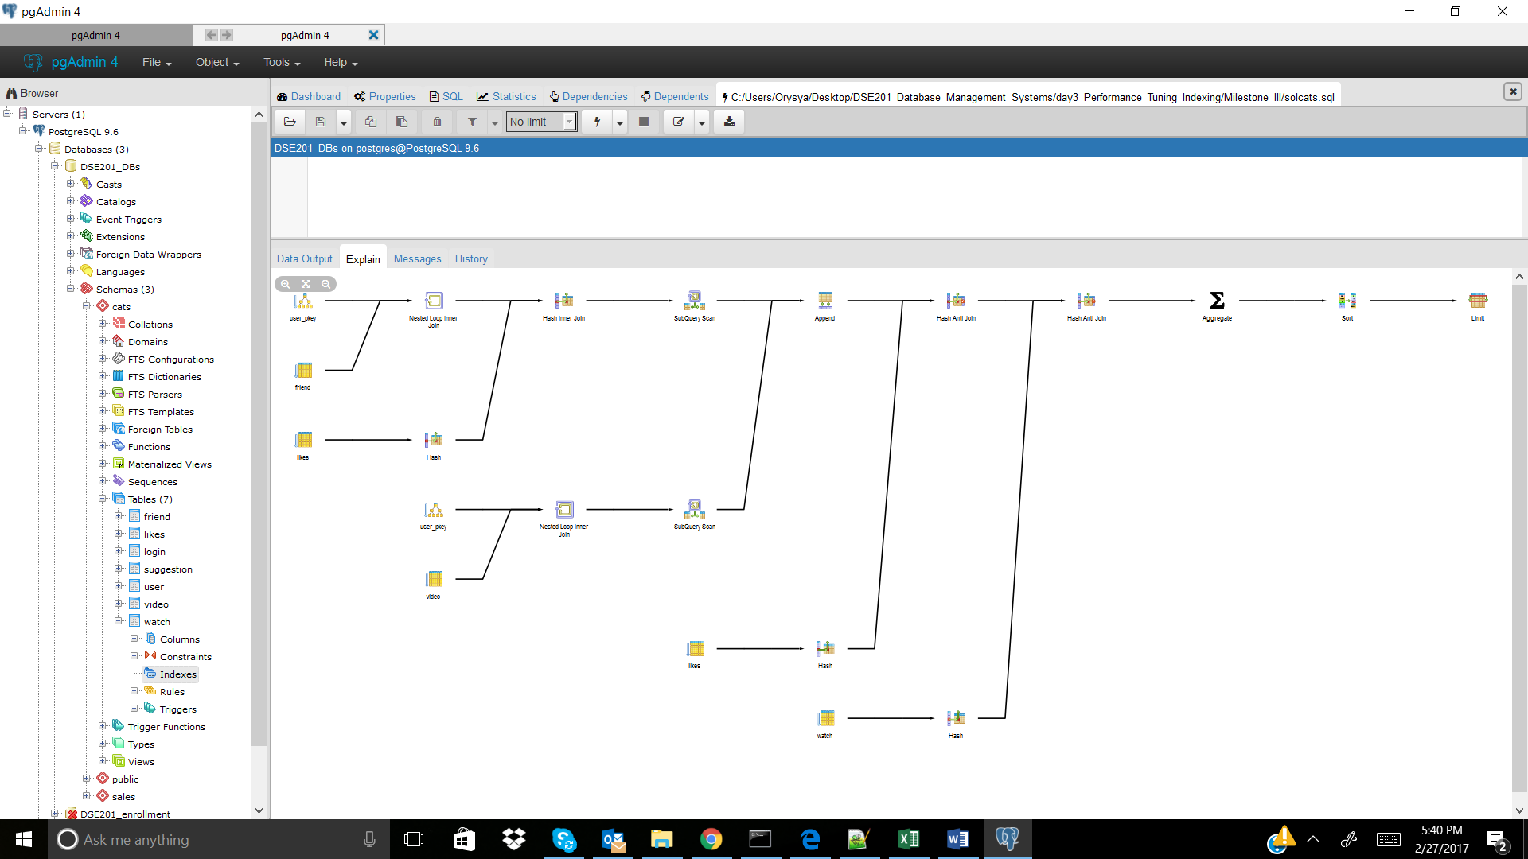

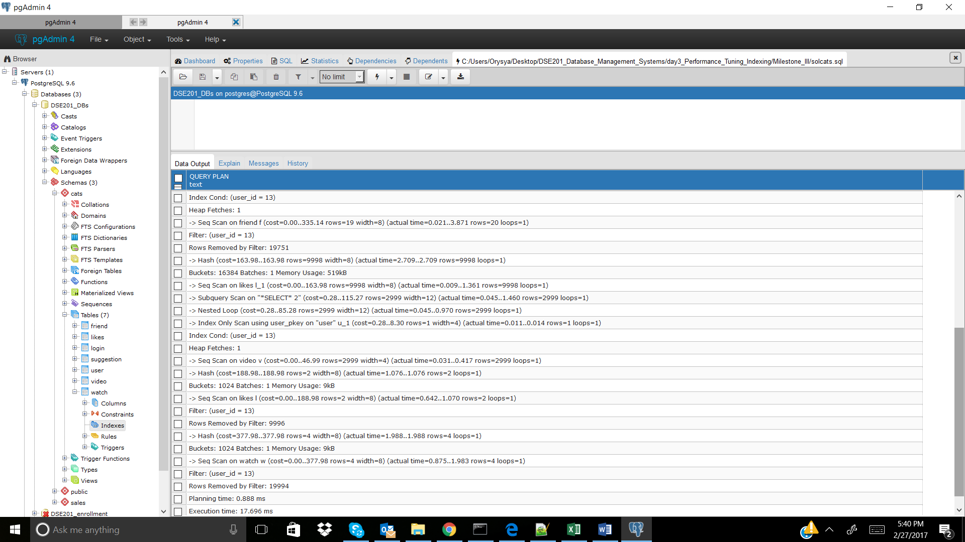

CREATE INDEX likes_user_id_index ON cats.likes(user_id); -- didn't improve, but incorporated

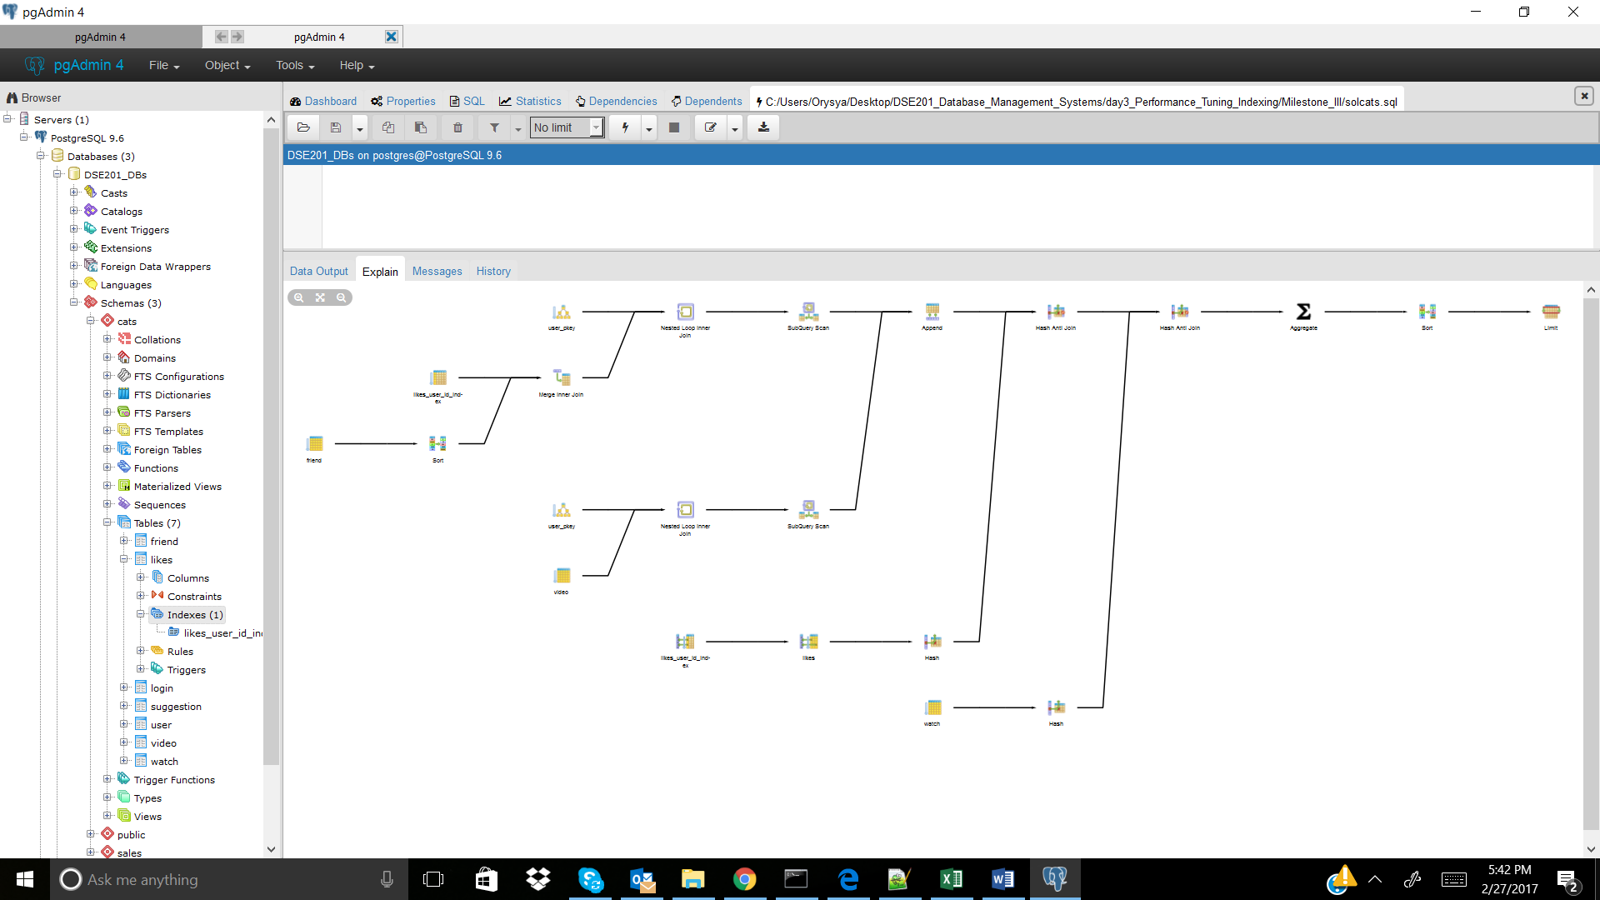

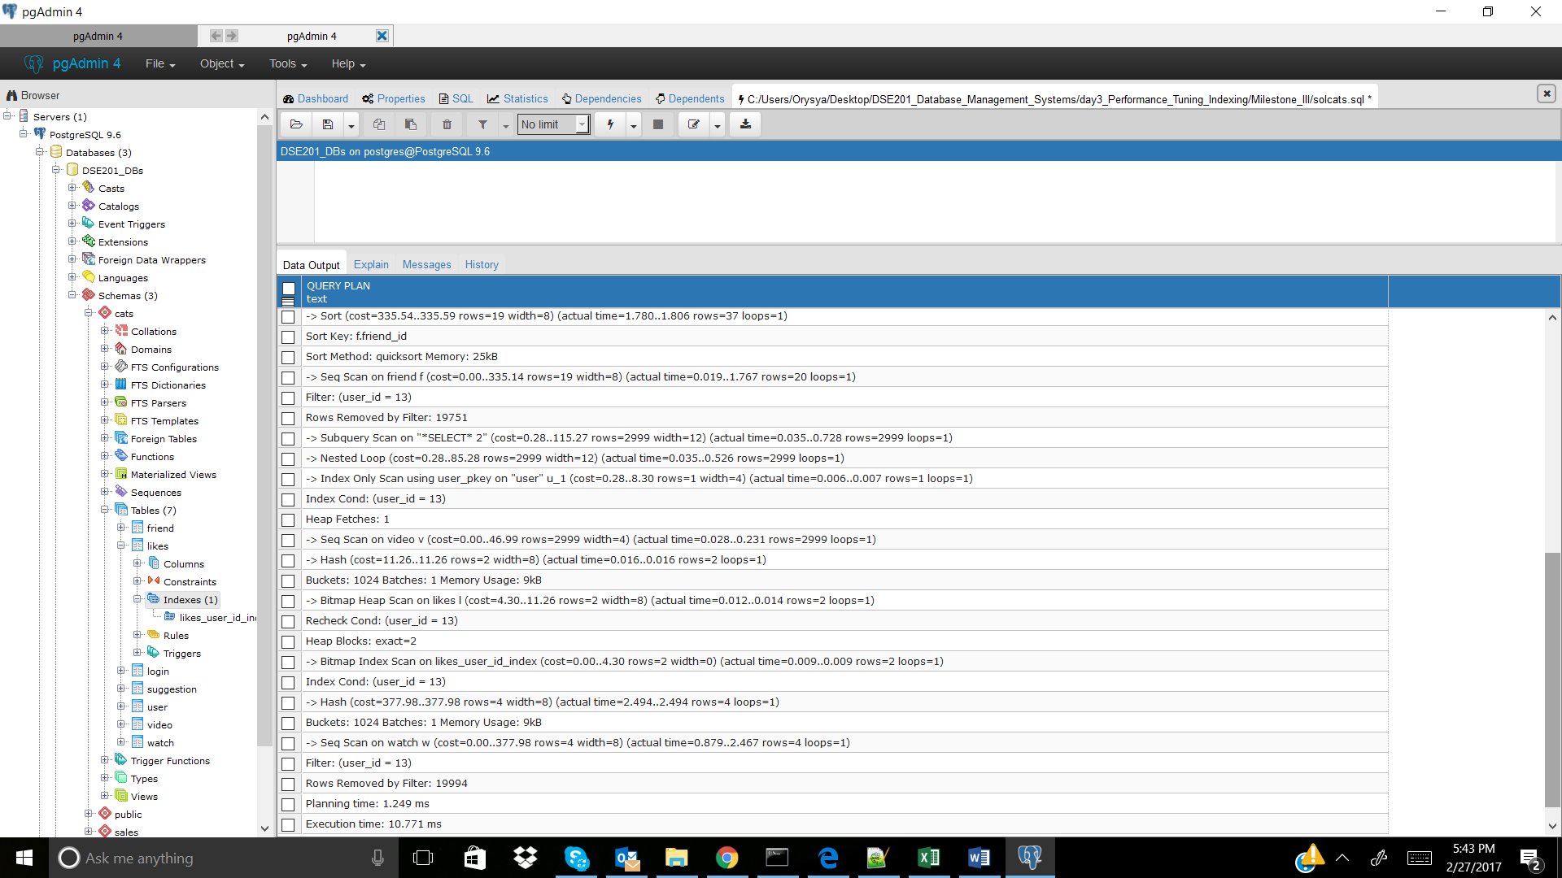

CREATE INDEX likes_video_id_index ON cats.likes(video_id); -- didn't improve, not incorporated

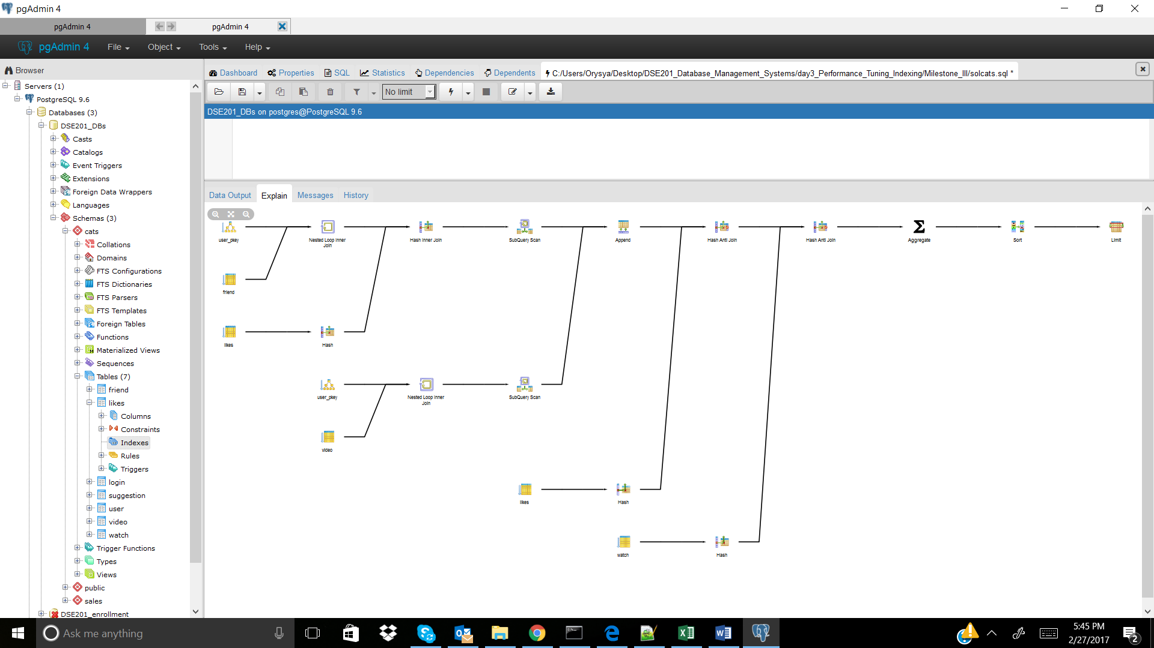

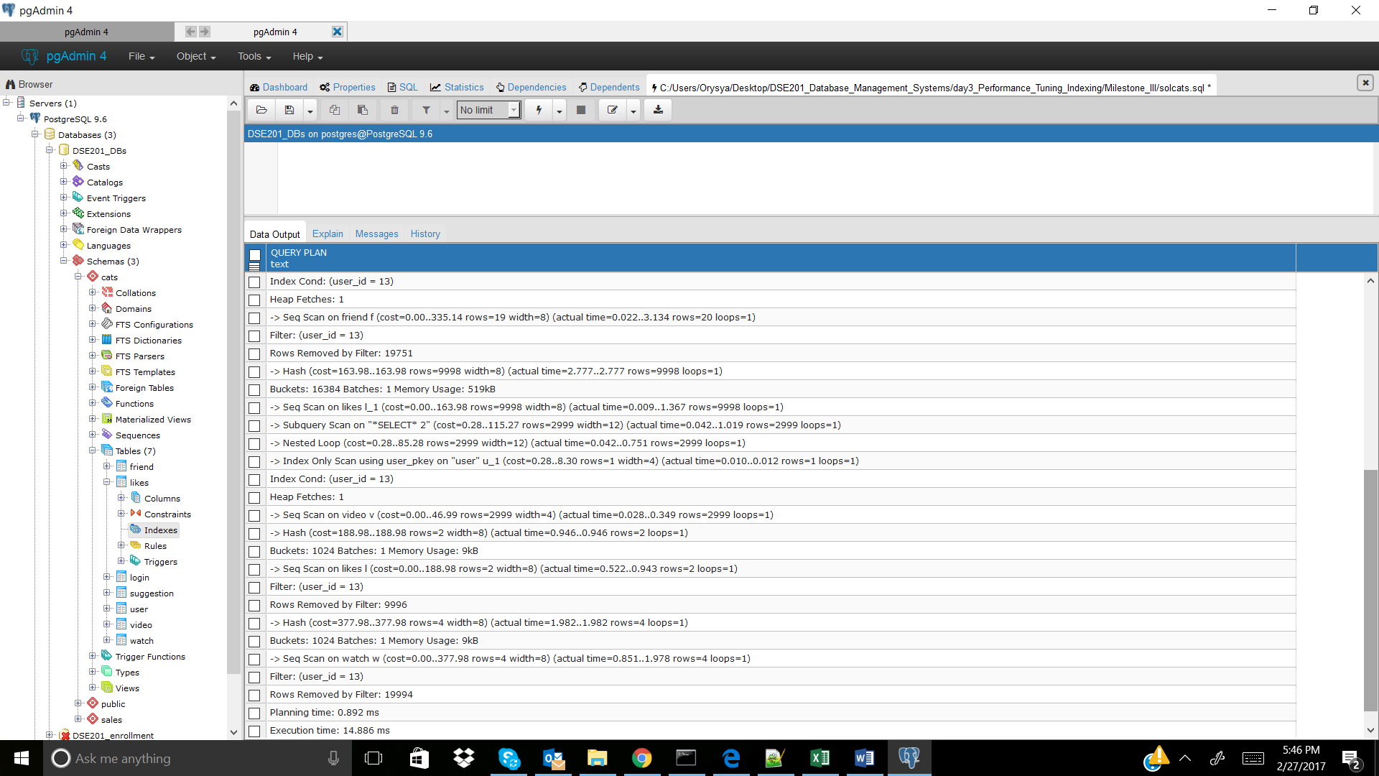

Cats_3

No index

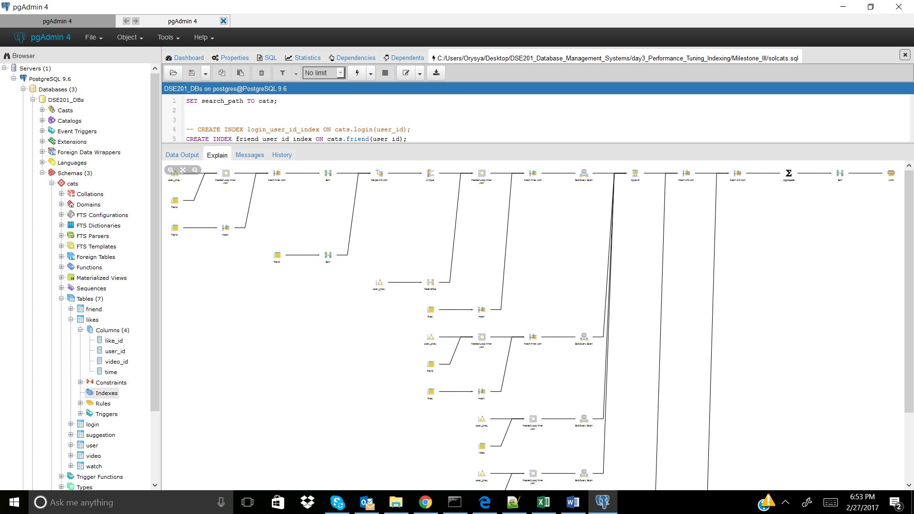

CREATE INDEX friend_user_id_index ON cats.friend(user_id); -- didn't improve, is included

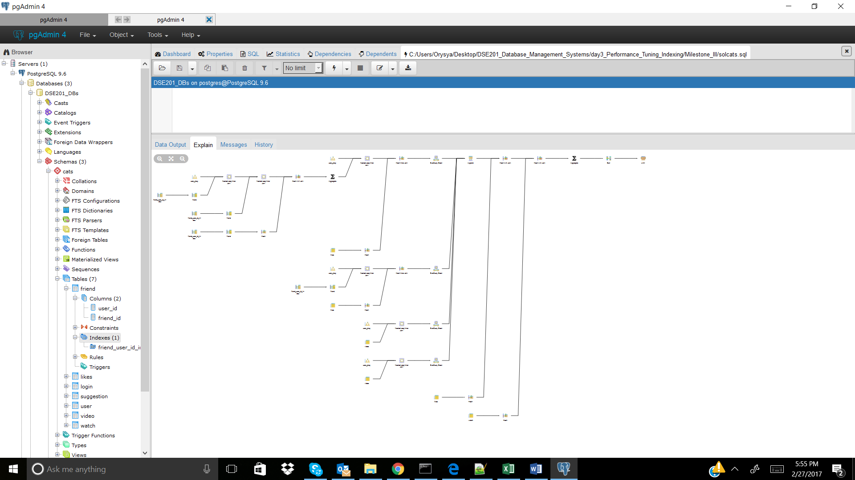

CREATE INDEX watch_user_id_index ON cats.watch(user_id); -- didn't improve, is included

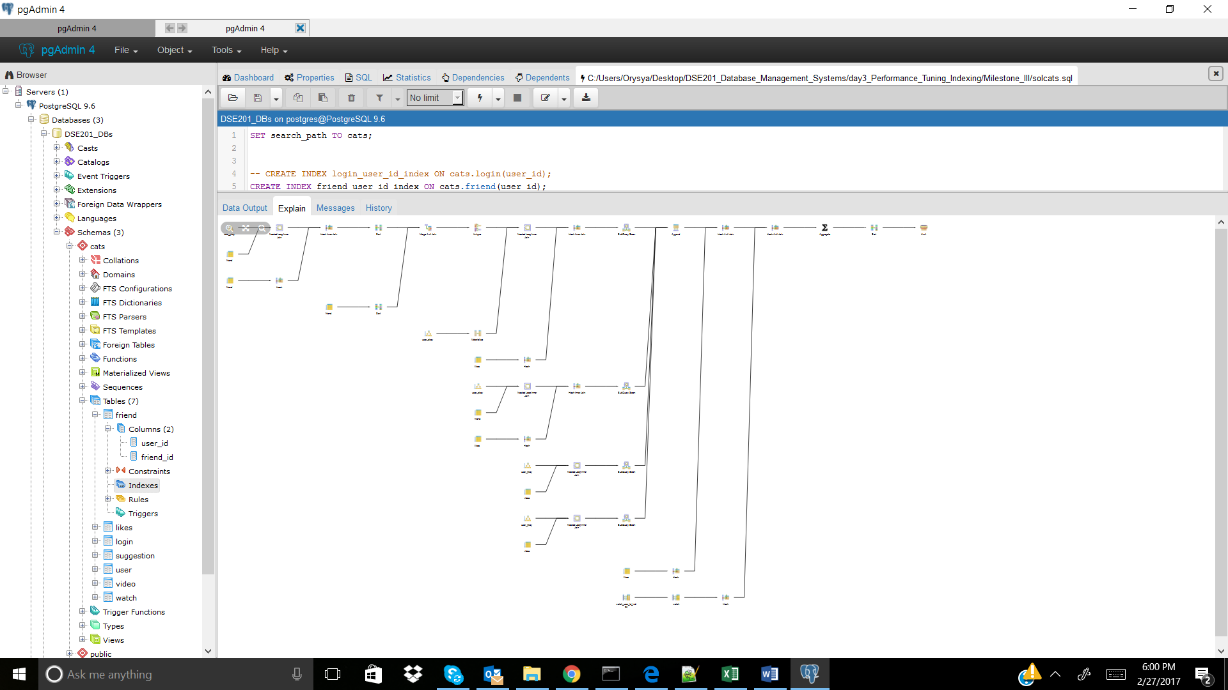

CREATE INDEX watch_video_id_index ON cats.watch(video_id); -- didn't improve, not included

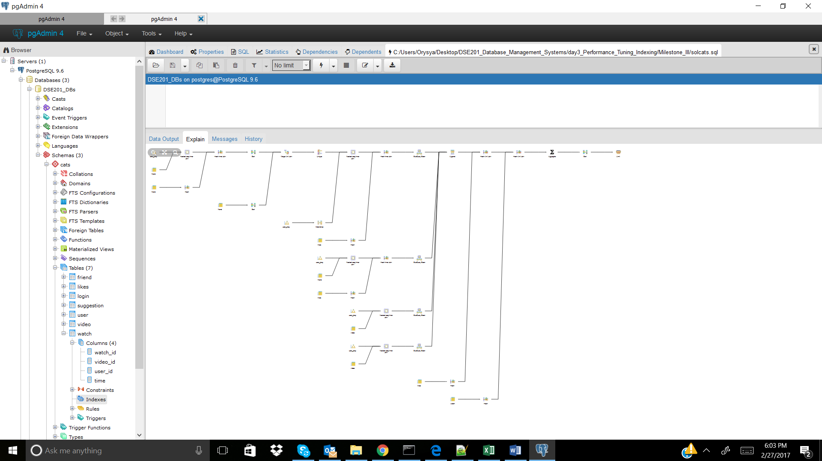

CREATE INDEX likes_user_id_index ON cats.likes(user_id); -- didn't improve, is included

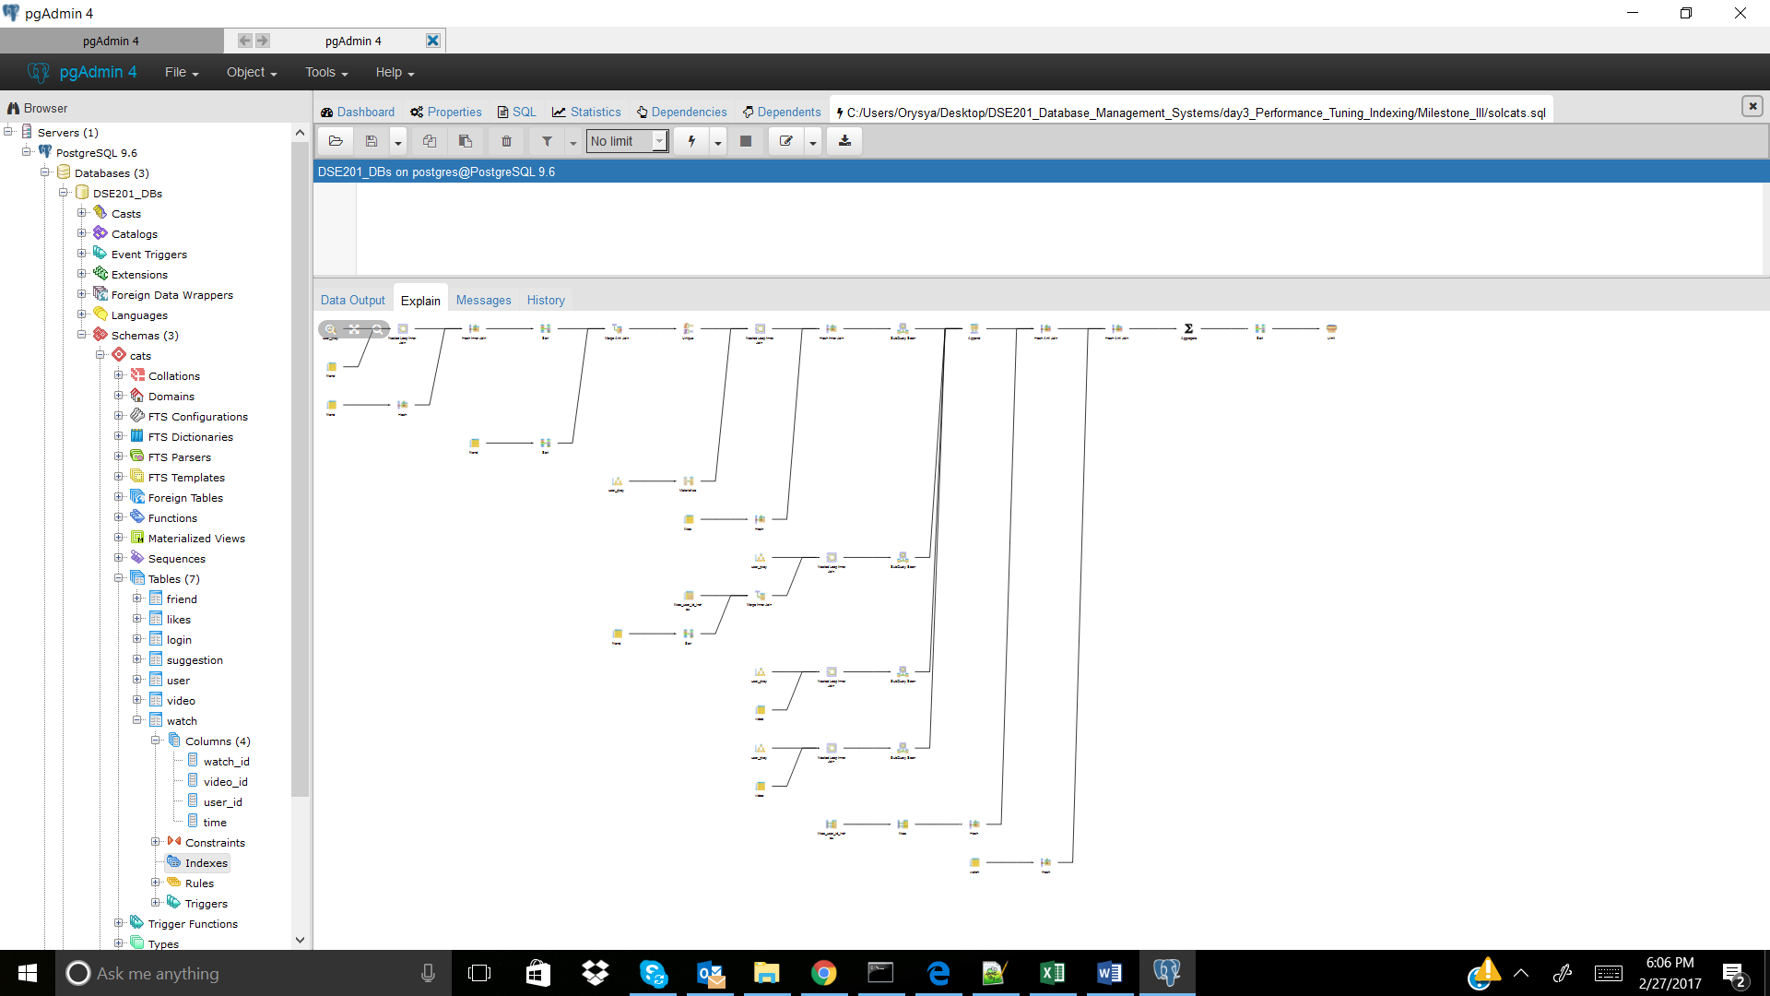

CREATE INDEX likes_video_id_index ON cats.likes(video_id); -- didn't improve, not included

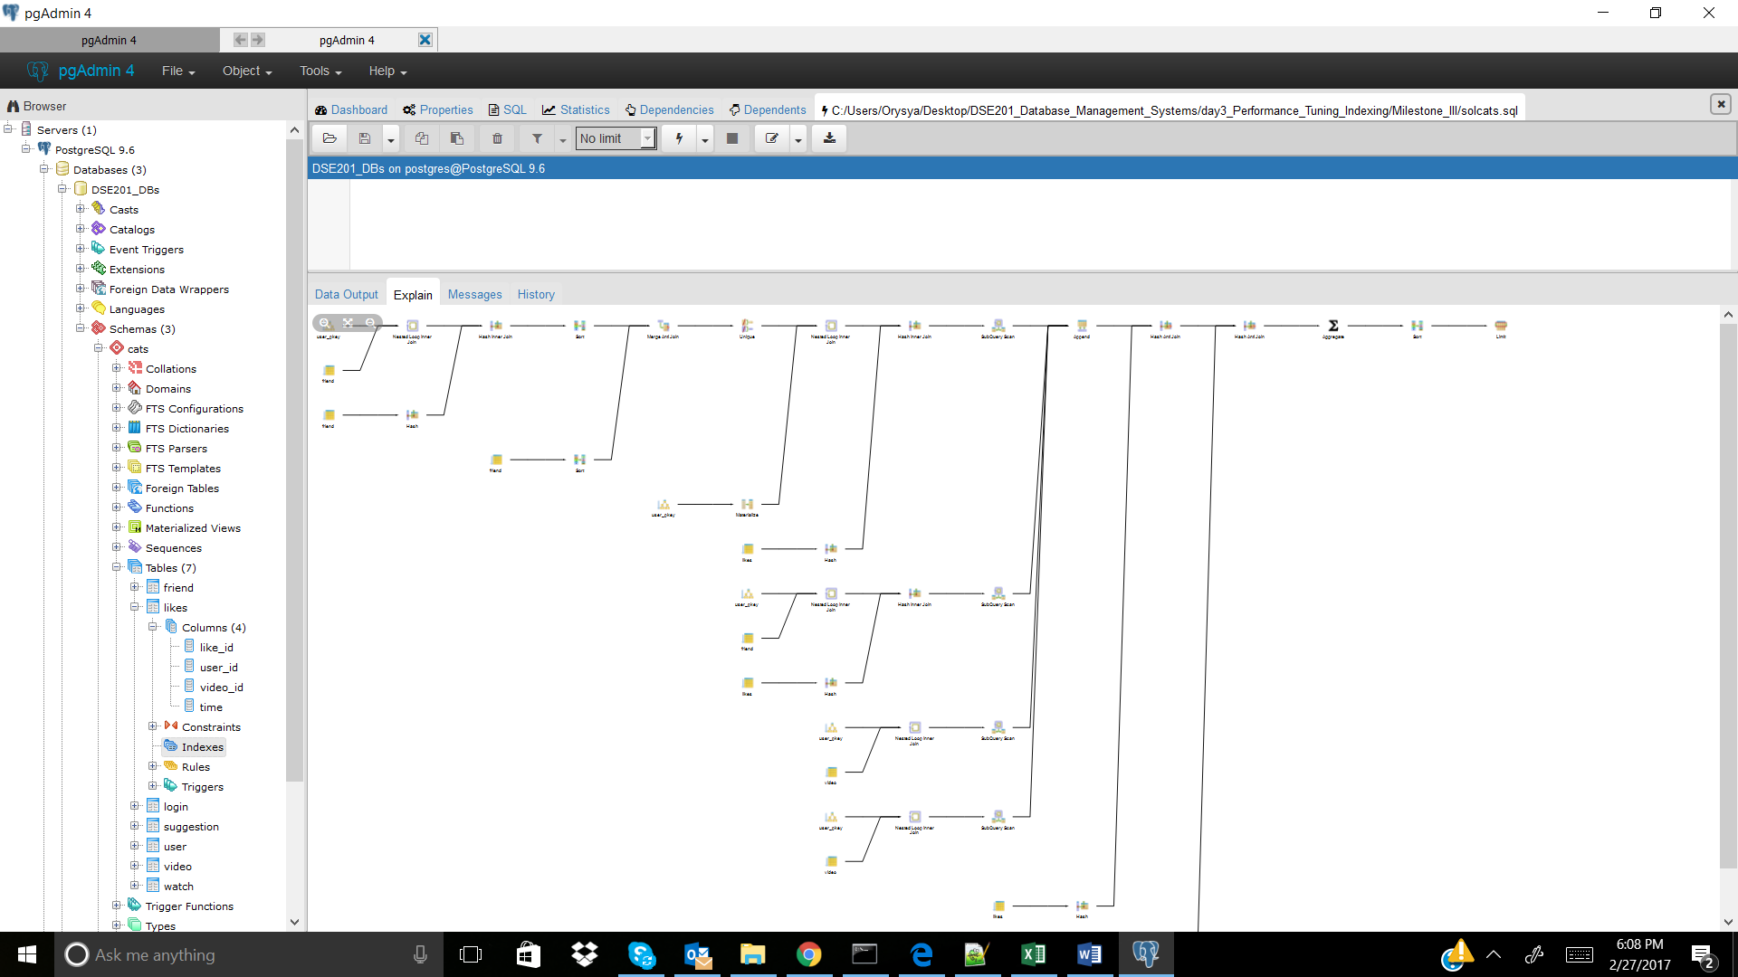

Cats_4

No Index

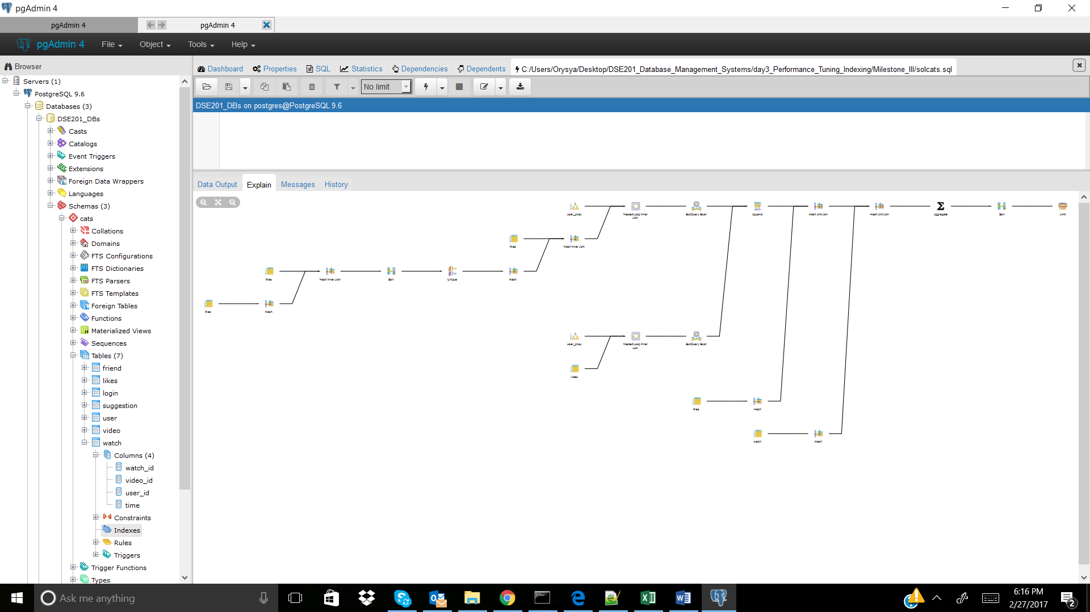

CREATE INDEX watch_user_id_index ON cats.watch(user_id); -- didn't improve, is incorporated

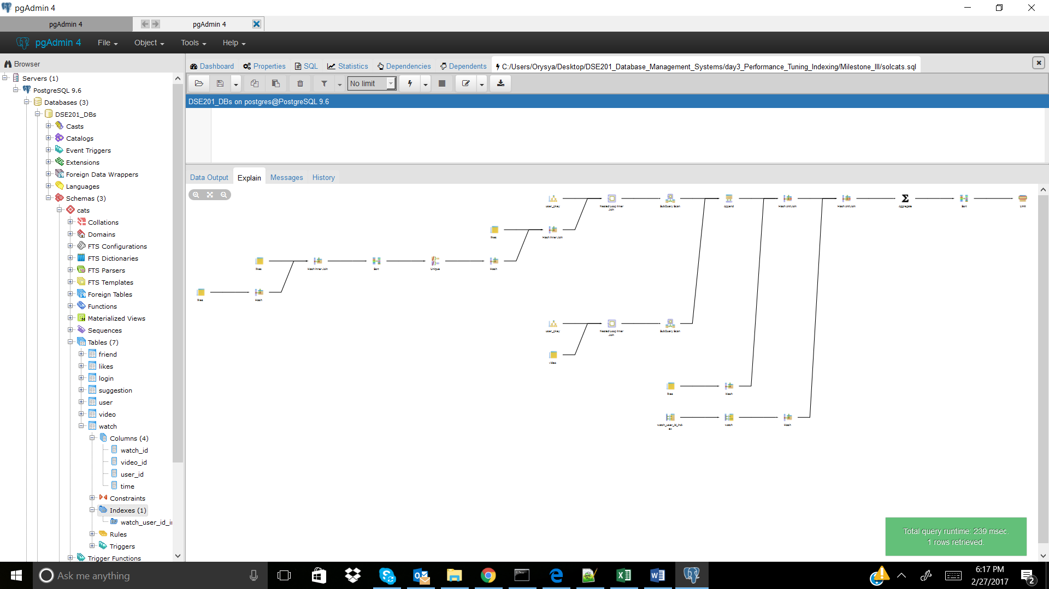

CREATE INDEX watch_video_id_index ON cats.watch(video_id); -- didn't improve, not incorporated

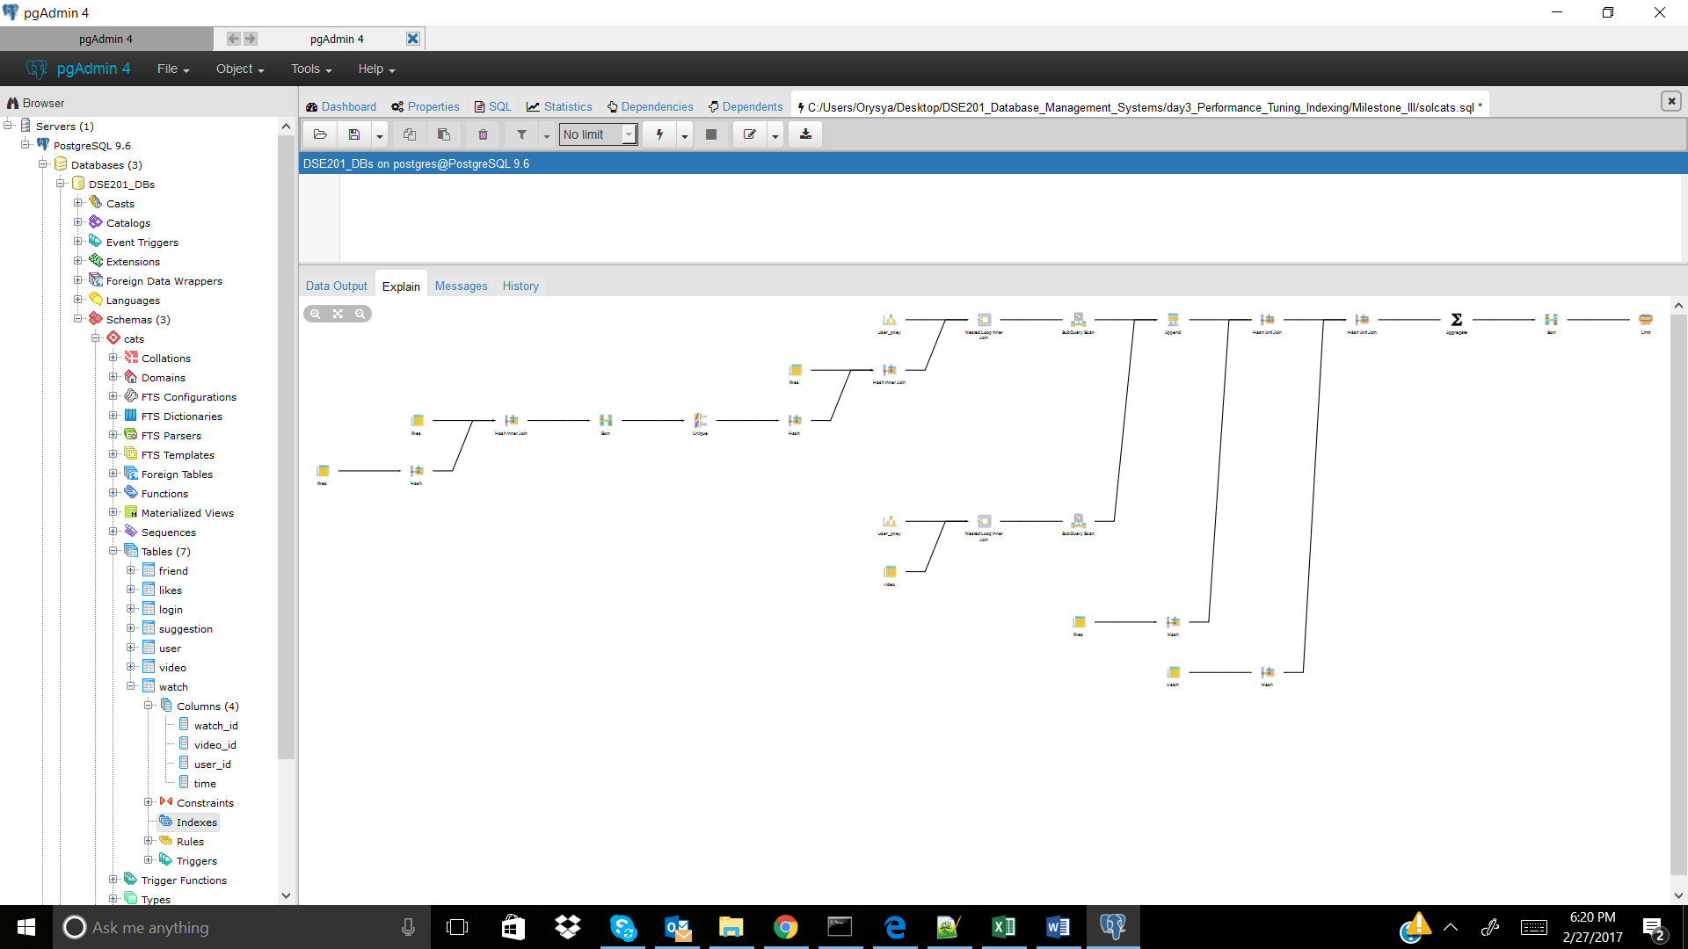

CREATE INDEX likes_user_id_index ON cats.likes(user_id); -- improved, is incorporated

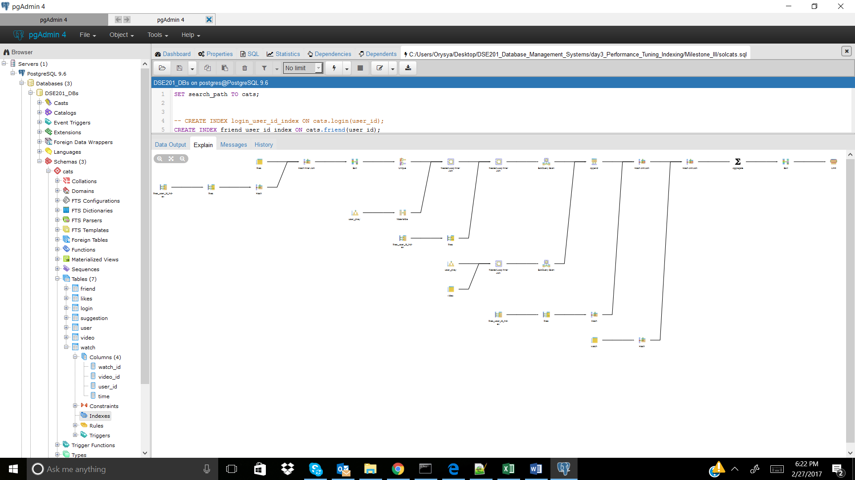

CREATE INDEX likes_video_id_index ON cats.likes(video_id); -- improbed, is incorporated

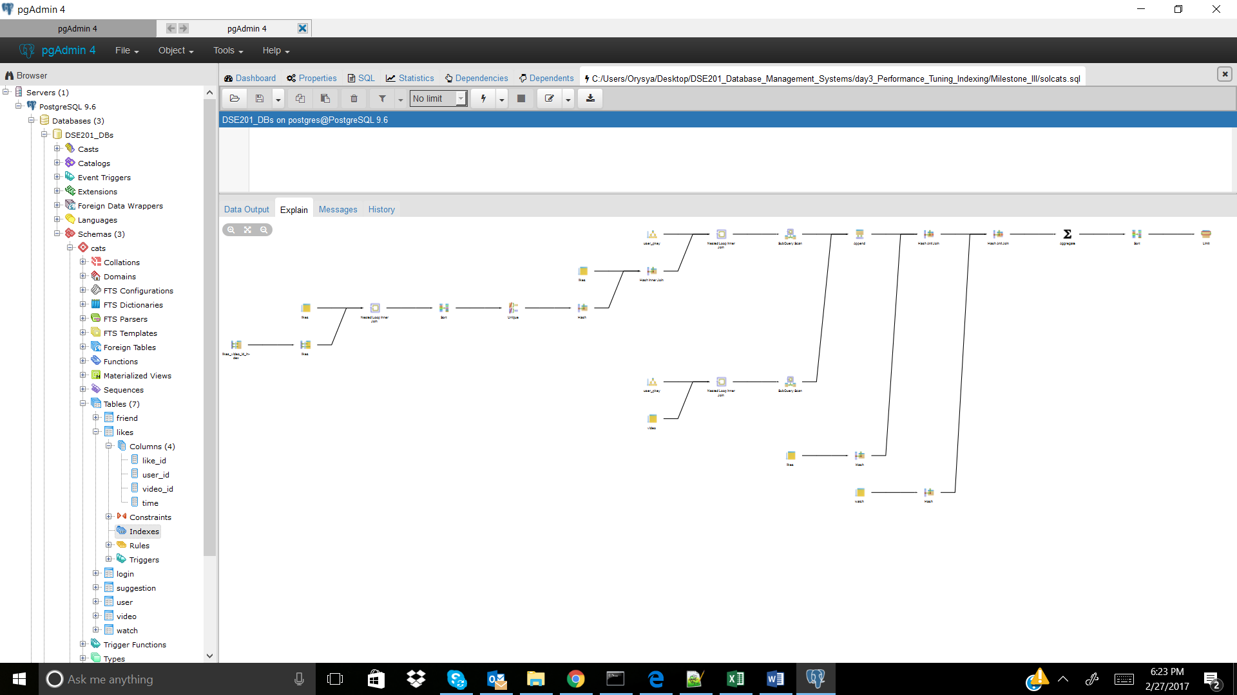

Cats_5

No index

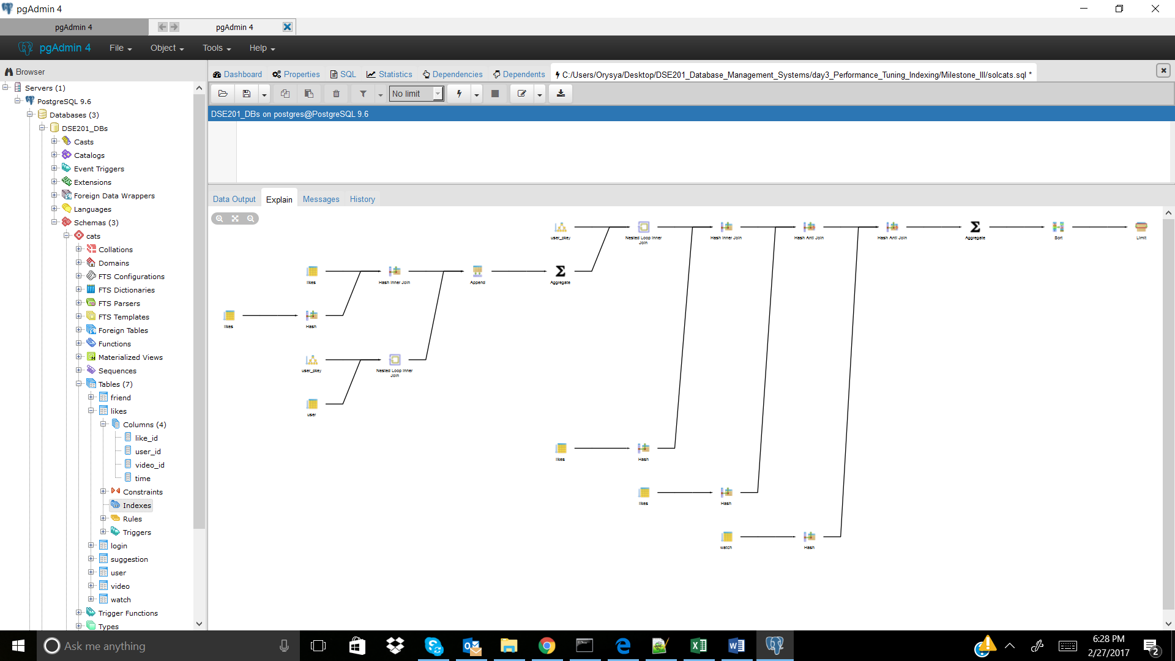

CREATE INDEX friend_user_id_index ON cats.friend(user_id); -- didn't improve, is incorporated

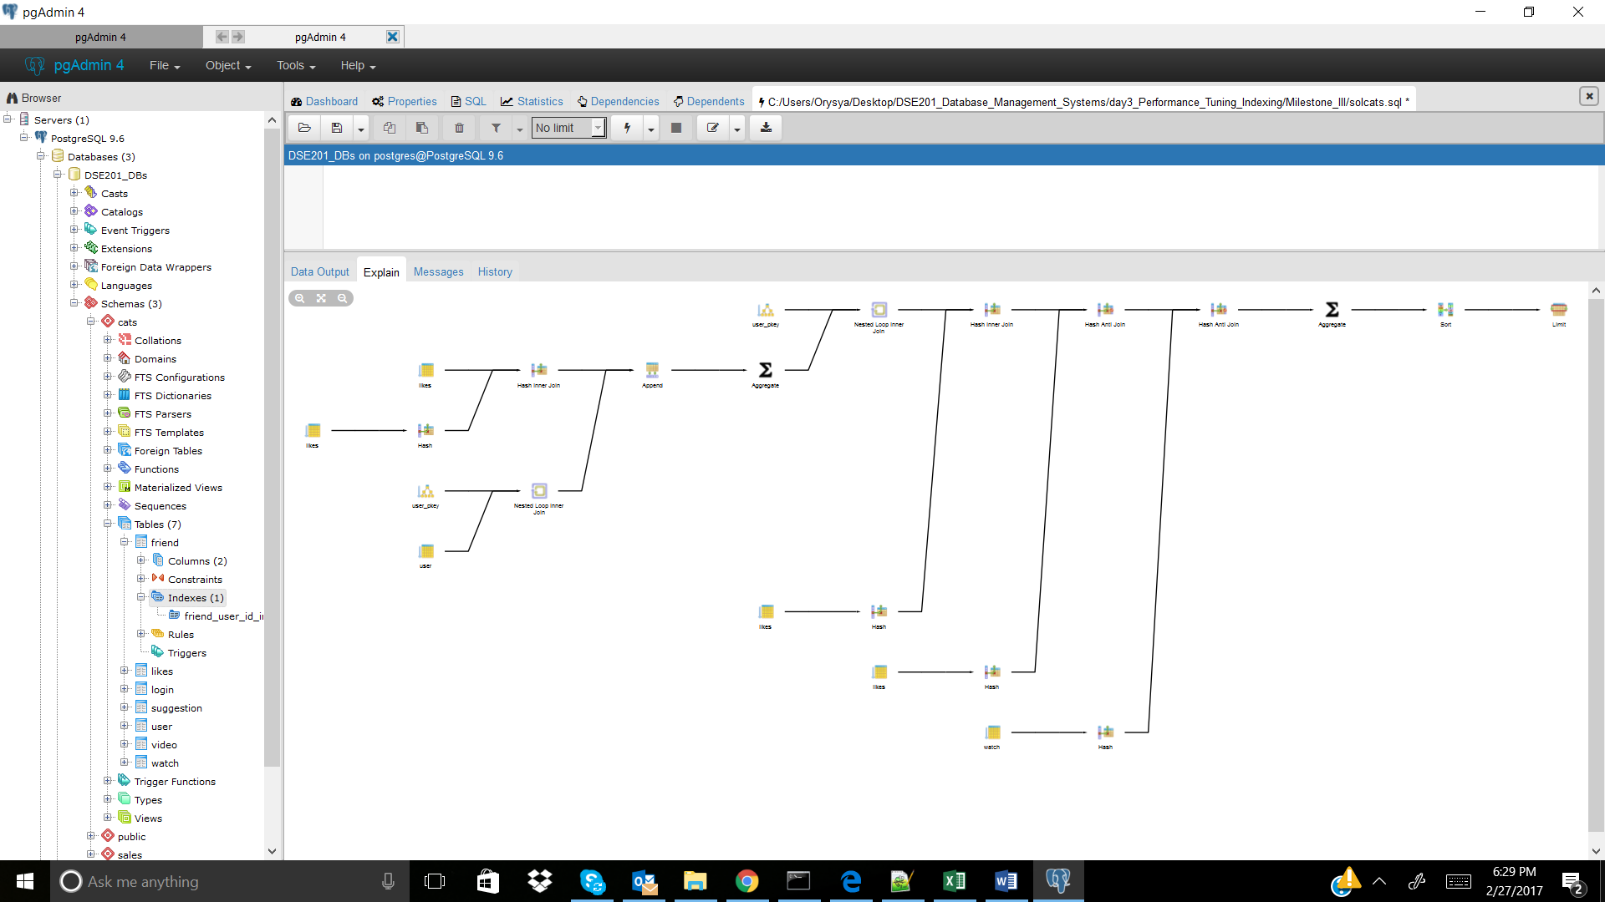

CREATE INDEX watch_user_id_index ON cats.watch(user_id); -- didn't improve, is incorporated

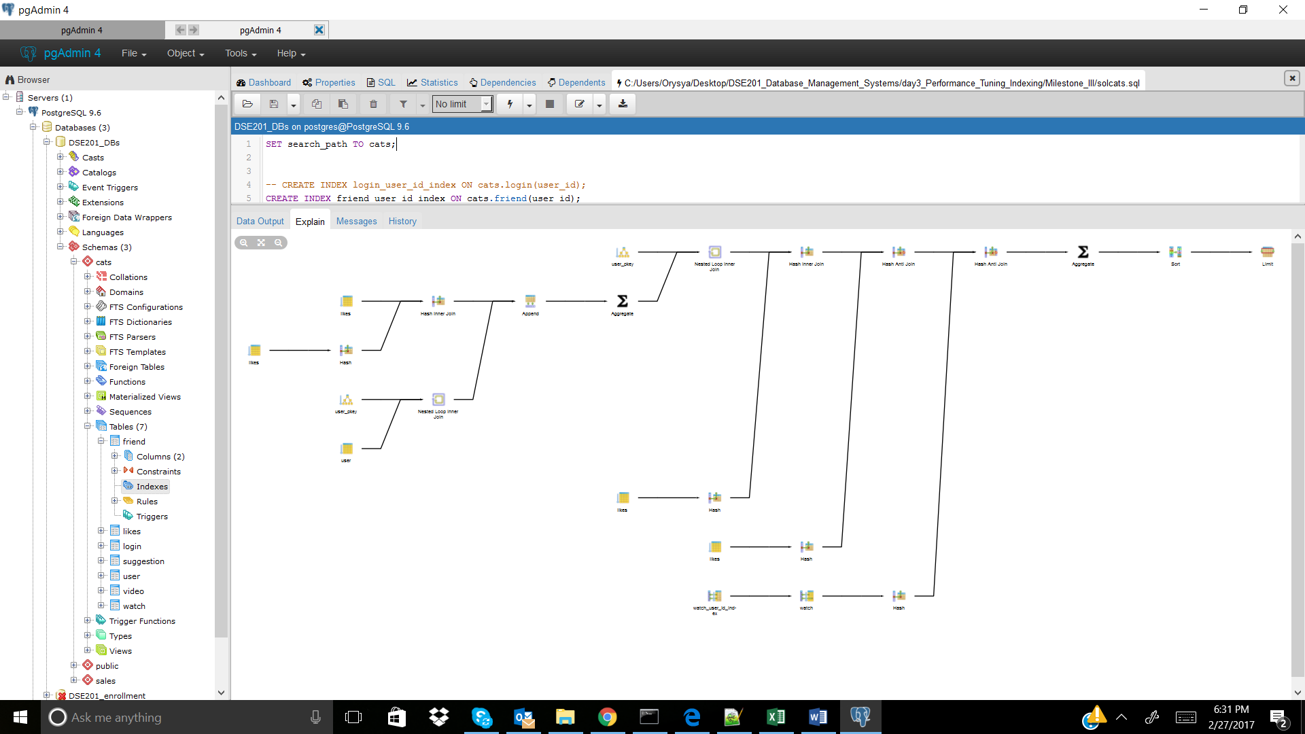

CREATE INDEX watch_video_id_index ON cats.watch(video_id); -- didn't improve, not incorporated

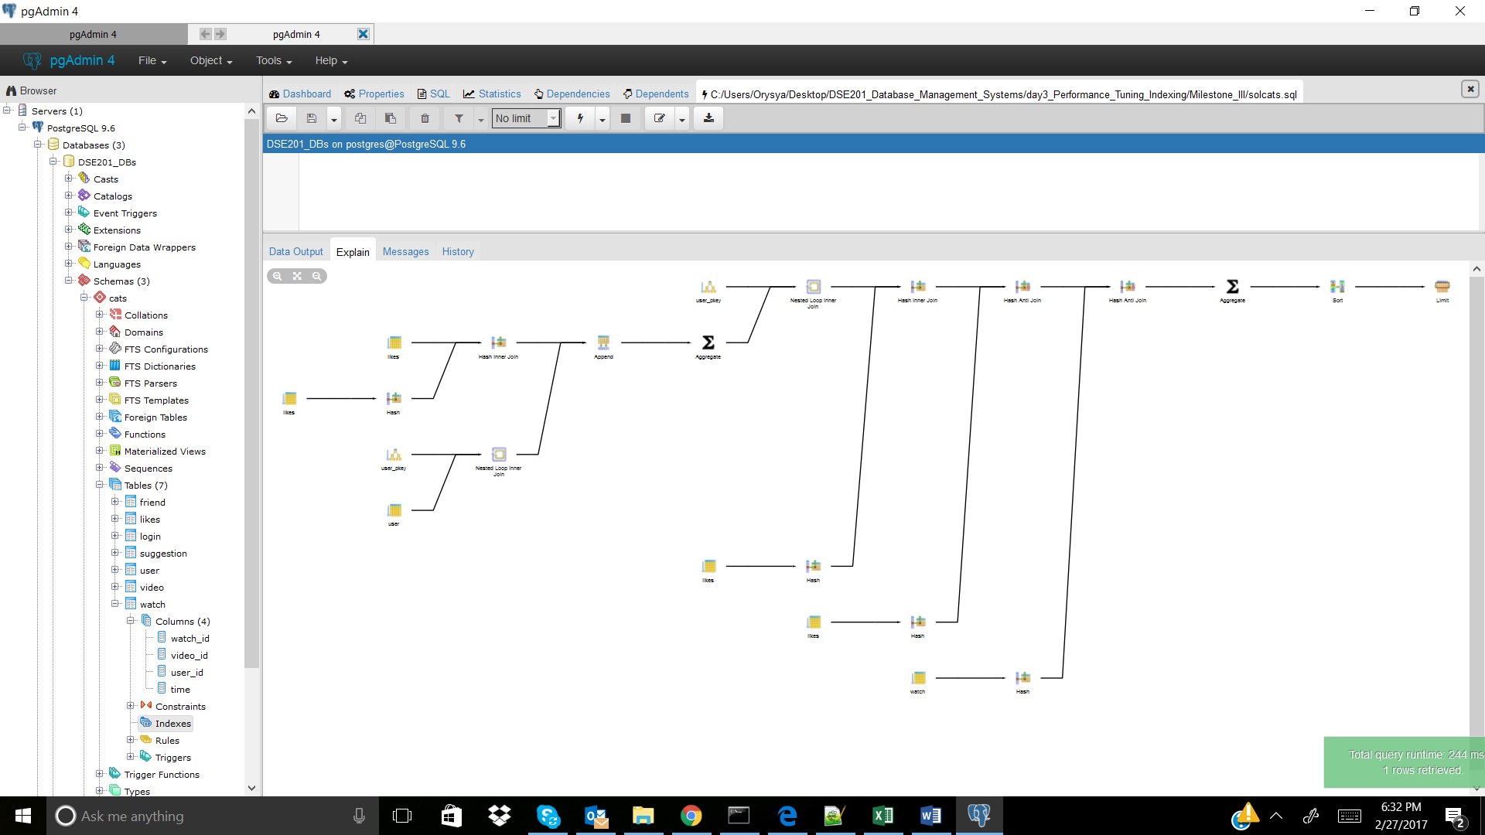

CREATE INDEX likes_user_id_index ON cats.likes(user_id); -- didn't improve, is incorporated

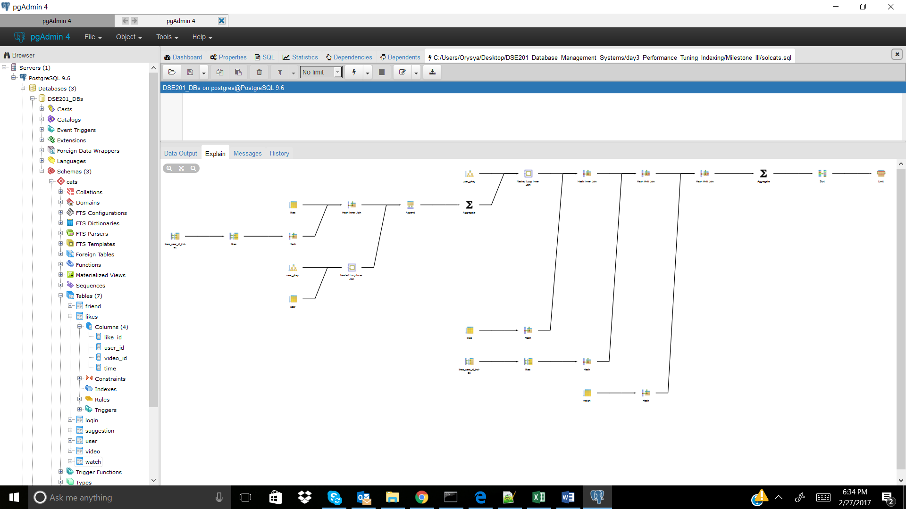

CREATE INDEX likes_video_id_index ON cats.likes(video_id); -- didn't improve, is incorporated